CSE5DL EXAM REVISION

Mark(s):

-**100 marks** of the exam will be allocated to multiple choice. (25 multiple choice questions)

-**60 marks** will be short question and answer.

-**20 marks** are programming questions.

TOTAL: 180 MARKS

**NOTE:**

IMPORTANT QUESTIONS

ADDITIONAL SPECIAL EXAM QUESTIONS

ADDITIONAL NORMAL EXAM QUESTIONS

Week 1

Lecture 1

* Why deep learning is particularly good for supervised learning of unstructured data?

Deep learning eliminates some of data pre-processing that is typically involved with machine learning. These algorithms/any deep learning model can ingest and process unstructured data, like text, computer vision and images.

* What is feature learning and how is it better than handcrafted features?

Feature Learning helps move machine learning to include feature representation. Which learns features automatically which is it better than handcrafted features created manually engineered by data engineers and scientists.

* Give examples of computer vision problems that deep learning is good for solving.

-Object detection

-Semantic segmentation

-Multi-object tracking

-Pose estimation

* Give examples of natural language processing problems that deep learning is good for solving.

Examples of natural language processing problems that is good for solving are,

-Parts of Speech

-Ontologies (WordNet)

-Anaphora

-Named entity recognition

-Stemming

-Parsing

Reason:   
The important point is for NLP traditionally people had to do feature engineering before they can feed the data into a ML model.

* Why is programming deep learning like playing Lego?

-Programming deep learning are composed of many different plug and playable blocks. Requires a combinatorial number of algorithms can be created. For instance, one block turns an image into a vector, 2nd block turns vector into text.

**SUMMARY**

* Deep learning has many real-world applications.
* Deep learning is more accurate than competing methods for almost all problems that involve unstructured data.
  + Images
  + Text
  + Video
  + Audio
  + Etc.
* Programming deep learning has become much easier with programming frameworks such as Pytorch and tflow.

Lecture 2

* Why do we need activation functions?

Without activation functions it will be harder to create to separate classes. Leaving to create only linear decisions (linear functions) only.

* Know the popular activation functions.

-Sigmoid function

-tanh

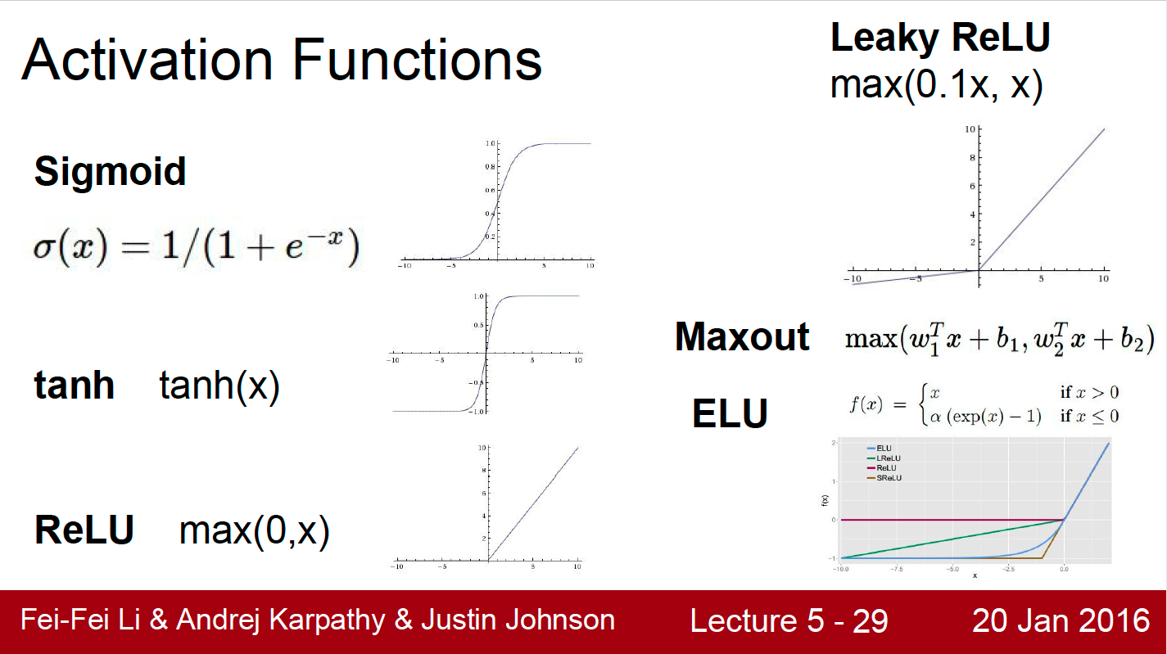-ReLU

* What is the advantage of making models deeper?

Making the models deeper can learn much more complex representations of the data. Which enables better efficiency in creating more complex decision boundaries between our input and output parameters.

* How does backpropagation work?

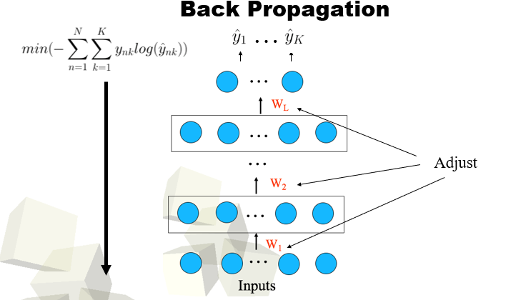

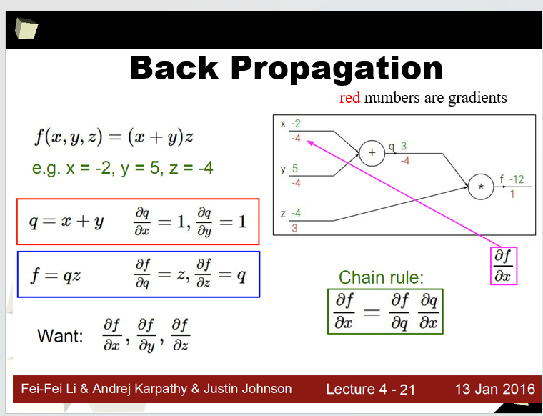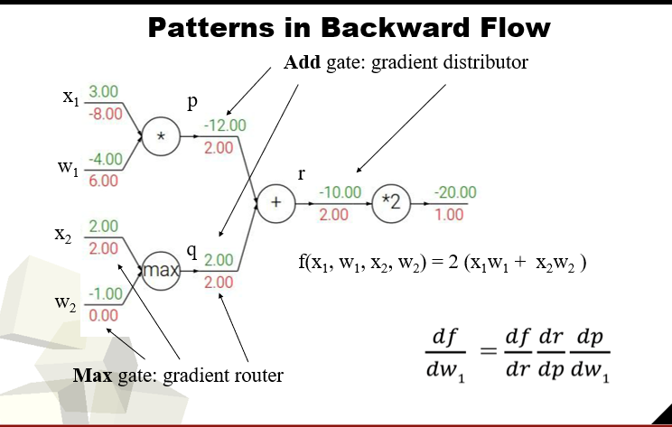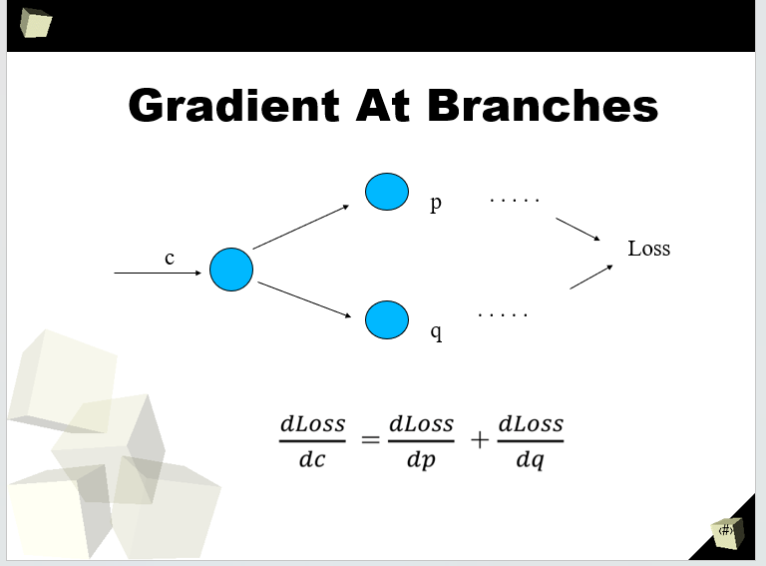

To have backpropagation to work we first,

Use the calculus chain rule to propagate the gradient of the loss from the output all the way back to all the weights.

Second,

Adjust the weights using the gradients.

* What do optimizers do?

An optimizer is an algorithm or function that adapts the neural network’s attributes, for example the learning rate and weights. It improves accuracy and reduces the total loss.

* Why do we need to have loss functions? 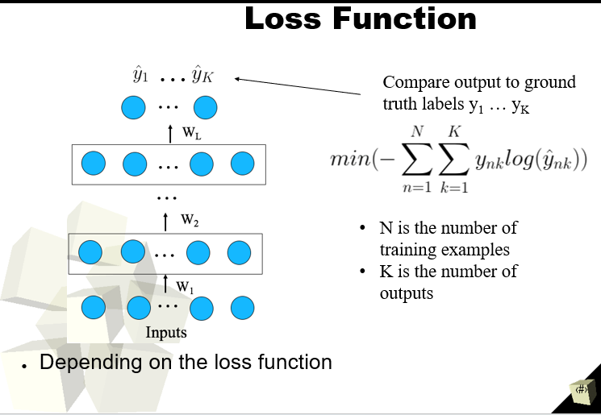

We need to have a loss function to determine which performance of the model is evaluated against and the parameters learned by the model are determined by minimizing a chosen loss function.

* Understand the following.
  + Soft-max
  + Cross entropy loss

What does the softmax function do?

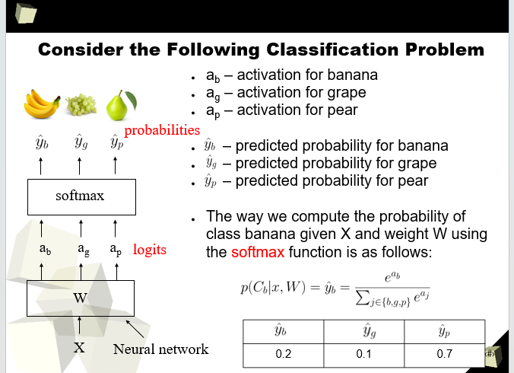

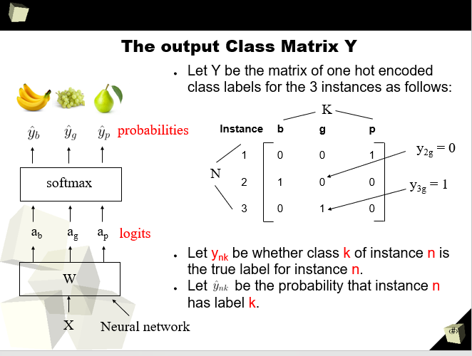

**What does cross-entropy loss do? How does it relate to the softmax function?**

The Cross Entropy Loss takes form of maximum function in terms of N, K multiples of the SoftMax function. We then later take the negative log base 10 on both sides to achieve this goal**.**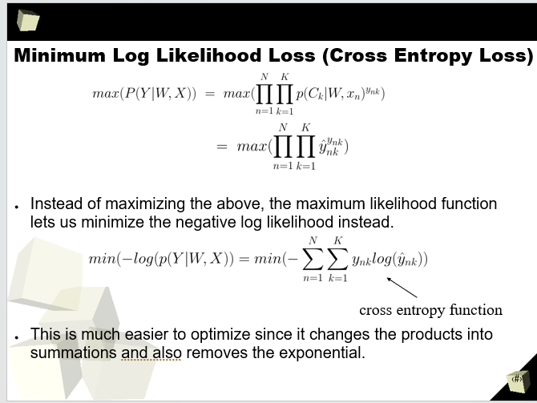

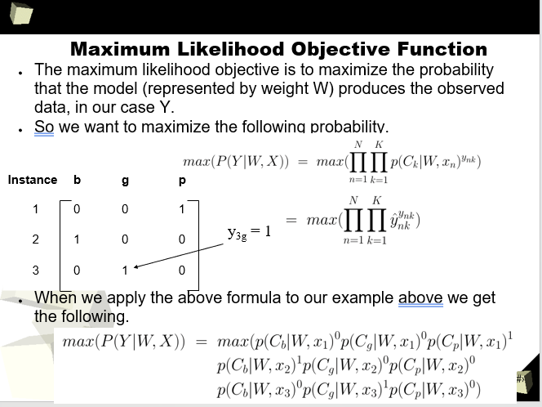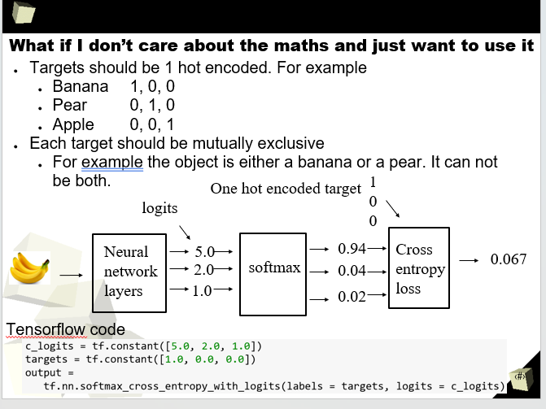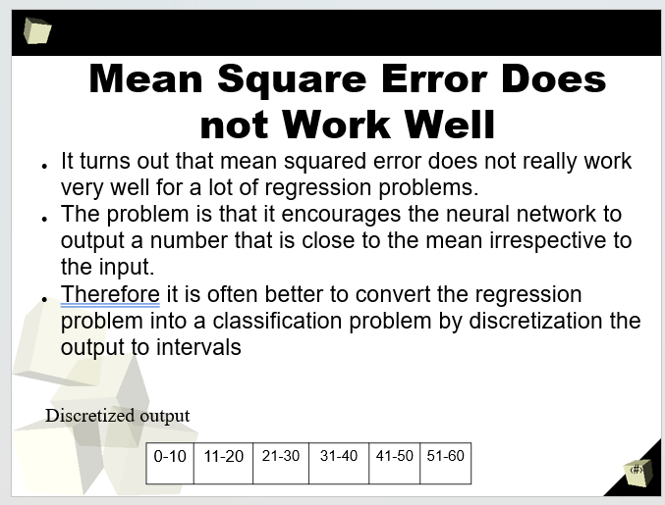

* **NOTE: You will be given some basic pytorch code, you need to be able to find what the mistake is.**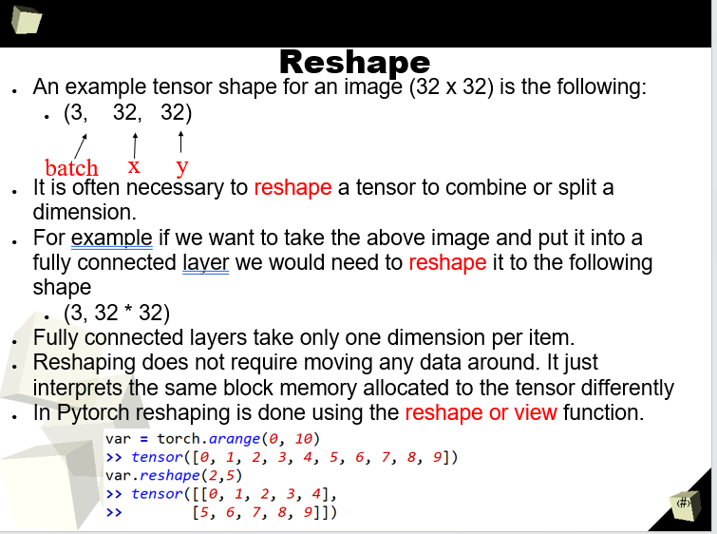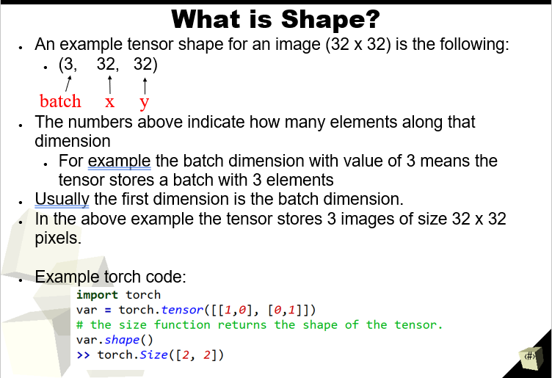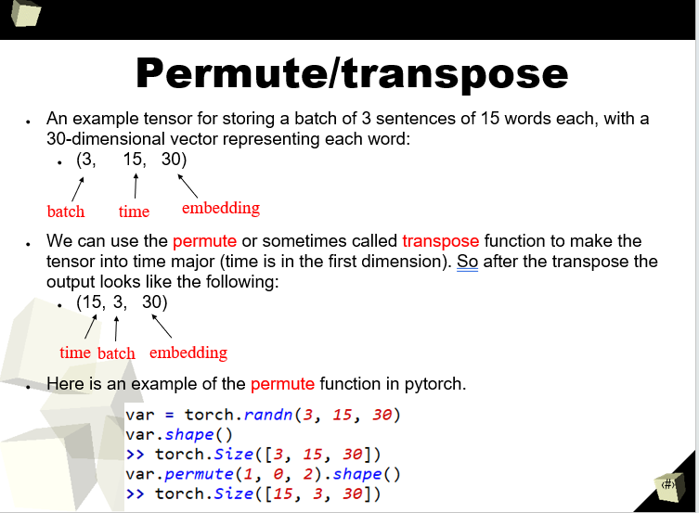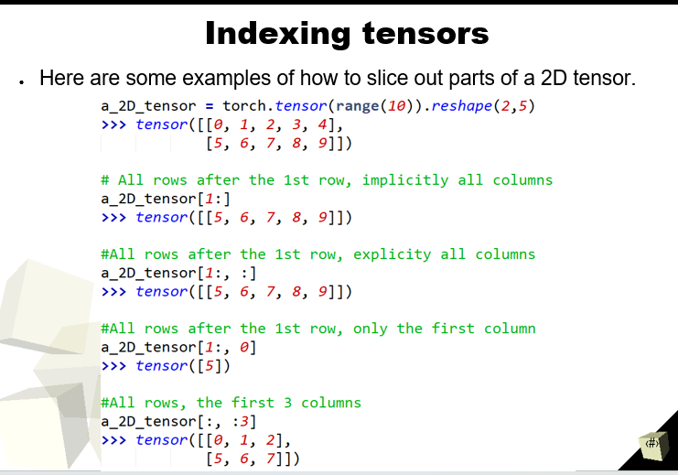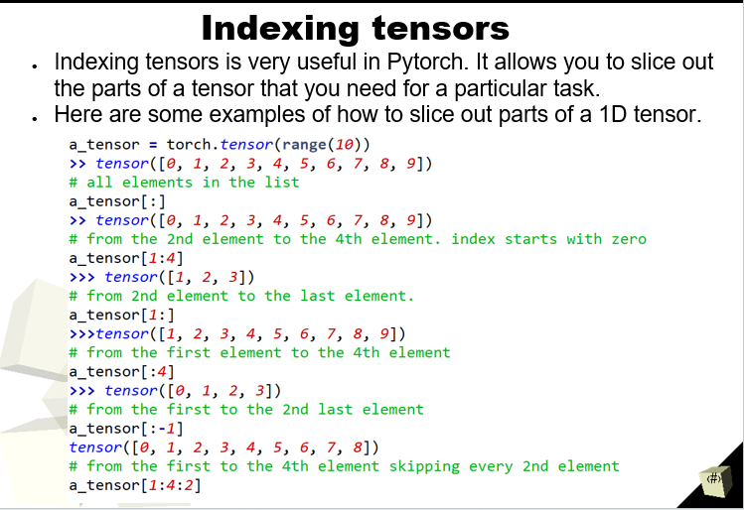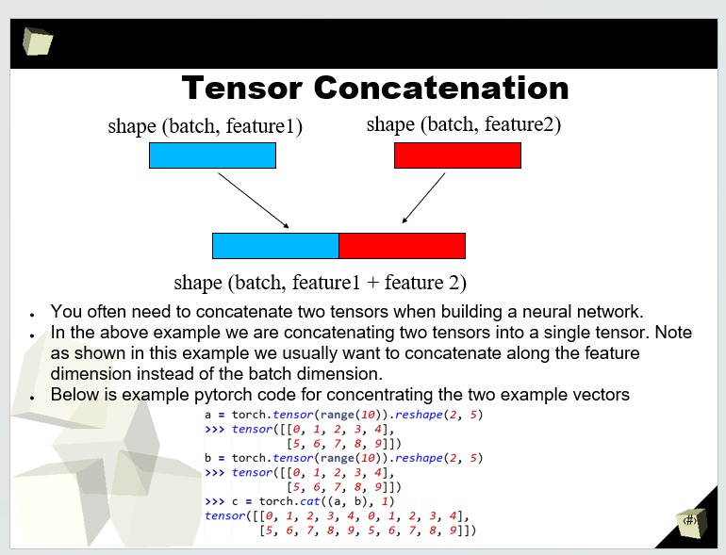

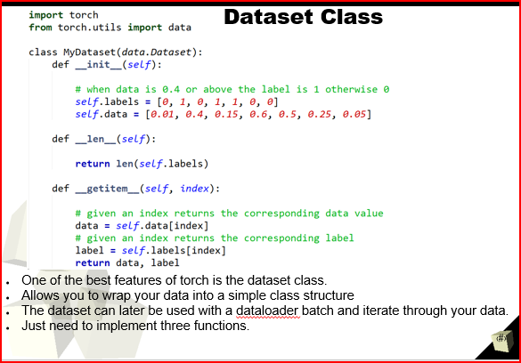What is the purpose of the PyTorch Dataset class?

What functions do you need to implement on a subclass of PyTorch’s Dataset class?

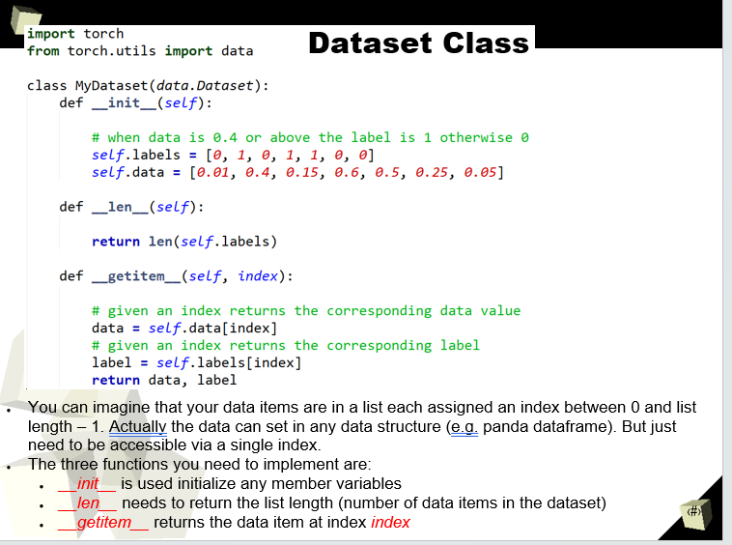

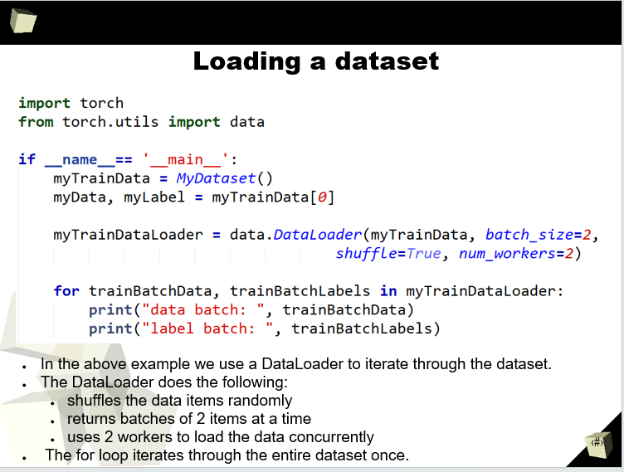

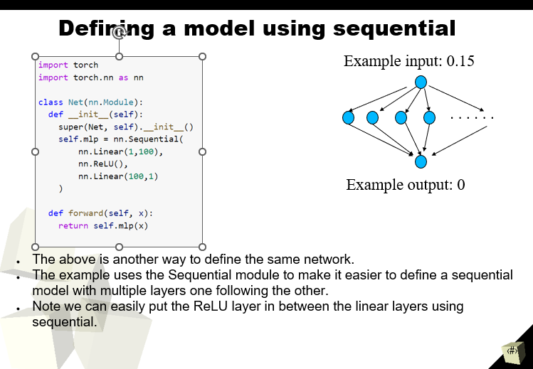What functions do you need to implement on a subclass of PyTorch’s Module class?

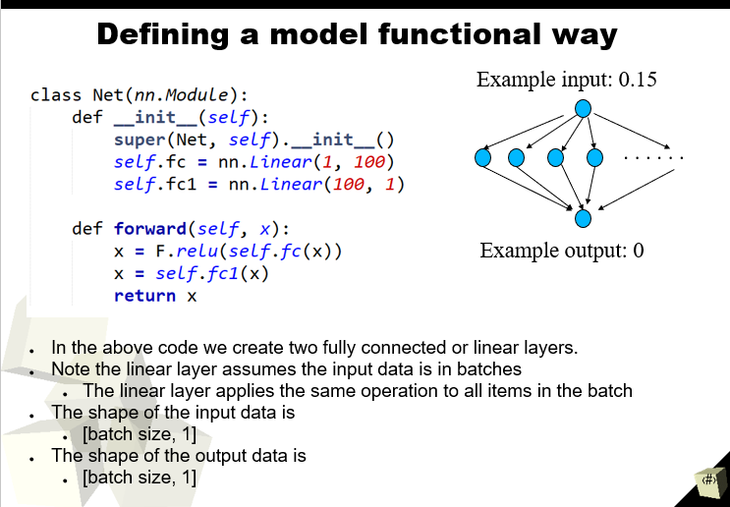What do the arguments to nn.Linear change?

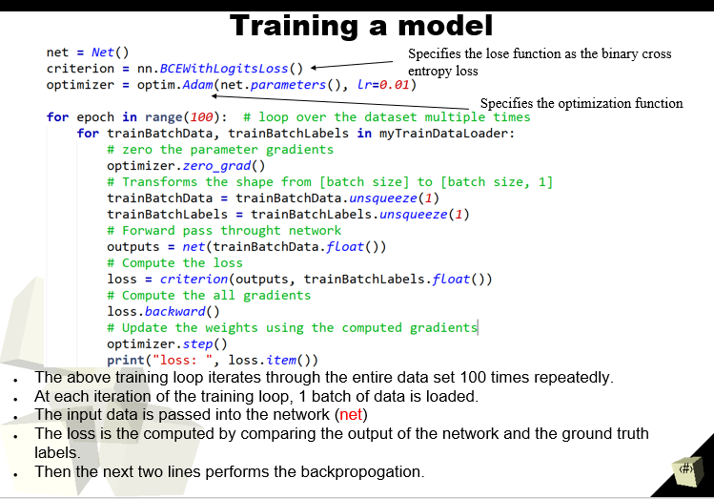(!) Given a model and a data loader, how do you write a basic training loop?

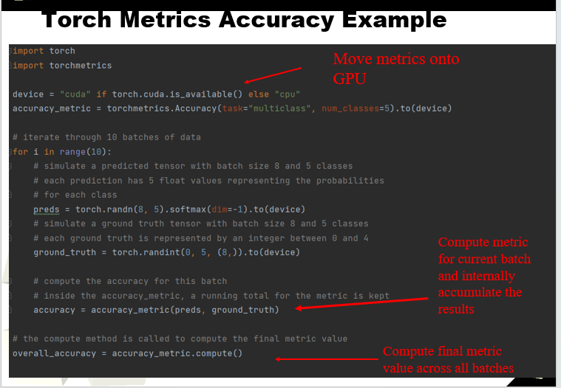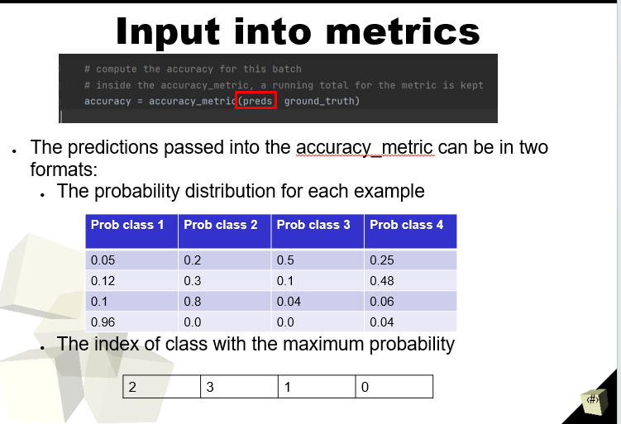

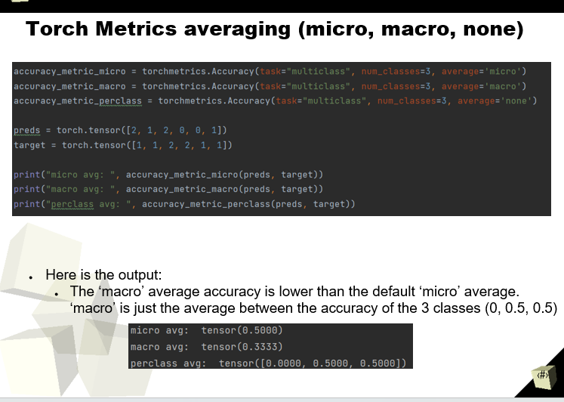

* What are some examples of image tasks using deep learning?

Some of the examples of image tasks for deep learning are.

**Image Recognition: Hand Crafted Features**

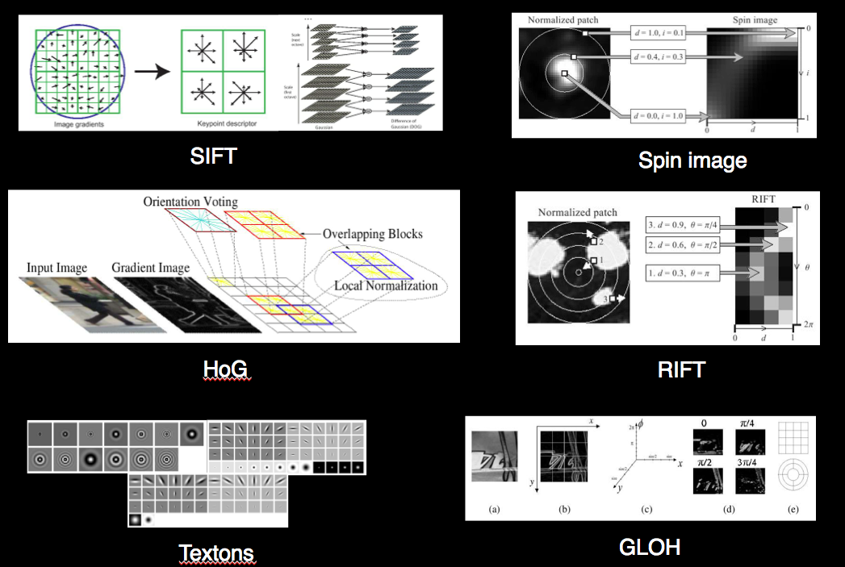

**Image caption generation**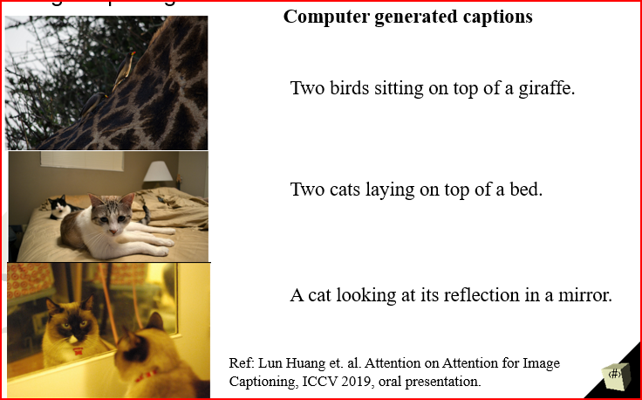

* What are some examples of text tasks using deep learning?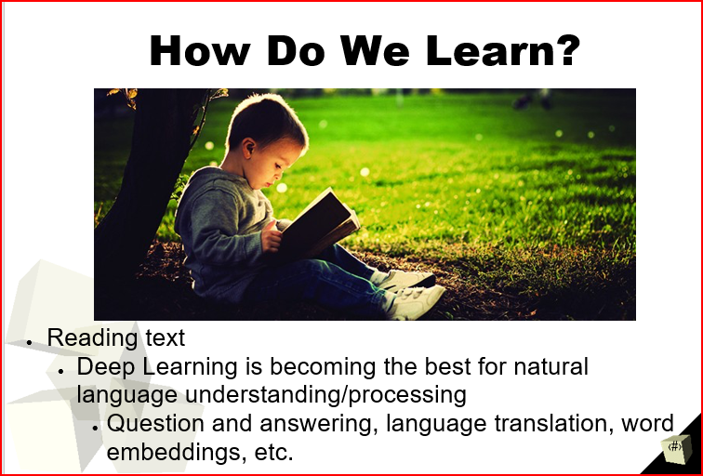

**Playing Lego**

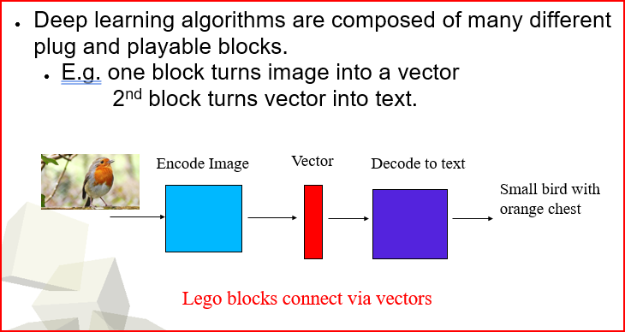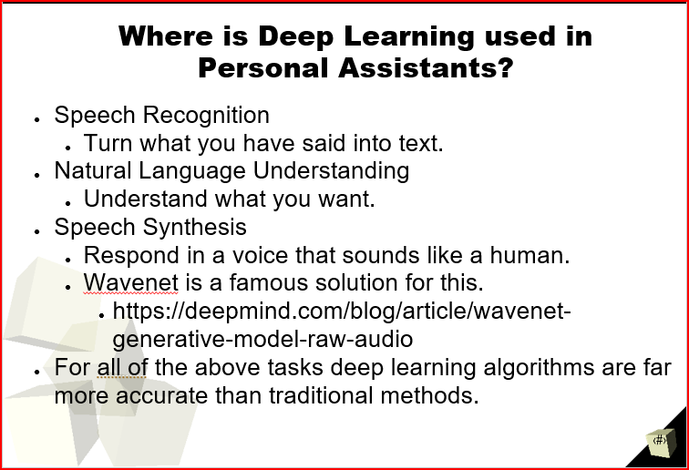

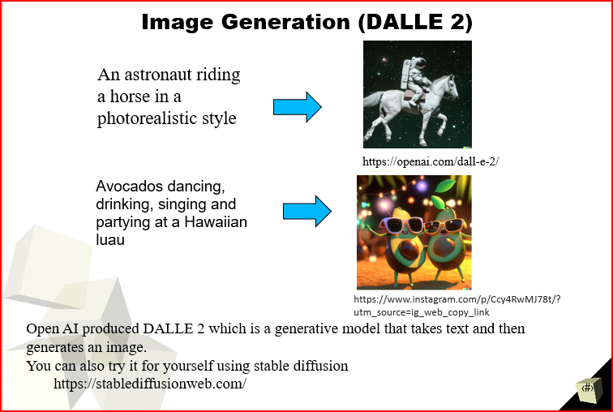

How do gradients tell us how to change weights?

It plays an essential role in Automatic Differentiation; you can achieve this by writing any new operation and the system will automatically compute the gradient for you when you perform back propagation. Using the chain rule of calculus, the gradients of the individual constituent operations are combined to arrive at the overall gradient for the entire new operation. 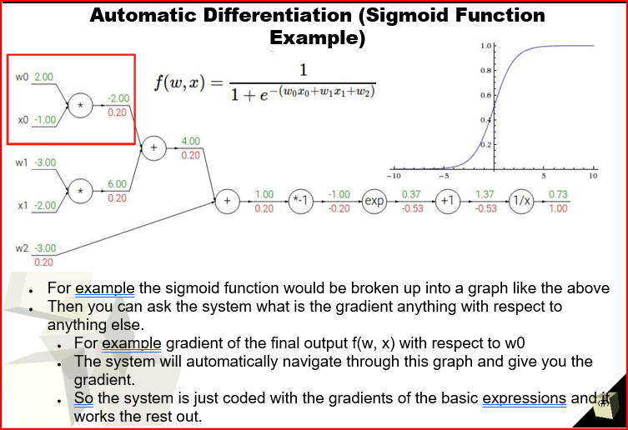

Week 2

Lecture 3

* Why are CNNs so effective for computer vision applications?

CNNs are effective for computer vision applications to reduce high dimensionality of images or videos without losing its information.

* What is a feature map?

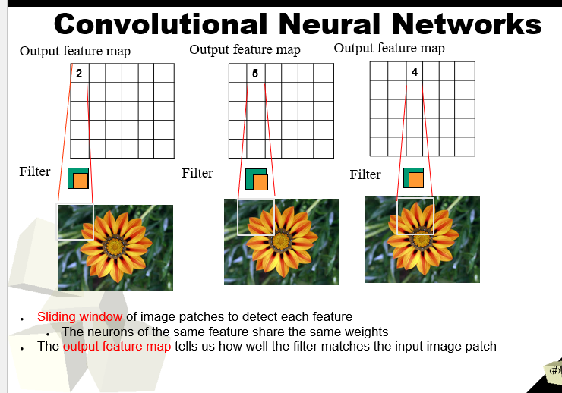

* How does CNNs achieve translation invariance?

Translation invariance can be achieved by pooling, meaning that region or object can become invariant to (small) translations after application of pooling.

* What is the receptive field?

A receptive field is the size of the region in the input that produces the feature(3). Represents 3 non-linearities instead of one. Which measures an association of an output feature (of any layer) making decision function more discriminative. (refer from VCG)

* How do deep layers differ from shallower layers of an CNN model?

While a shallow neural network has only one hidden between the input and output layers, while a deep neural network has multiple hidden layers.

* + Why do they differ in this way?

Shallow has only two data processing layers, with the second on linear by taking a linear combination of several functions of type. For Deep learning has several nonlinear data processing layers.

* What are linear/fully connected layers useful for? 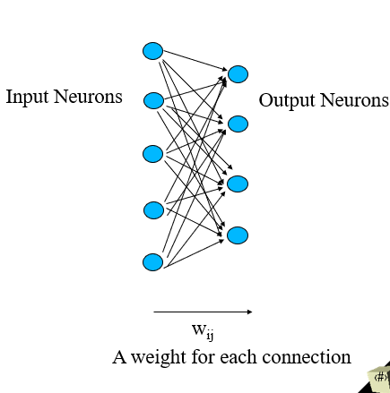

Linear/fully connected layers are useful for changing the number of outputs to match the required number of inputs.

* What is the advantage of using batch norm?

Using batch norm can allow much higher learning rates, which further increases the speed in which networks train closer to normal. Making the weights easier to initialize, be very difficult when creating deeper networks. Often used by ResNet. 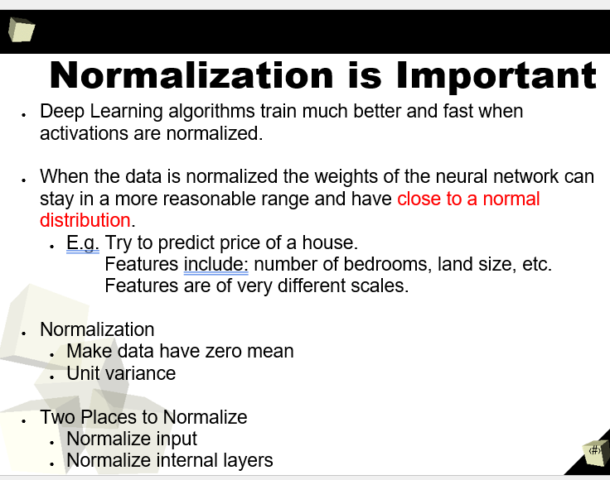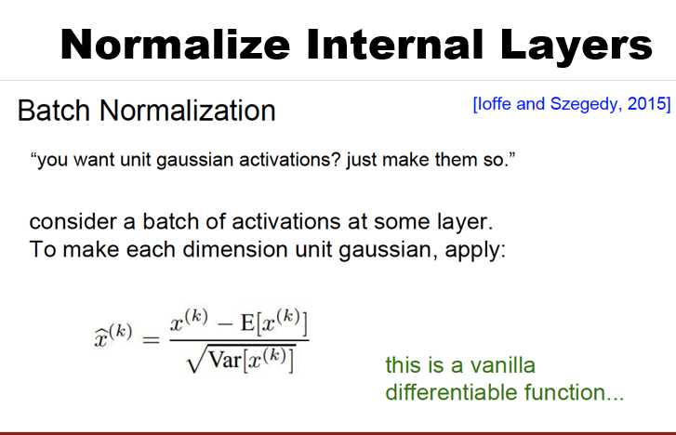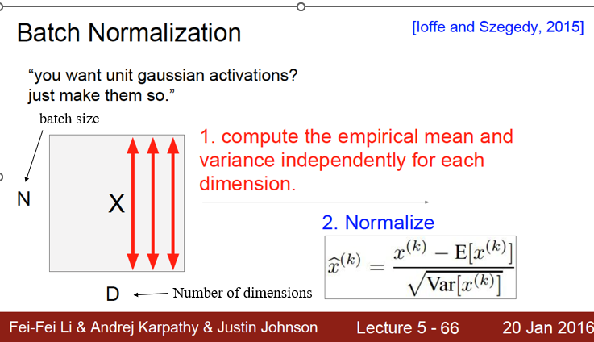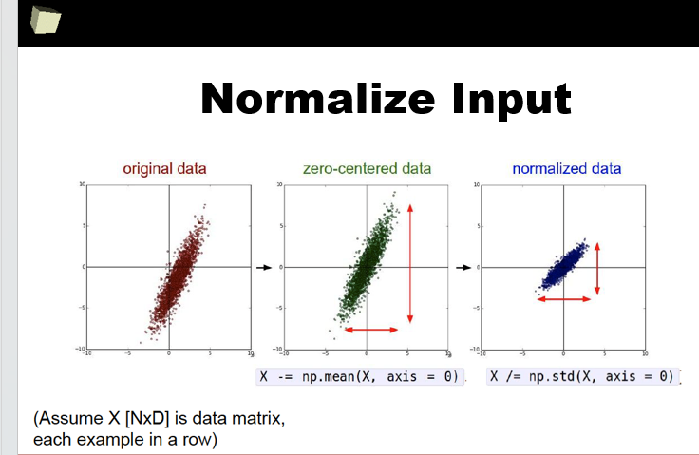

* What is the advantage of skip connections?

Able to help preserve information and gradients that might otherwise be lost or diluted by passing through multiple layers. Which is practically used in different architectures in ResNets skipping connections can solve the degradation problem adding more layers/accuracy is going much deeper.

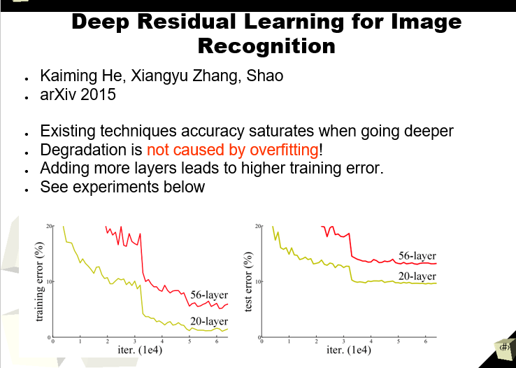

**Convolution computations**

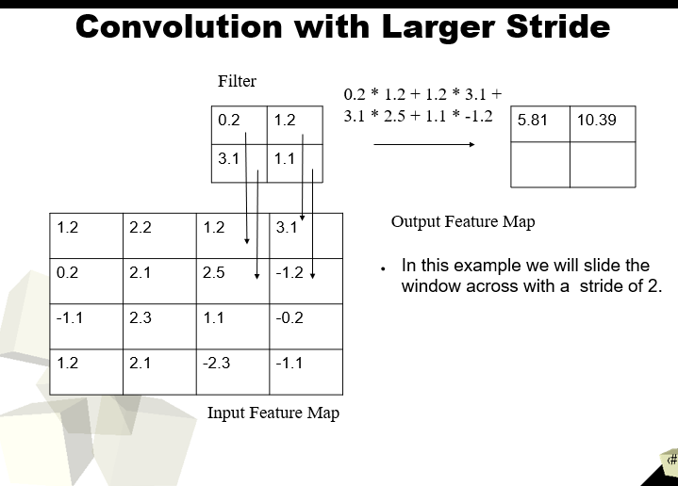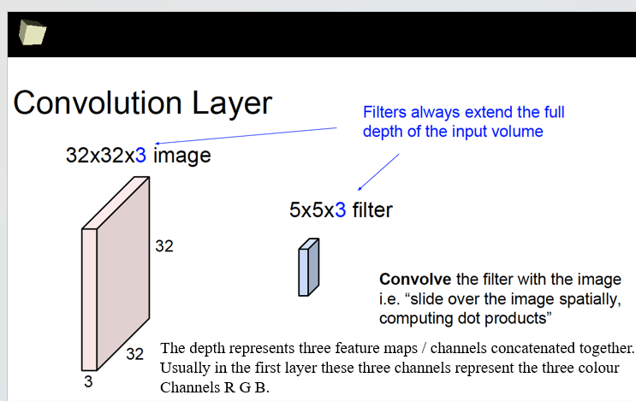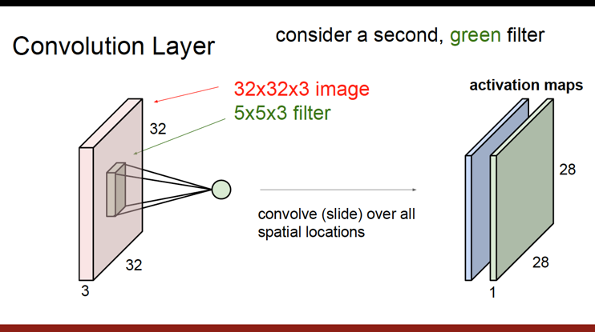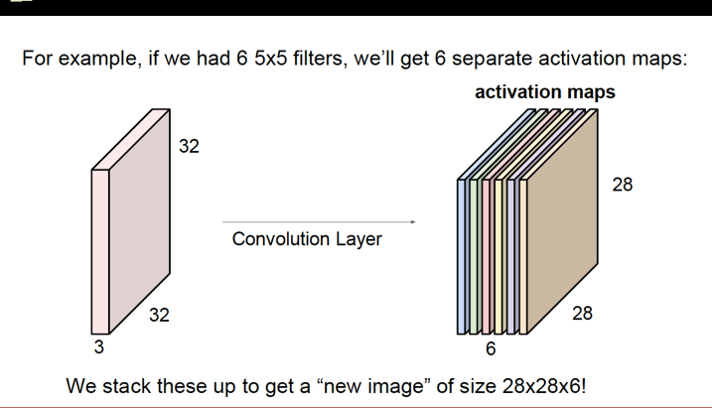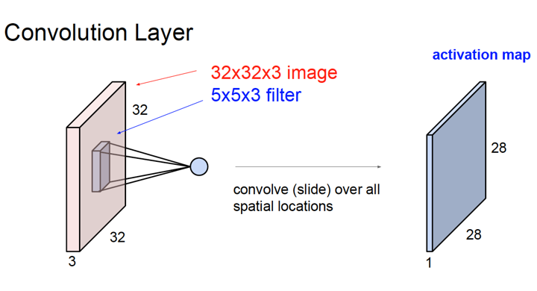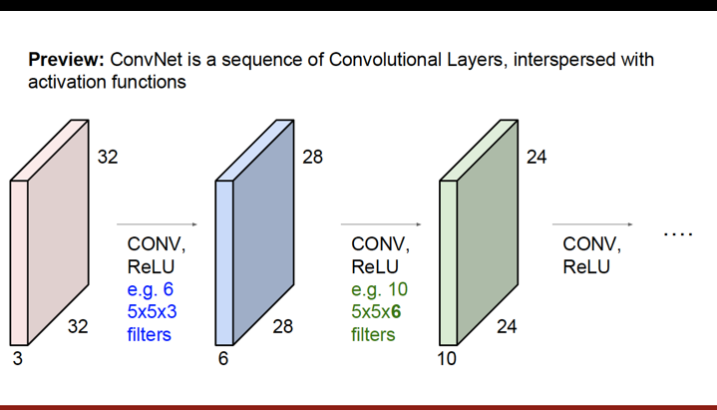

**Coding Parts in Lecture 3**

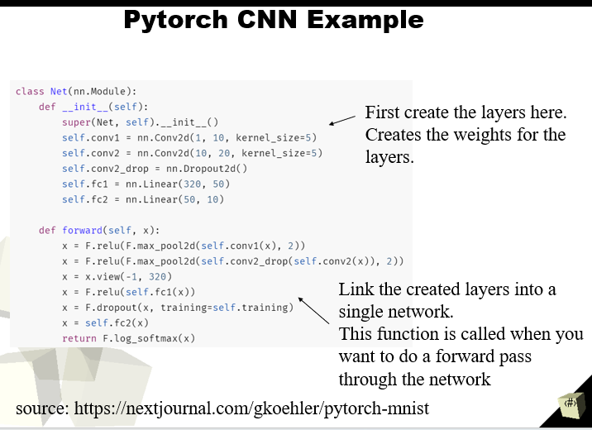What PyTorch layer is used for learning a convolution on images?

What do the arguments to that layer change?

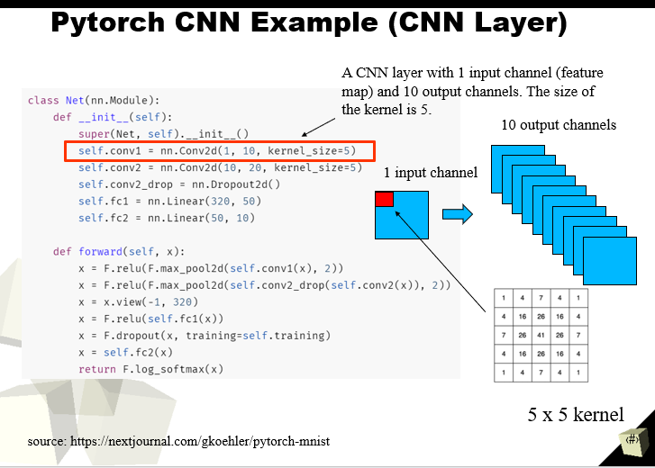

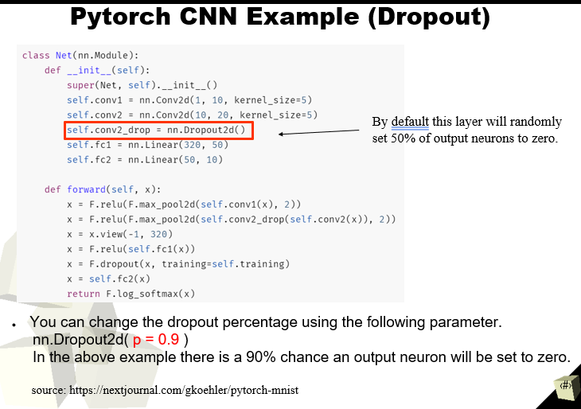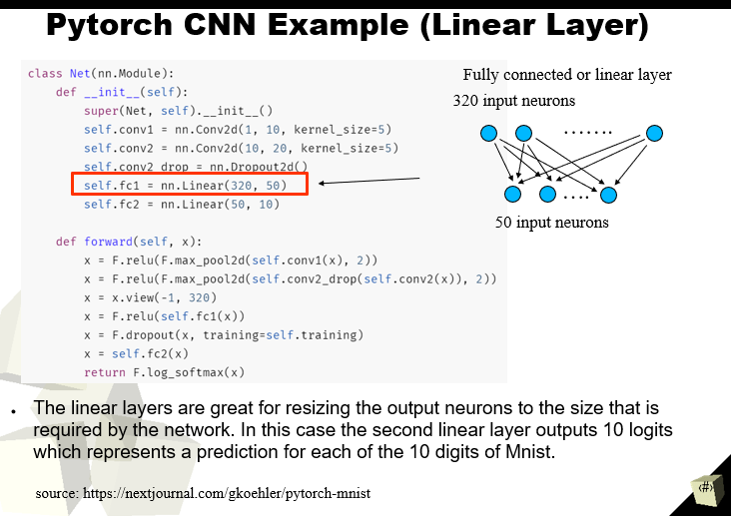

Which PyTorch layers are used to downsample?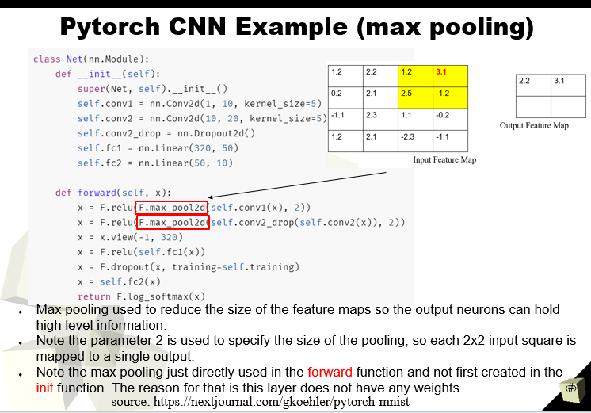

How do we connect the feature-extracting convolutions with the Linear classifier?

Convolutional Layers:

The initial layers of the CNN consist of multiple convolutional layers. These layers perform the feature extraction by applying convolutional filters to the input data, learning hierarchical features at different levels of abstraction. The output of these convolutional layers is a set of 3D feature maps, where each map represents a specific feature detected in the input.

Global Average Pooling (GAP) or Flattening:

After the feature extraction, one common approach is to use Global Average Pooling (GAP) or flattening to transition from the 3D feature maps to a 1D representation. Global Average Pooling involves taking the average of each feature map along its spatial dimensions (height and width), resulting in a single value per feature map. This reduces the spatial dimensions to 1x1, effectively compressing the spatial information. Flattening, on the other hand, reshapes the 3D feature maps into a 1D vector, where all spatial information is collapsed into a long sequence. 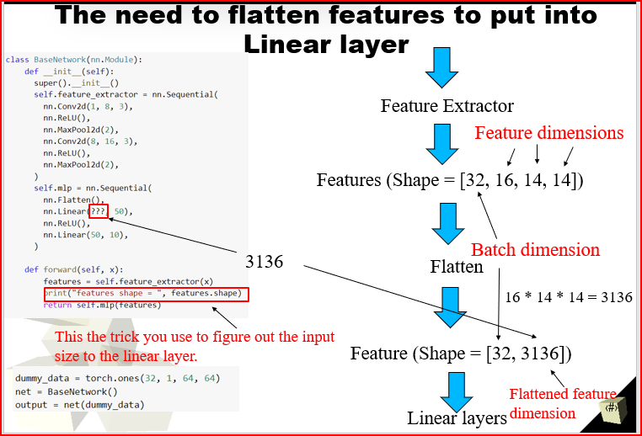

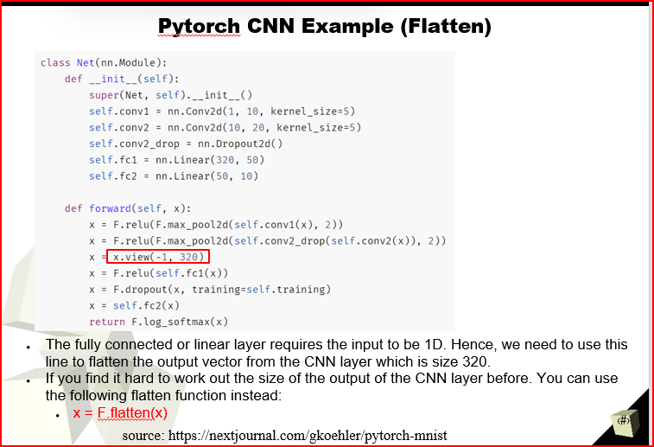

Fully Connected (Linear) Classifier:

After the feature maps have been transformed into a 1D representation, they are connected to a fully connected (linear) layer. This layer acts as the classifier, taking the 1D feature vector as input and producing the final class scores or probabilities as output. The fully connected layer has learnable weights and biases that are updated during the training process to optimize the network's performance for the specific classification task.

Why are images 4D when training a CNN?

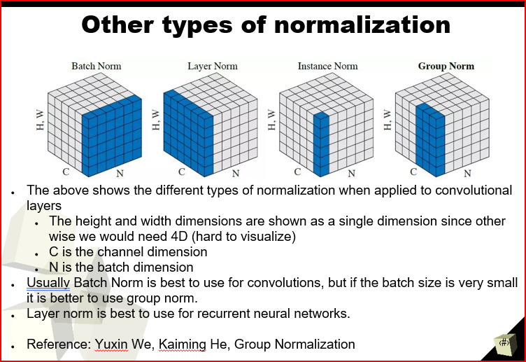

**More coding parts in Lecture 3**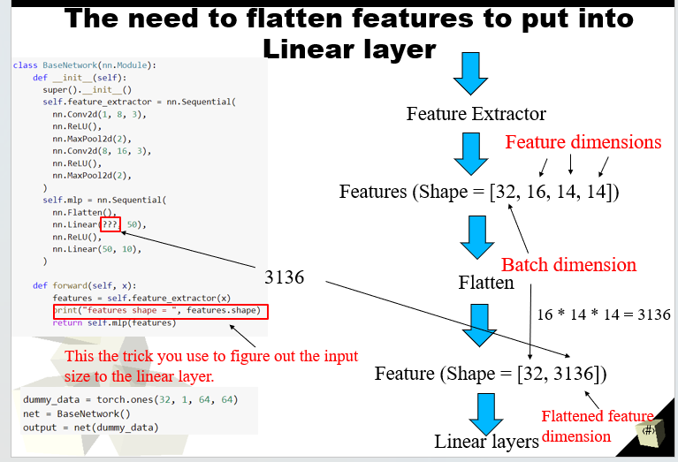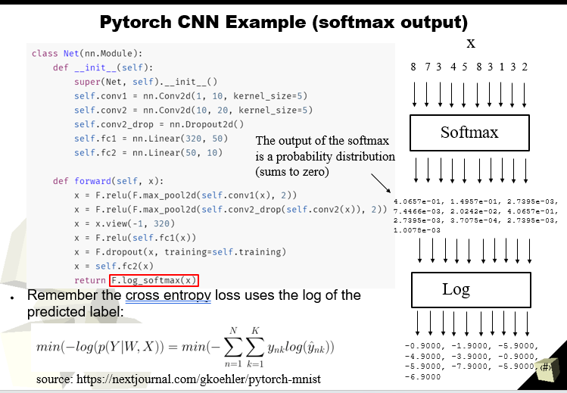

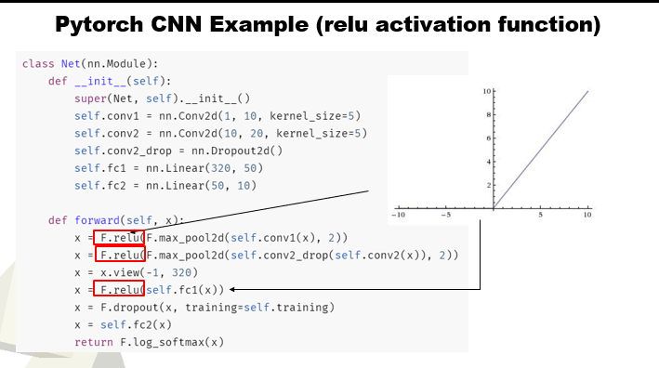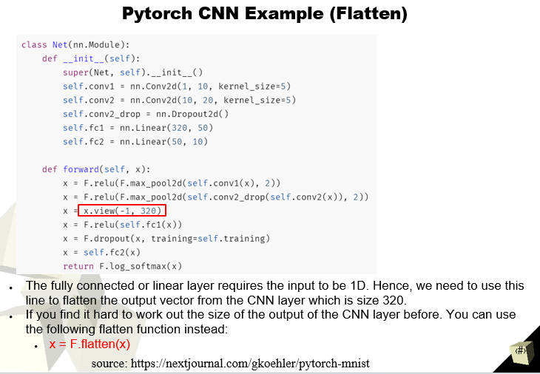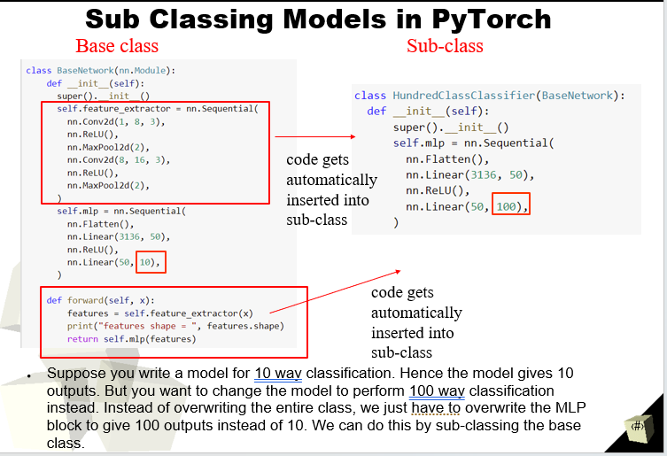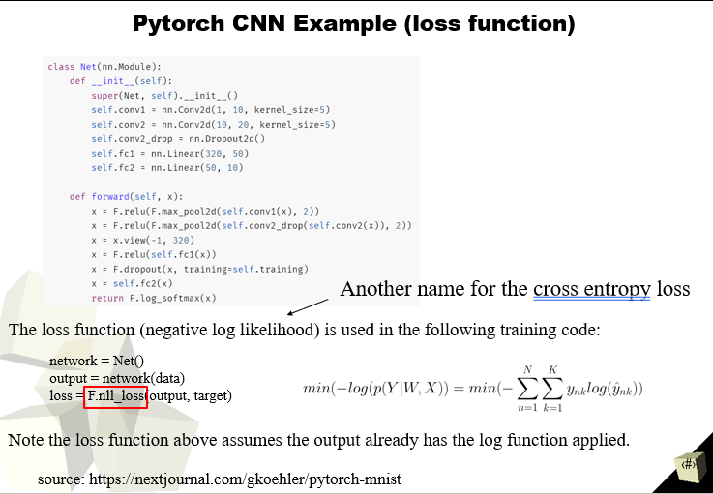

What is translation invariance?

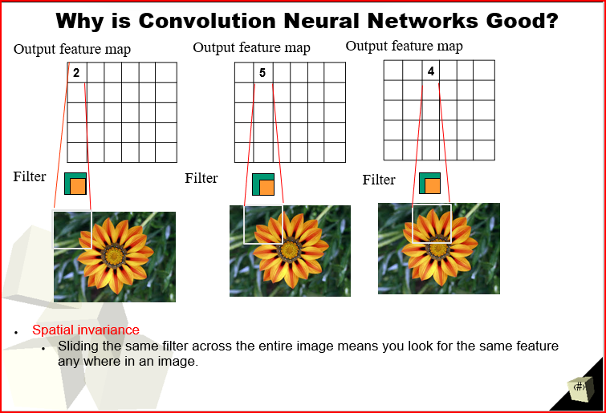Convolutional Neural Networks (CNNs) are an example of models that can exhibit translation invariance. CNNs use convolutional layers with shared weights and pooling operations, allowing them to effectively detect features at different spatial positions in an image. This shared-weight architecture enables them to recognize patterns even if they are translated within the input image.

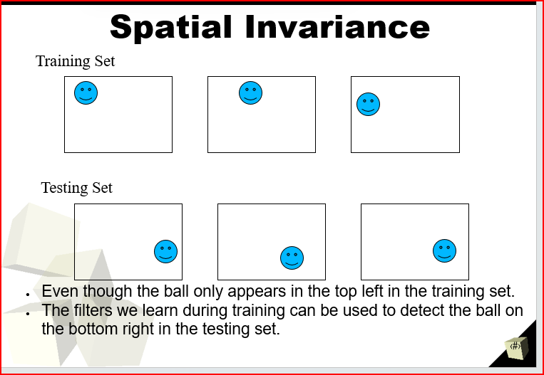Why is translation invariance good for images?

What is downsampling? Why is that useful?

Downsampling, in the context of Convolutional Neural Networks (CNNs), refers to the process of reducing the spatial dimensions (width and height) of an input feature map while retaining essential information. This reduction in spatial dimensions is typically achieved through operations like max pooling or average pooling.

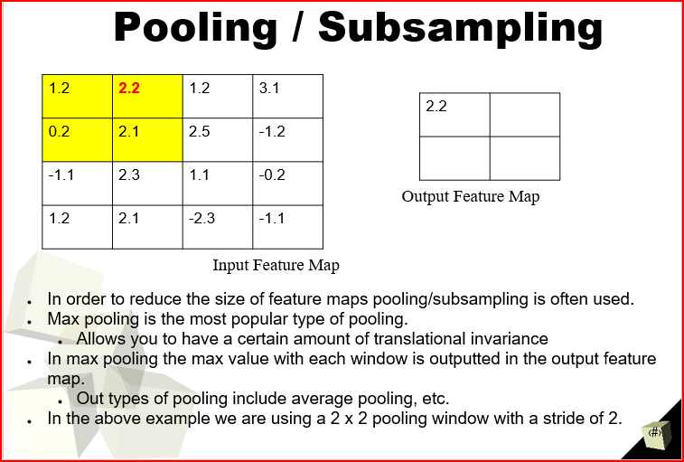

How do the outputs of deeper layers differ from the outputs of earlier layers? Why?

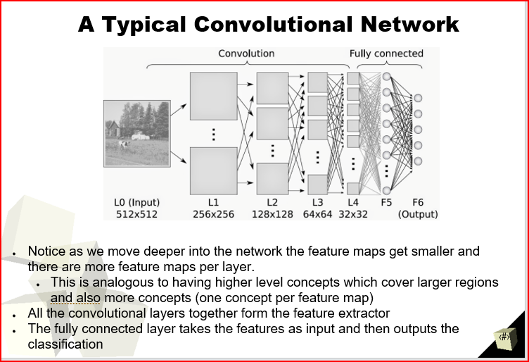

What is multi-task learning? When should we use it?

A machine learning approach in which a single model is trained to perform multiple related tasks simultaneously. Instead of training separate models for each individual task, a multi-task learning model shares and leverages information across tasks to improve overall performance.

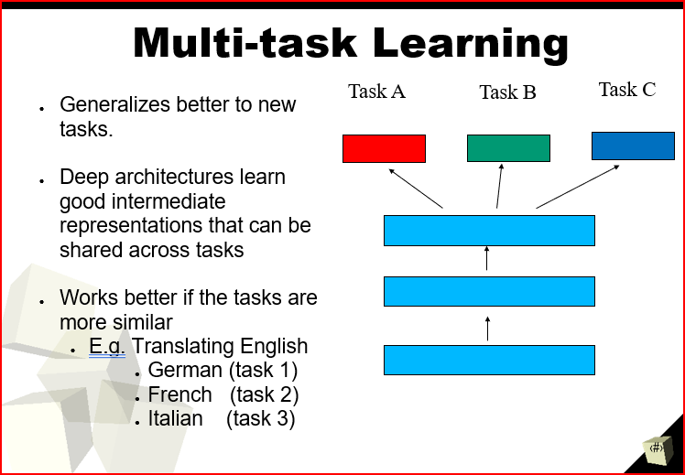

What is curriculum-task learning? When should we use it?

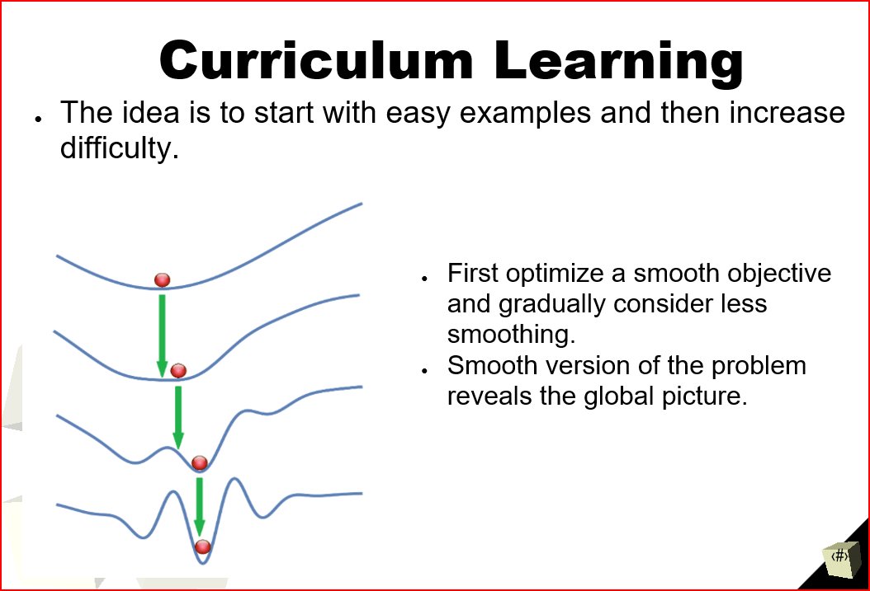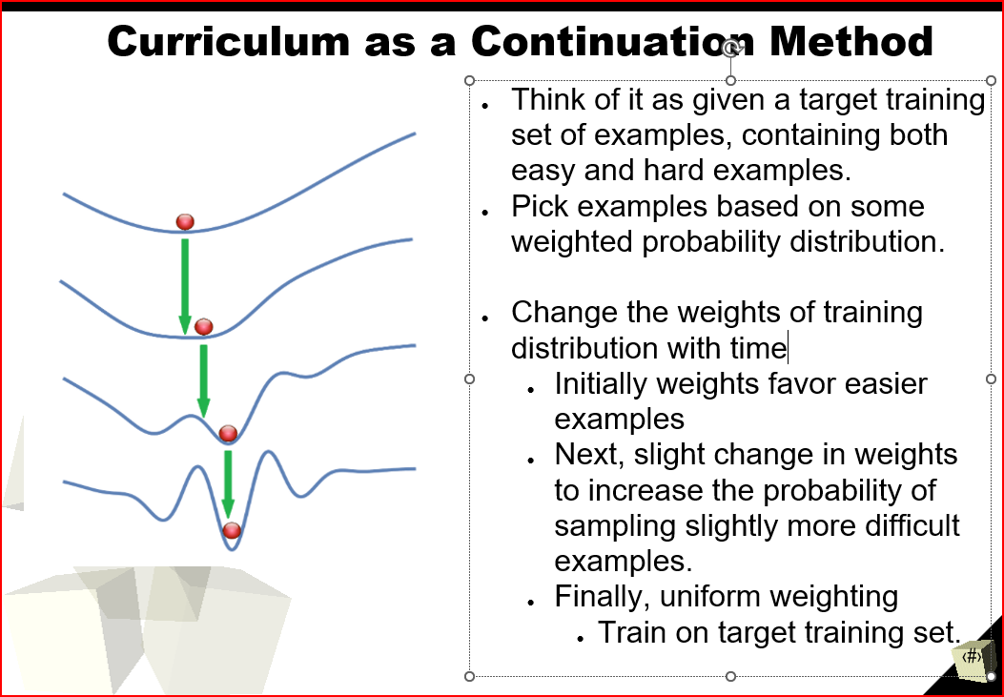

Lecture 4

How do we change a model to combine ancillary data together with image data?

**Step 1: Start simple**

Start with simple model

* + - Image: simple baseline CNN architecture. Try Resnet later.
    - Text: simple RNN
    - Any other data: fully connected layer

Use sensible defaults

* + - Adam optimizer with learning rate of 3e-4.

Normalize input

* + - Subtract mean
    - Divide by standard deviation

Simplify the problem

* + - Start with a simpler version of your problem
    - E.g. small subset of the data

**Step 2: Implement and Debug**

Common bugs

* + Incorrect shapes for the network tensors
    - Silent failure. Deep learning algorithms are very robust the system may not crash but it will not give good results.
  + Pre-processing inputs incorrectly
    - E.g. wrong normalization
  + Incorrect input to the model’s loss function
    - Make sure you check what kind of input your loss function expects
      * E.g. Loss function expects logits but you gave it output of softmax.

Overfit to a single batch!

* + Train your model so that it gets zero training error while training on a single batch of data.
  + You should always be able to achieve zero training error on a single batch.

This is my personal favorite way to debug deep learning models.

* + You will be surprised how often you find bugs using this very simple trick!

Possible causes for not overfitting a single batch

Problem: Error goes up

* + Possible causes:
    - The loss function has the sign flipped
    - The learning rate is too high
    - Softmax taken over the wrong dimensions

Problem: Error explodes

* + Possible causes:
    - Numerical issues. Check all exp, log, and div operations
    - Learning rate too high

Problem: Error oscillates

* + Possible causes:
    - Data or labels corrupted (e.g. zeroed or incorrectly shuffled)
    - Learning rate too high

Problem: Error converges high

* + Possible causes

Problem: Error converges high

* + Possible causes:
    - Learning rate too low
    - Gradients not flowing through the whole model.
    - Too much regularization (e.g., too much dropout)
    - Incorrect input to loss function (e.g., SoftMax instead of logits)
    - Data or labels corrupted

**Step 3: Evaluate**

How can we identify underfitting and overfitting when training?

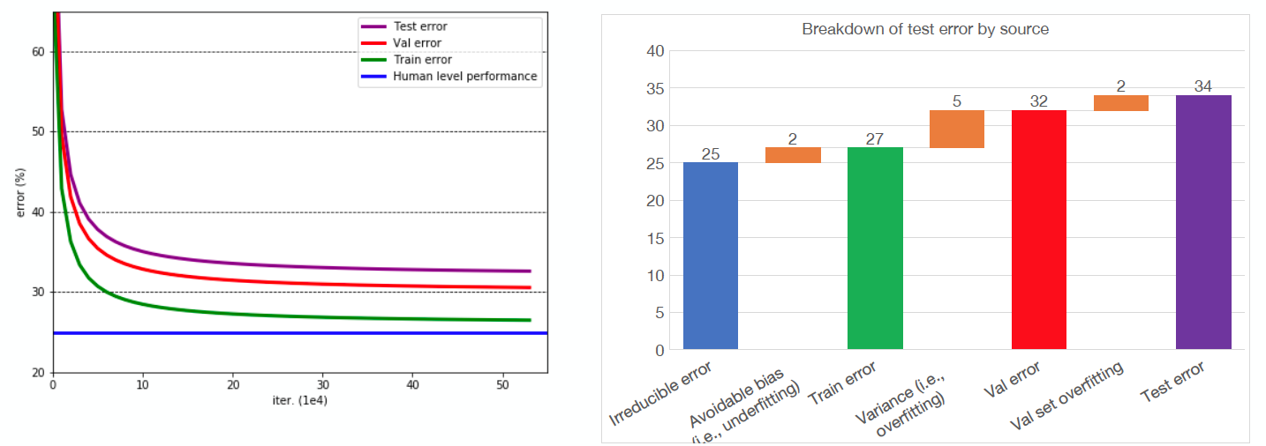

The training error is not at the level of human level performance

* + This called underfitting or avoidable bias

The validation error is higher than the training error

* + This is called overfitting or the variance

The testing error is higher than the validation error

* + This is called validation overfitting.

**Step 4: Improve the models and data.**

How can we overcome underfitting/overfitting when training neural networks?

**Address underfitting**

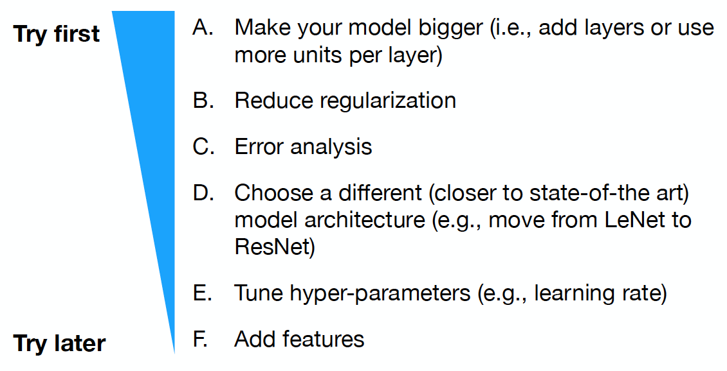

**Address overfitting**

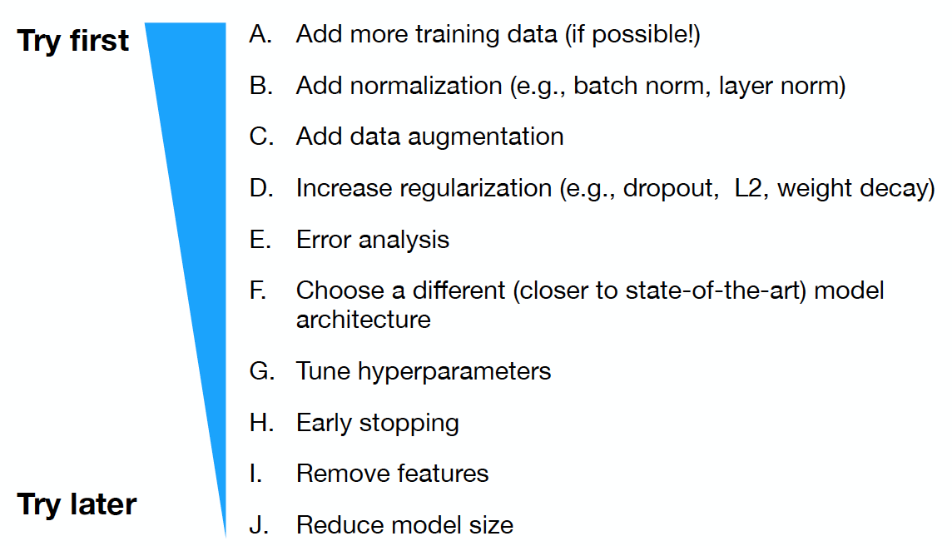

**Step 5: Tune hyper-parameters.**

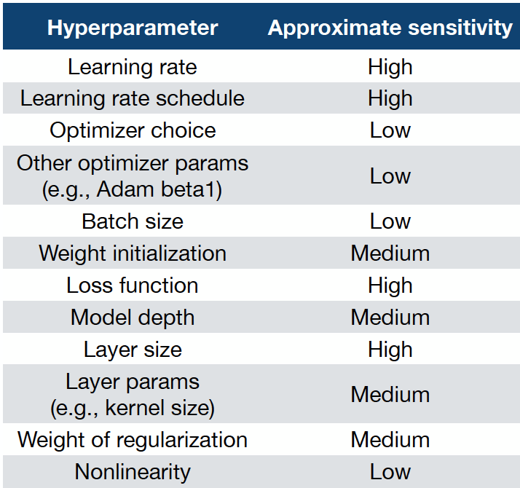

Tunning hyper-parameters is an important tool for achieving higher accuracy and can be used to reduce both overfitting and underfitting.

Below is a list of hyper-parameters that can be tunned and the approximate sensitivity of the results to different hyper parameter values.

* Given some training situation. You need to determine if there is a bug in the code. Explain the reason for your answer.

Refer to Step 2: Implement and Debug

* Name some ways of overcoming overfitting when training neural networks.

**Ways to overcome overfitting.**

Unsupervised learning

* + Can be of some help but usually not as good as transfer learning.

Transfer learning

* + The go to method for avoiding overfitting. Use for almost every problem in computer vision.

Data augmentation

* + Almost everyone does this since it is easy almost always improves performance.

Early stopping

* + Sometimes used but usually only used if the data is small.

Semi-supervised learning

* + Useful if you have a lot of additional unlabelled data.

Introduction to few shot learning

* + Useful in the extreme case you only have a very few (e.g. 1 or 5) labelled examples per class.

Some of the examples for instance,

-Dropout

-Batch Normalization

-Early stopping

-Data augmentation

-Increase training data size

**Possible causes for not overfitting a single batch**

* Problem: Error goes up
  + Possible causes:
    - The loss function has the sign flipped
    - The learning rate is too high
    - Softmax taken over the wrong dimensions
* Problem: Error explodes
  + Possible causes:
    - Numerical issues. Check all exp, log, and div operations
    - Learning rate too high
* Problem: Error oscillates
  + Possible causes:
    - Data or labels corrupted (e.g. zeroed or incorrectly shuffled)
    - Learning rate too high
* Problem: Error converges high
  + Possible causes
* How to deal with class imbalance.
  + During training over sample the minority class, so the overall number of examples fed into the model is balanced.
  + Adjust the loss function so the incorrect predictions for the minor class get higher weight.
* How can we identify a class imbalance in our dataset.
* When you train a model on skewed data:
  + Vast majority of gradient updates adjust the model to predict the majority class.
  + The model will tend to almost never predict the minority class.
* Why is debugging deep learning code so difficult?

You don’t know what the result should be.

Not sure if it is possible to train a model that can generalise to the testing set.

There maybe nothing wrong with your code but you just can not get the model to converge to a good result.

* Suppose you have determined there is some problem with your code. What are some steps you can take to try to debug the code.

Refer to Step 2: Implement and Debug

* Know how transfer learning works.

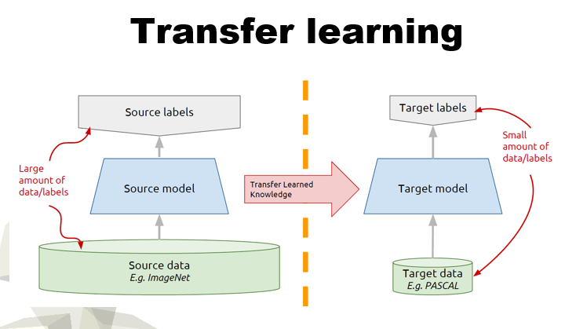The go to method for avoiding overfitting. Use for almost every problem in computer vision.

* What is data augmentation useful for?

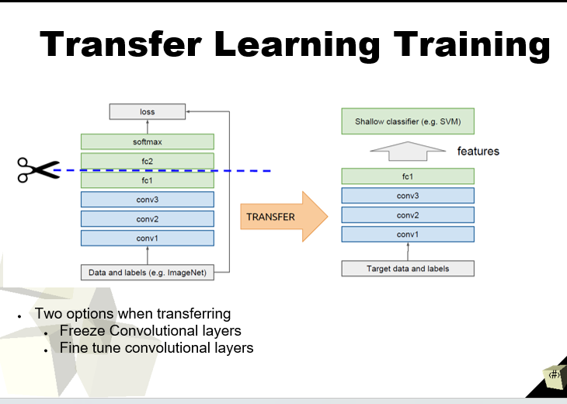

You can use data augmentation to artificially enlarge your data set but creating more examples of images that have been slightly altered using image transformations.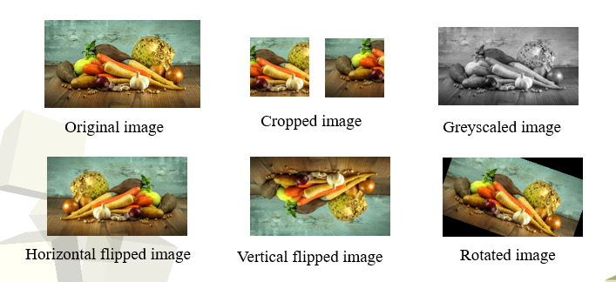

**OUTLINE**

* Practical Deep Learning

Different types of learning

* + - Multi-task learning
    - Curriculum learning

Incorporating ancillary data

Debugging neural networks

Ways of dealing with small, labelled datasets

* + - Unsupervised pre-training
    - Transfer learning
    - Data augmentation
    - Early stopping
    - Semi-supervised learning
    - Introduction to few shots learning.
    - Zero shot learning

What is unsupervised pre-training?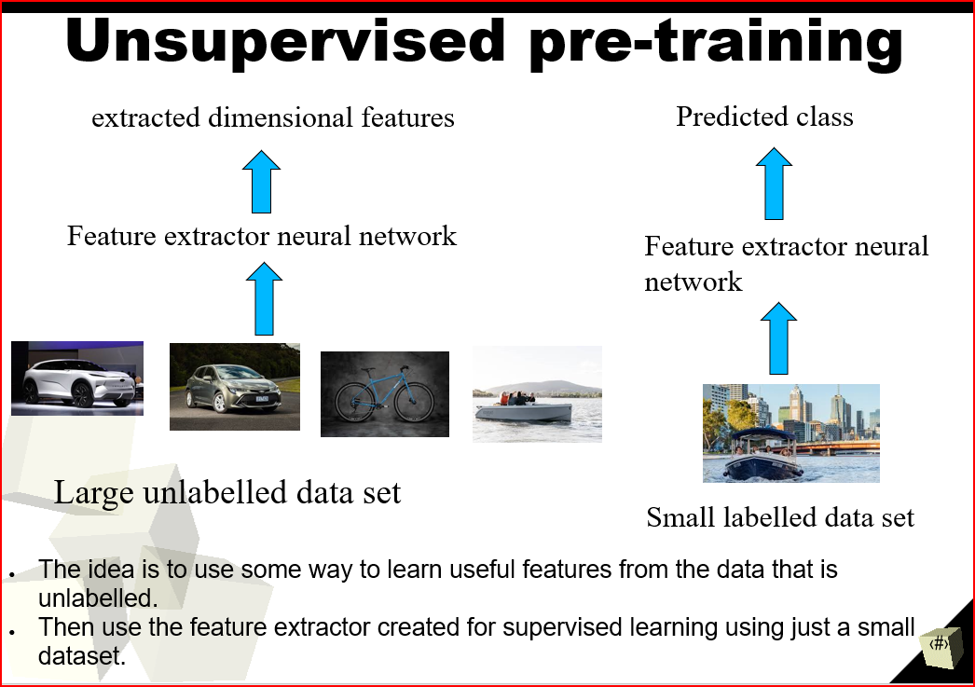

What is the difference between transfer learning and unsupervised pre-training?

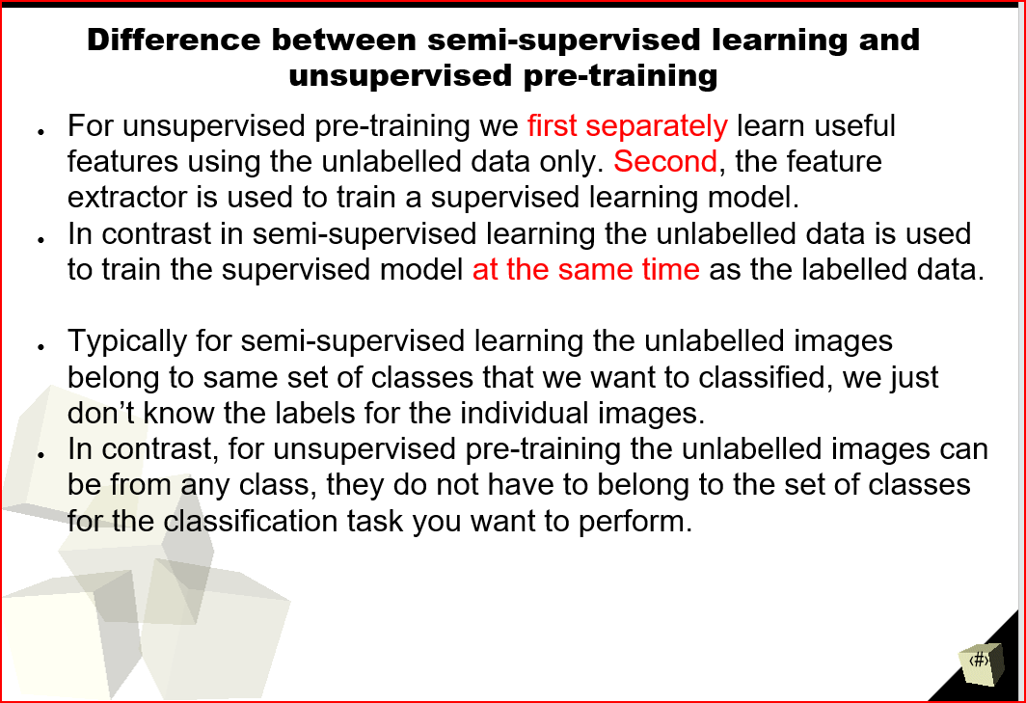

What is early stopping? 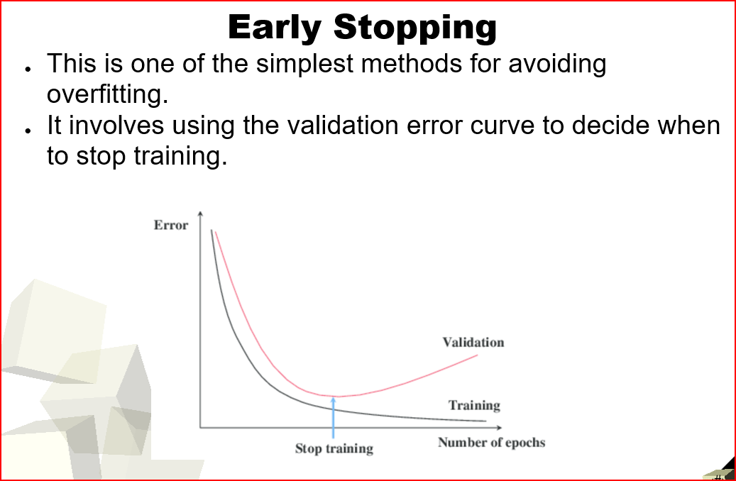

Week 3

Lecture 5

* Why would you want to turn text into a vector?

In Natural language processing (NLP),

It turns out deep learning is good at dealing with sequences.

Words

* + Sequence of characters

Sentences

* + Sequence of words

Paragraphs

* + Sequence of sentences

Document

* + Sequence of paragraphs
* How to model text if you care about the order of the words?

If we want concerned about the order of words use

* + - N-grams
    - Recurrent neural networks
    - Skip thought vectors.
* What is the advantage of using word embeddings compared to one hot encoding?

One hot encoding does not tell anything about the semantics of the items but embedding will group co-occurring items together in the representation space. So, word embedding is a better solution than one-hot encoding as it gives better results.

* What are the limitations of recurrent neural networks?

One drawback to standard RNNs is the vanishing gradient problem, in which the performance of the neural network suffers because it can't be trained properly. This happens with deeply layered neural networks, which are used to process complex data.

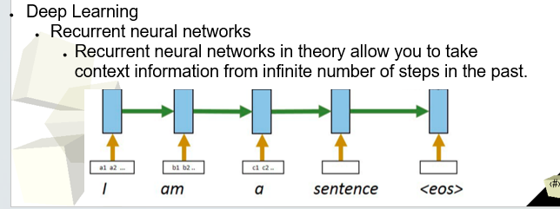

* + How do we overcome those limitations?

Refer/ read from the question How do we change a model to combine ancillary data together with image data?

LSTMs (Long Short Term Memory) solve the problem using a unique additive gradient structure that includes direct access to the forget gate's activations, enabling the network to encourage desired behaviour from the error gradient using frequent gates update on every time step of the learning process

* How does language modelling work?

Language models work to determine a word probability by analysing text data. For example, by applying the distribution word representation (Word2Vec) shown below, (add more/evidence 1-2 sentences to back up your answer.)

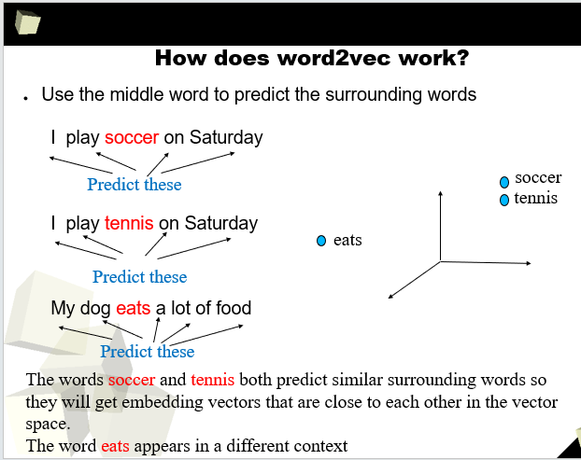

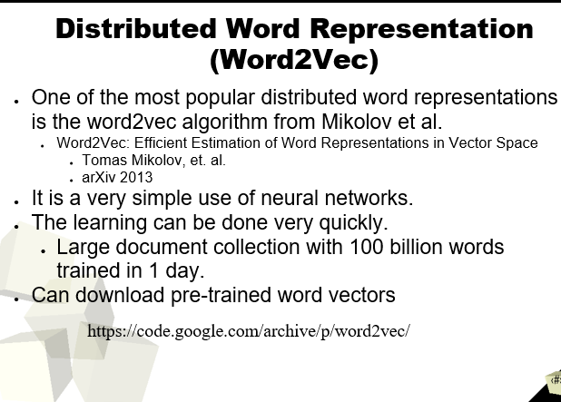How does Word2Vec create word vectors?

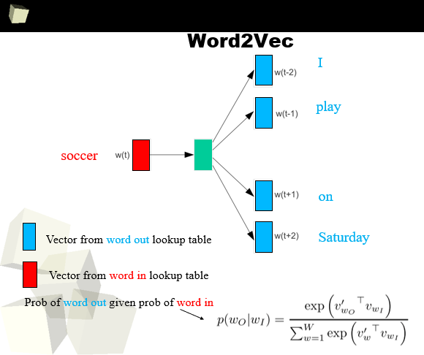

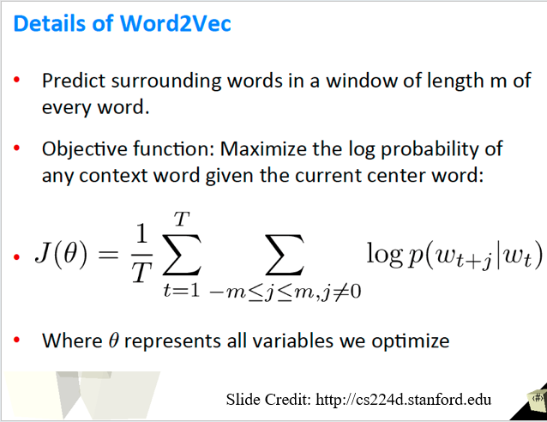

What are word vectors/embeddings? How do we get them?

Unsupervised Word Embeddings

* Word2Vect
* FastText
  + Very fast implementation
  + Very popular
  + From facebook
* Glove Vectors
* You can download pre-trained word embeddings for all three above
  + Trained on large text data sets.

Is there a difference between a word vector and a word embedding?

**Word Vector:**

A word vector is a generic term for any numerical representation of a word in vector form. It could be a one-hot encoded vector, a frequency-based vector, or any other vector representation used to represent words. One-hot encoding, for example, represents a word as a vector where all elements are zero except for one element that is set to one, indicating the word's position in a predefined vocabulary.

**Word Embedding:**

Word embedding, on the other hand, is a specific type of word vector representation that is typically learned from data using techniques like Word2Vec. Word embeddings are dense, low-dimensional, and continuous representations of words in a vector space. These representations capture semantic relationships between words, allowing similar words to be closer in the embedding space. Word embeddings are usually learned from large text corpora, and the learned representations can capture various linguistic properties such as word similarities, analogies, and contextual meanings.

What type of data is an RNN designed to work on?

The type of data a RNN is designed to work on for example, word embeddings.

* Word2Vect
* FastText
  + Very fast implementation
  + Very popular
  + From facebook
* Glove Vectors
* You can download pre-trained word embeddings for all three above
  + Trained on large text data sets.

Some other examples of data types applied for instance Time series data, natural language processing, Speech Recognition and Generation.

How does a recurrent neuron differ from a standard neuron?

Standard Neuron in Feedforward Neural Networks:

In a feedforward neural network, the standard neuron is the basic building block that processes inputs and produces outputs. It consists of an activation function, which takes the weighted sum of the inputs and biases, and then applies a non-linear function to produce the neuron's output. However, a standard neuron does not have any memory or internal state to retain information from previous time steps or data points.

Recurrent Neuron in Recurrent Neural Networks (RNNs):

In contrast, a recurrent neuron in an RNN is designed to handle sequential data by introducing memory or internal state. The core idea behind an RNN is to allow information to persist over time, so the network can capture dependencies and patterns in sequential data.

What is wrong with plain RNNs?

Plain RNNs suffer from vanishing gradient and exploding gradient problems, making them ineffective in capturing long-term dependencies in sequential data. They have short-term memory and struggle to model complex sequential patterns. More advanced architectures like LSTM and GRU were introduced to address these issues and have become popular for sequential data tasks.

What variant of RNNs is most common?

Long Short Term Memory (LSTM) according to the lectures In practice when using RNNs, people always use LSTMs or some other variants of it like GRU.

What is a causal temporal (1D) convolution?

A causal temporal (1D) convolution is a type of convolutional operation that ensures predictions are made based only on past and current time steps, maintaining causality in time series or sequential data. It restricts the filter's use to prevent "peeking into the future," making it useful for tasks like time series forecasting and natural language processing.

What is a dilated convolution?

In a dilated convolution, the filter's dilation rate determines the spacing between the filter's elements, creating gaps between them. By increasing the dilation rate, the receptive field expands, allowing the network to capture larger patterns and long-range dependencies in the data without increasing the number of parameters or computational cost.

Dilated convolutions are commonly used in various deep learning architectures, especially in tasks that require capturing global context information, such as semantic segmentation and image generation. They have shown to be effective in extracting multi-scale features and handling large input sizes, making them valuable for tasks involving high-resolution data and capturing context across different scales.

What is the advantage of dilated versus non dilated temporal convolution?

Dilated temporal convolutions provide a more efficient and effective way to handle long sequences and capture global temporal context without significantly increasing the number of parameters, making them advantageous over non-dilated temporal convolutions in tasks requiring long-range dependencies and multi-scale information in sequential data.

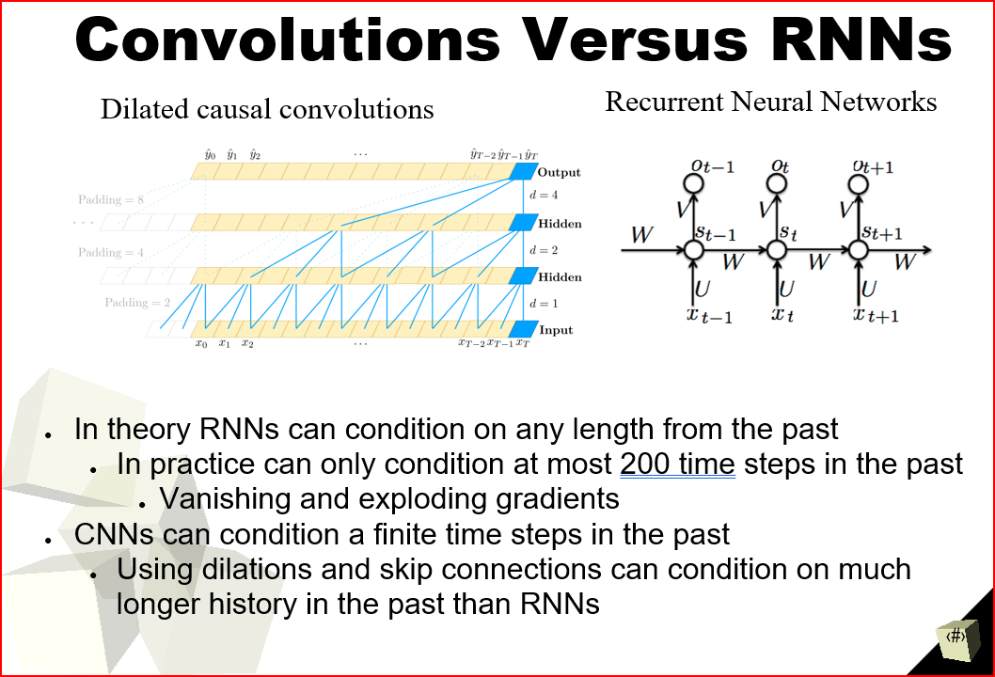

Lecture 6

* How to deal with words that do not exist in the vocabulary?

Usually, words that do not map to any word in the vocabulary are mapped to an output vocabulary word index. To deal with this we apply using the pre-trained embedding vectors called torchnip which contains NLP utilises for loading pre-trained word embeddings.

* Know the key benefits of using a transformer network.

-Easier to train

Training can be easily parallelized (can use GPUs much better)

-Transfer learning actually works!

Pre-trained models can be fine-tuned for new tasks.

-Can be trained on unsupervised text

All the world’s text data is now valid training data.

* What is the difference between context-aware word embeddings and context unaware embeddings?

**Context-aware word embeddings** take context as an argument. It can assign each word a representation based on its context, thereby capturing uses of words across varied contexts and encoding knowledge that transfers across languages.

Eg.

Word Embedding = f(word, context)

**Context-unaware word embeddings** is useful such as word2vec, fasttext,etc. often stated that word2vec and GloVe are non-contextual embeddings.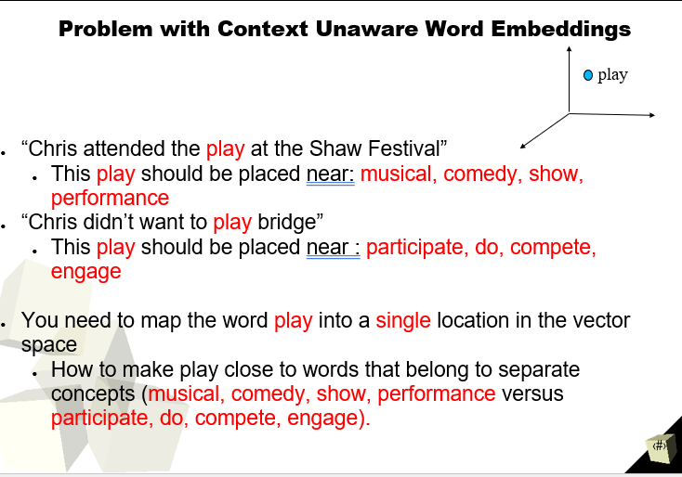

* Compare the benefits and disadvantages of using transformer networks versus LSTMs for NLP.

LSTM limitations

Difficult to train

Very long gradient paths

LSTM on 100-word doc has gradients like 100-layer network

Transfer learning never really worked

Needs specific labelled dataset for every task

Hard to parallelize training

Advantages of Transformer networks

Easier to train

Training can be easily parallelized (can use GPUs much better)

Transfer learning actually works!

Pre-trained models can be fine-tuned for new tasks.

Can be trained on unsupervised text

All the world’s text data is now valid training data.

* Understand at least at a high level how transformer models work?

A transformer is a deep learning model. It is distinguished by its adoption of self-attention, differentially weighting the significance of each part of the input (which includes the recursive output) data. It is used primarily in the fields of natural language processing (NLP) and computer vision (CV).

* + What is self attention and how does it work?

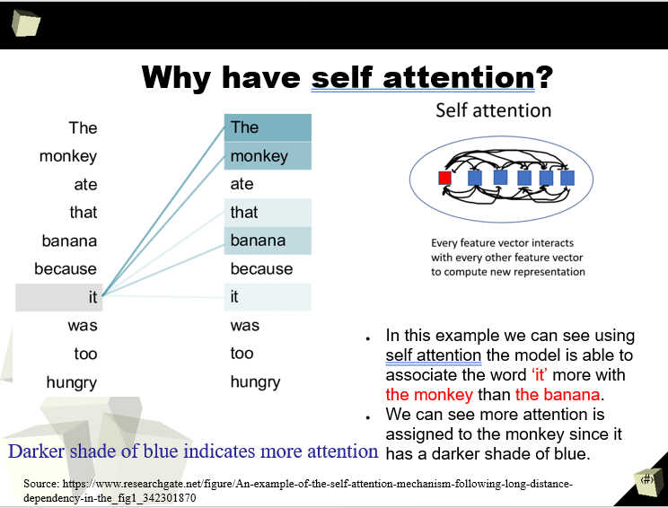

What is text tokenisation?

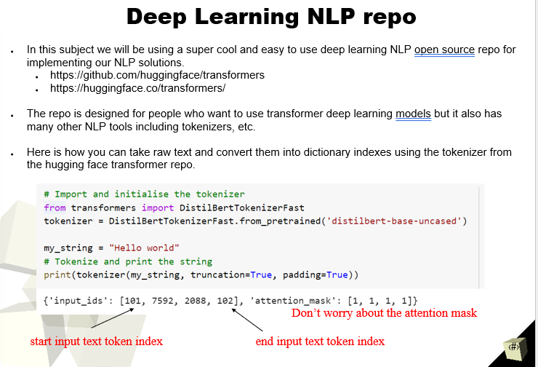Text tokenization is the process of dividing a text into smaller units called tokens, which are typically words or subwords. It is a critical step in natural language processing (NLP) that transforms continuous text into discrete units, making it easier for NLP algorithms to process and analyze the text. Tokenization is essential for tasks like text classification, sentiment analysis, and language modeling.

What is the most common type of tokenisation? Character, word, n-gram?

The most common type of tokenization in natural language processing is word tokenization. It involves breaking the text into individual words or tokens, which are meaningful units of language. Word tokenization is widely used because it helps NLP models understand the syntactic and semantic relationships between words, which is crucial for various NLP tasks. While character and n-gram tokenization are used in specific scenarios, word tokenization remains the most popular and versatile approach.

Why does the tokenisation need to be consistent at training and testing time?

Tokenization needs to be consistent at training and testing time to ensure that the model interprets the text in the same way during both phases. If tokenization differs between training and testing, the model will see different token representations of the same text, leading to incorrect predictions and poor generalization. Consistency ensures that the model processes inputs consistently and learns meaningful relationships between tokens during training, allowing it to make accurate predictions on unseen data at testing time.

What is autoregression?

Autoregression is a time series forecasting method where a model predicts a future data point in a sequence based on its previous values. In short, it involves using past observations to make predictions about the next observation in the sequence. Autoregressive models are commonly used in time series analysis and forecasting tasks to capture patterns and dependencies within the data over time.

**Model Classes (Autoregressive models)**

* Autoregressive models are pretrained on the classic language modelling task.
  + Try to predict the next word
* Uses the decoder of the original transformer network
* Although these can be used to perform other tasks. They are best for text generation.
* Model examples
  + Original GPT
    - Huggingface provides implementation for language modelling and multitask language modelling/multiple choice classification.
  + GPT-2
    - Huggingface provides implementation for language modelling and multitask language modelling/multiple choice classification.
  + Transformer-XL
    - Huggingface provides implementation for language modelling only.
  + XLNet
    - Huggingface provides implementation for language modelling only.

What is position encoding? Why is it necessary in a transformer?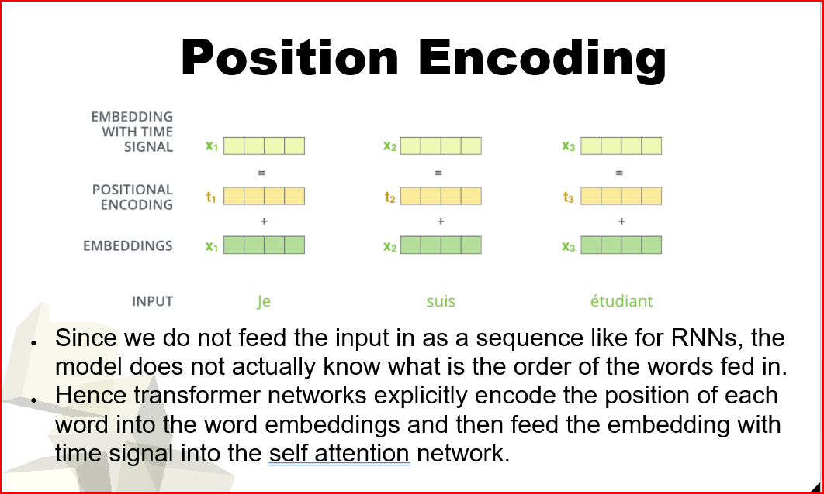

How does a transformer use the self-attention and Linear layers? 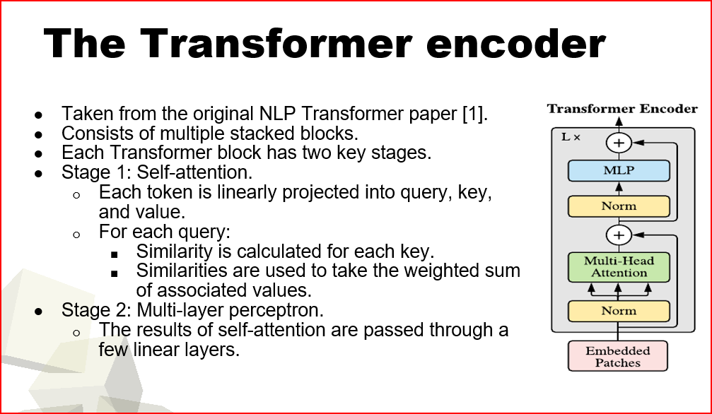

How can we use the Hugging Face transformers library to download a pre-trained tokenizer and network?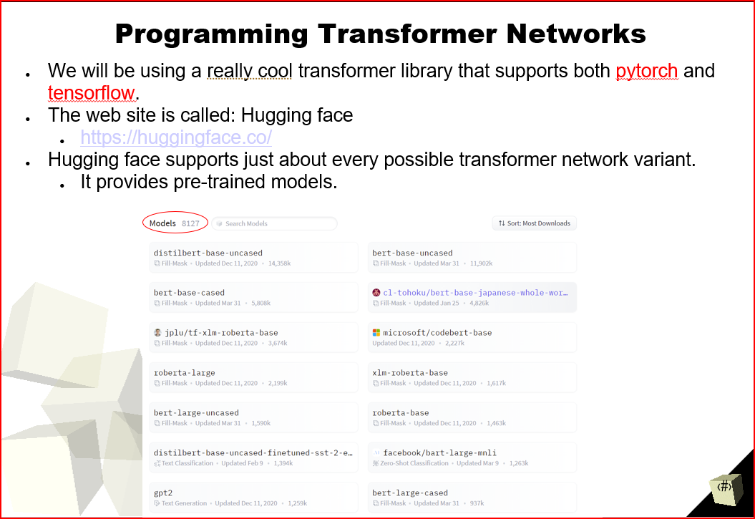

To use the Hugging Face transformers library to download a pre-trained tokenizer and network, follow these steps:

Install the Transformers Library: Install the transformers library using pip if you haven't already: pip install transformers.

Import the Required Modules: Import the necessary modules from the library in your Python script or notebook.

Download Pre-trained Tokenizer: Choose a pre-trained model from the Hugging Face Model Hub and download its tokenizer using AutoTokenizer.from_pretrained().

Download Pre-trained Network: Similarly, download the pre-trained model (network) using AutoModel.from_pretrained().

How can we fine-tune a Hugging Face model on a new task with PyTorch?

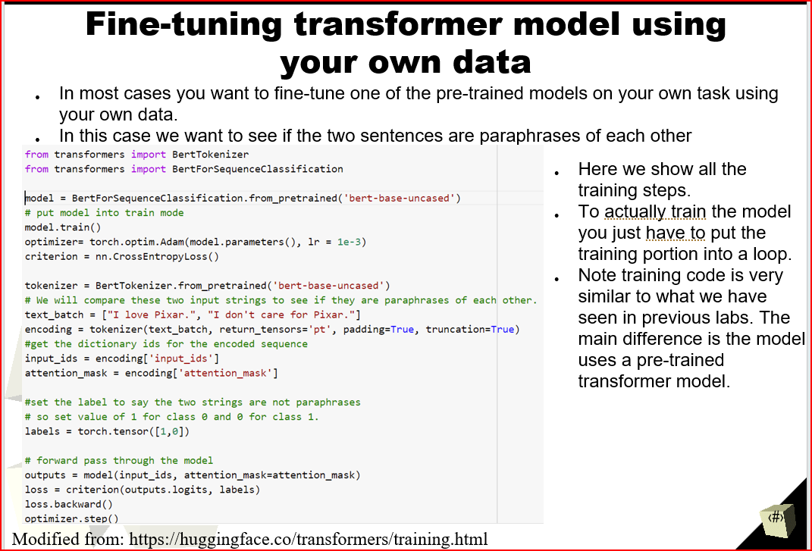

What are the two main types of chatbots?

Goal oriented chatbots

* + The chatbot has a goal that it wants to achieve.
    - e.g. Restaurant reservation
  + Personal assistant
  + More likely to use response selection

Chit chat

* + No specific goal, focus on natural responses
  + More likely to use response generation
  + Most use sequence-to-sequence models.

How does ChatGPT (instruct GPT) use reinforcement learning to produce more desirable output?

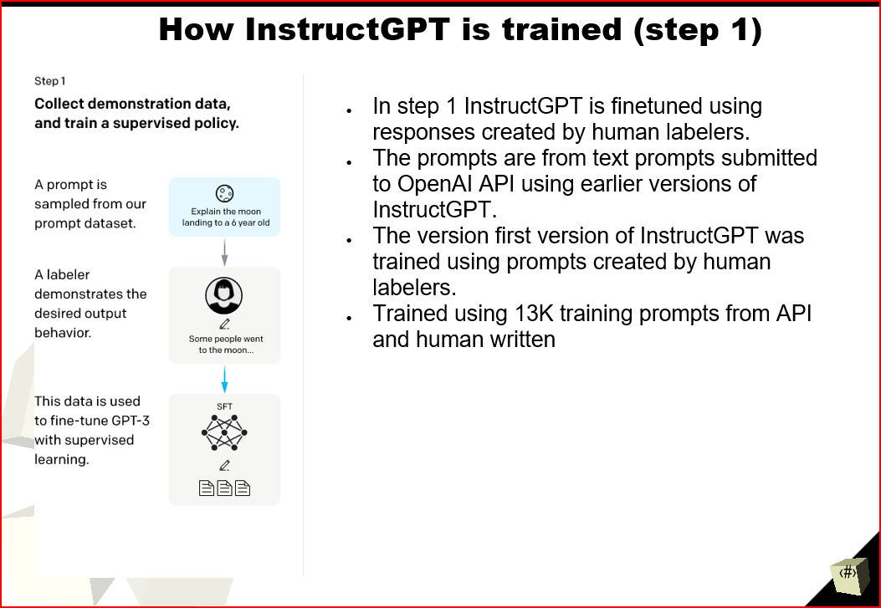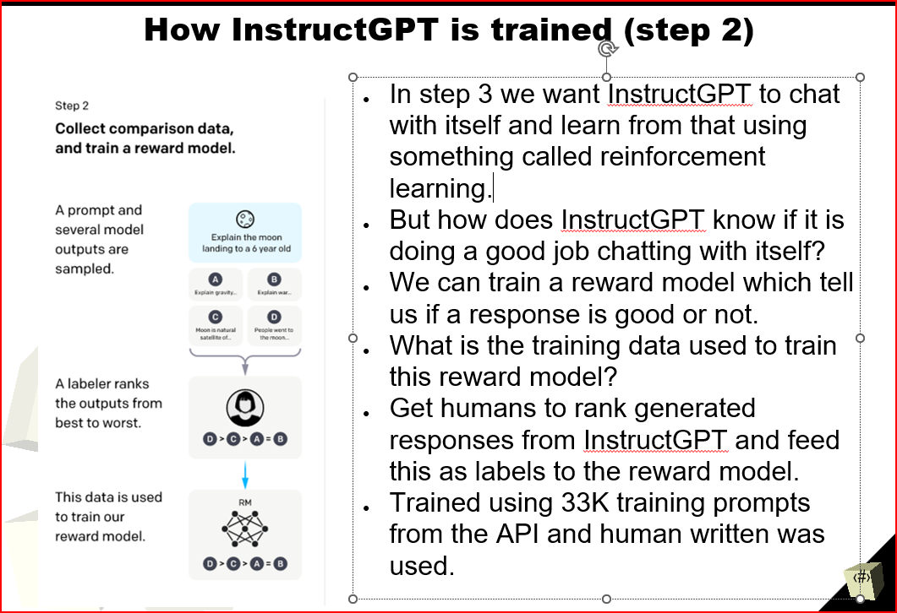

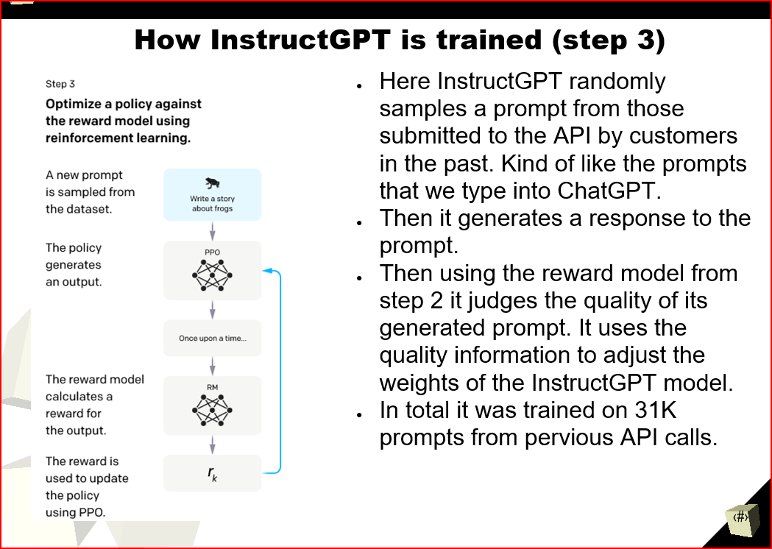

What are the four steps in a typical machine learning lifecycle?

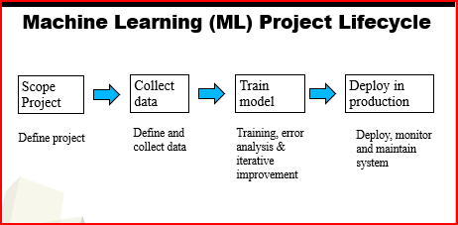

Why can’t we just collect more data to solve every data issue?

Collecting more data is not always a sufficient solution to every data issue because some problems may be inherently complex, requiring advanced models and feature engineering to achieve accurate predictions, while data collection might be impractical or expensive.

What are some techniques to detect bad or out-of-date data?

**Data Validation:** Performing data validation checks to ensure data consistency and correctness, such as range checks, format checks, and cross-field validation.

**Outlier Detection:** Identifying outliers or extreme values that deviate significantly from the expected distribution of the data.

**Time-Based Checks:** Checking for data that is too old or too recent compared to the expected time range, identifying potential out-of-date information.

**Duplicate Detection:** Identifying and removing duplicate entries in the dataset to avoid data redundancy.

**Rule-Based Filters:** Applying rule-based filters or data quality rules to identify problematic data points based on predefined criteria.

**Machine Learning Techniques:** Utilizing machine learning models to detect anomalies or inconsistencies in the data.

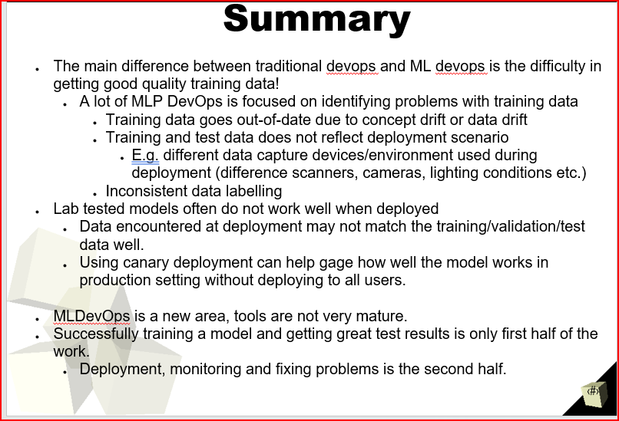

We have already tested our models. Why should we monitor model performance in production?

Monitoring model performance in production is essential because real-world data can differ from the training data, and models may face new challenges in a dynamic environment. Continuously monitoring performance helps detect drift, ensure model reliability, identify issues, and maintain accurate predictions over time, leading to better decision-making and user satisfaction.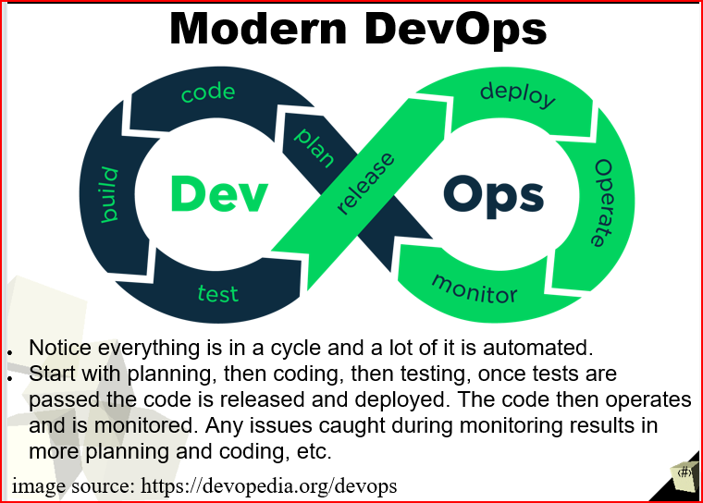

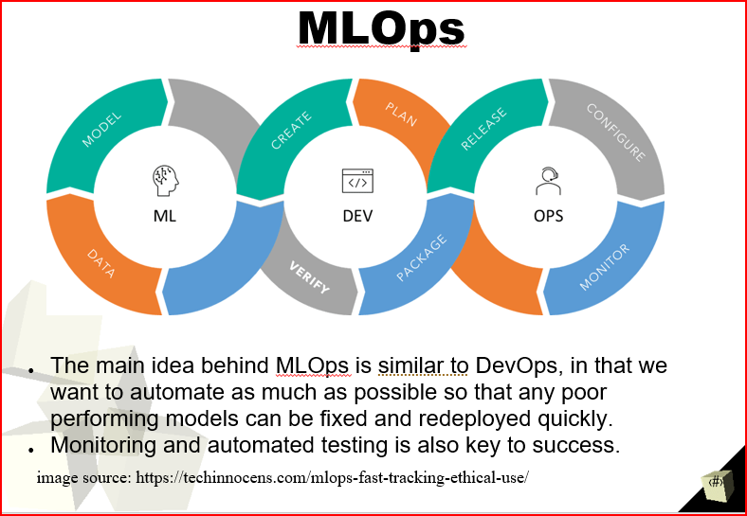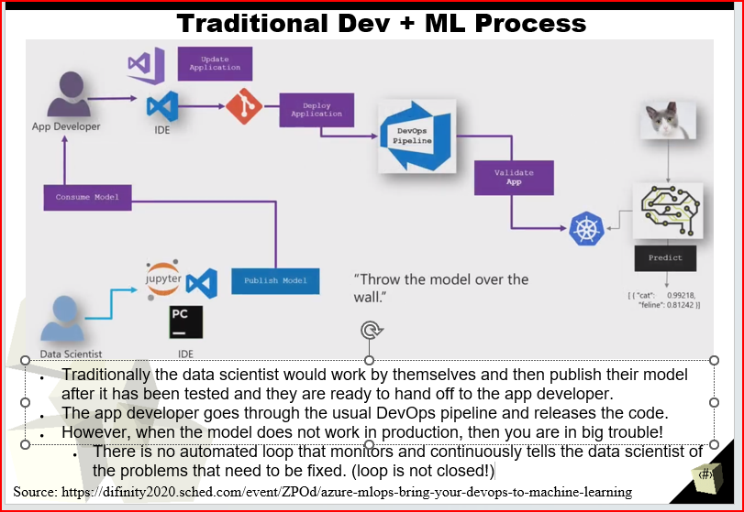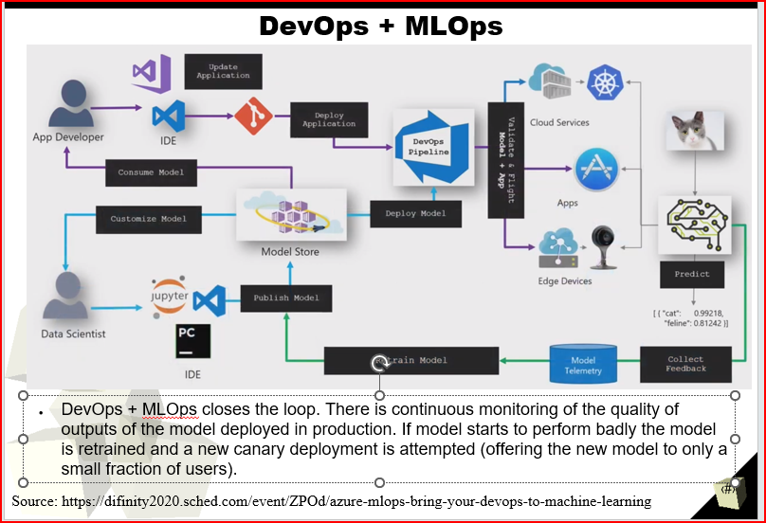

What’s wrong with a machine learning engineer making a model and then never touching it again?

Leaving a machine learning model untouched after development can lead to performance degradation due to changing data, new challenges, and shifting user needs. Without continuous monitoring, maintenance, and updates, the model may become outdated, unreliable, and less effective, impacting decision-making and user satisfaction negatively.

Week 4

Lecture 7

* What is the difference between data centric and model centric MLOps?

Model centric

* + Hold data constant
  + Try to improve model
  + How can I tune the model architecture to improve performance

Data centric

* + Hold model constant
  + Try to improve data quality
* How does MLOps differ from standard DevOps?

MLOps emphasizes on data management and model versioning. DevOps prioritizes overall application performance and reliability.

* Give some examples of how you can improve the quality of your training data when taking a data centric approach.

Some of the examples here include.

New examples

Data augmentation

Labelling

Data Cleaning

Data Normalisation

Feature Engineering

Outliner Detection

Balancing Classes

Cross-Validation

Domain Expertise

Continuous Monitoring

Feedback Loops

* Why do we need to retrain a model over time?

We need to retrain a model over time only if the model starts to perform badly.

* How can we detect data distributions that have changed?

Look at label distributions across labellers.

* + For example one labeller finds on average just 2 lego bricks while others find an average of 5 lego bricks.
  + For example the bounding boxes found for one labeller is much larger on average than those found by other labellers.

Get multiple labellers to label the same data and see if they agree with each other.

Inspect a random set of labelled data and see if they are correctly labelled.

* Why are containers so useful for MLOps?

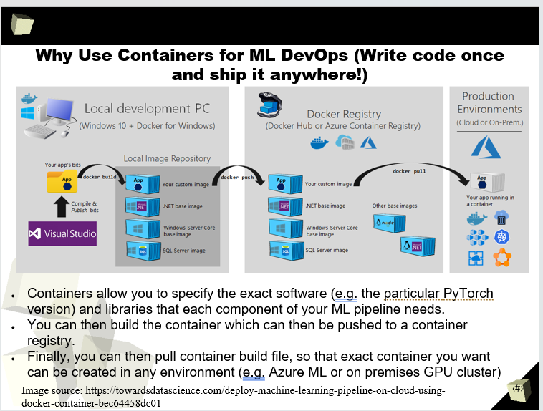

How does treating ML models as a continually updated service, rather than one-time package, make production better?

Treating ML models as a continually updated service improves production by ensuring that models adapt to changing data, user needs, and challenges over time. Continuous updates enhance model accuracy, reliability, and relevance, leading to better performance, more informed decisions, and increased user satisfaction in dynamic real-world environments.

Lecture 8

* Are deep learning models useful when you have data with no labels?
  + If so, how can deep learning models be used to perform useful tasks with no labels.

Yes, by Unsupervised Learning we create a simple framework for contrastive learning of visual Representatives (SimCLR)

1. Self-supervision
   1. Train on ImageNet with no labels.
   2. Then freeze the network and add a simple linear classifier on top of learnt representation.
      1. Then apply to a number different downstream tasks including ImageNet itself.
2. Outperforms previous self-supervised methods significantly.
3. Even outperforms smaller supervised method (ResNet 50)

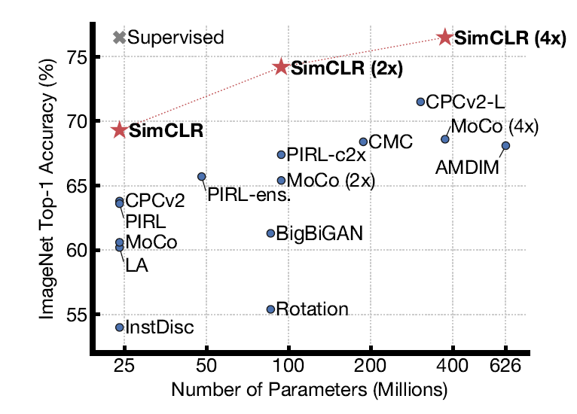

* How does generative adversarial networks work?

A generative adversarial network (GAN) has two parts: The generator learns to generate plausible data. The generated instances become negative training examples for the discriminator. The discriminator learns to distinguish the generator's fake data from real data.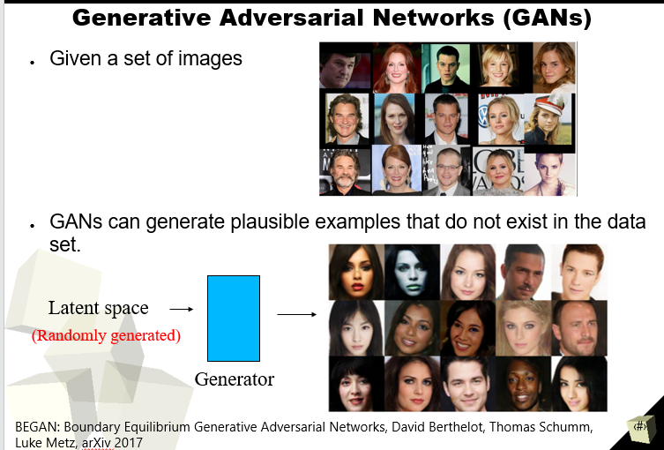

* What can auto encoders be used for?

Autoencoders provide a useful way to greatly reduce the noise of input data, making the creation of deep learning models much more efficient. They can be used to detect anomalies, tackle unsupervised learning problems, and eliminate complexity within datasets 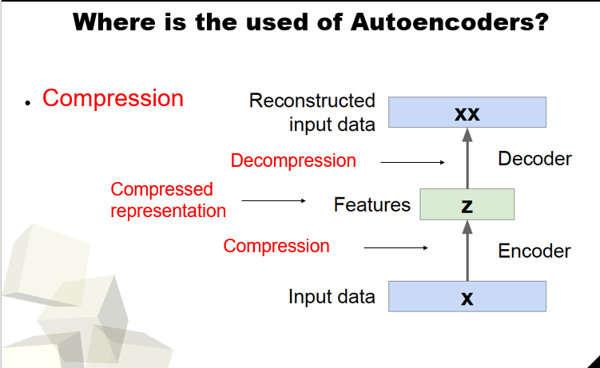 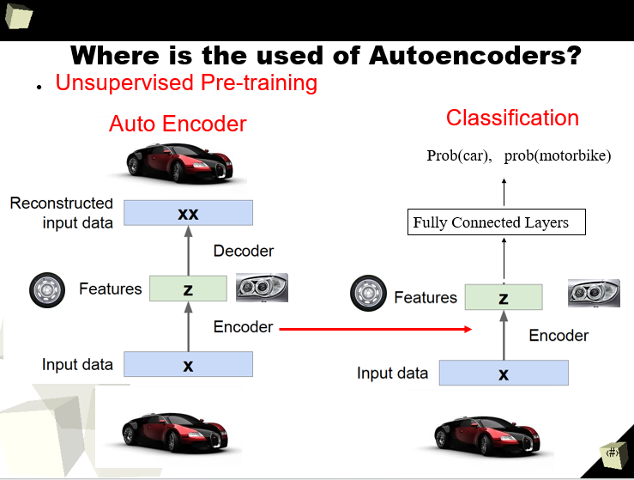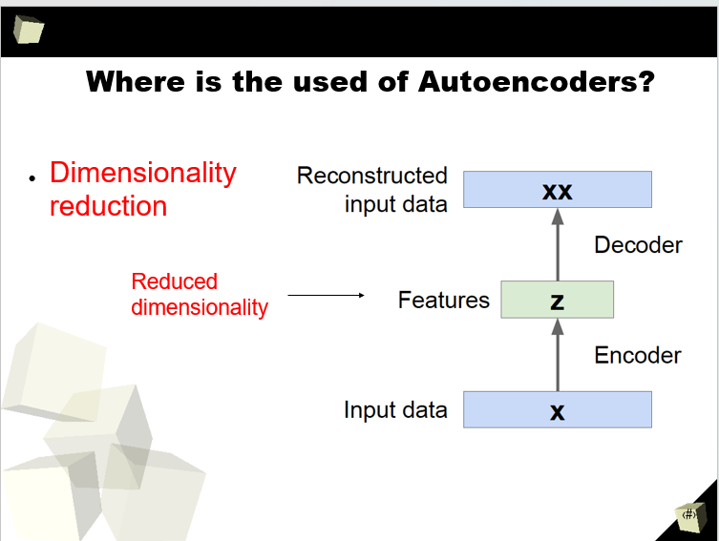

* What are some examples of labels that we can generate from unlabeled data for unsupervised learning?

Some examples include, Clustering, Dimensionality Reduction, Density Estimation, Auto coders, Manifold Learning, Similarity Measures.

What are the main pieces of GANs?

The main pieces of Generative Adversarial Networks (GANs) are the generator and discriminator. The generator creates fake data samples, while the discriminator tries to distinguish between real and fake data. During training, they compete in a "game" where the generator aims to improve its generated samples to deceive the discriminator, while the discriminator tries to become better at distinguishing real from fake data. This adversarial process leads to the generation of high-quality, realistic data samples.

How is time series analysis different to NLP?

Time Series Analysis: Time series analysis deals with numerical data collected over time, typically at regular intervals. The main goal is to understand patterns, trends, and seasonality in the data and make predictions about future values.

NLP (Natural Language Processing): NLP focuses on processing and analyzing human language text data. The main objective is to understand the meaning, context, and sentiment of the text, and perform tasks like language translation, sentiment analysis, and text generation.

In summary, time series analysis involves numerical data collected over time for prediction and trend analysis, while NLP deals with processing human language text data for tasks like understanding, translation, and sentiment analysis.

What techniques are popular in time series analysis?

Here are some techniques that are covered in deep learning.

Autoregressive Integrated Moving Average (ARIMA): A widely used model for time series forecasting that combines autoregression, differencing, and moving averages.

Long Short-Term Memory (LSTM): A type of recurrent neural network that can capture long-term dependencies in time series data and perform tasks like prediction and sequence-to-sequence modeling.

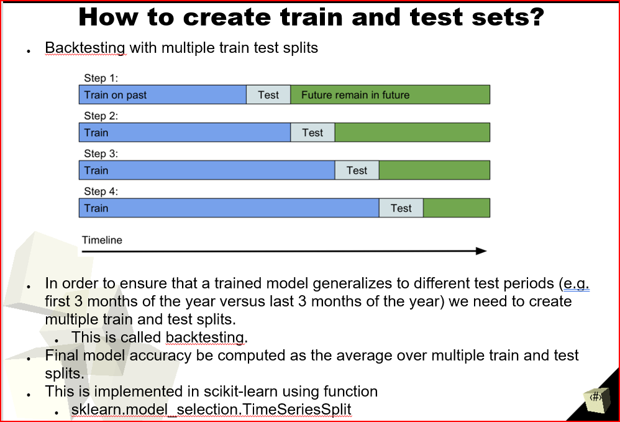What is backtesting? Why is it necessary for time series analysis?

Backtesting is a technique used to evaluate the performance of a model or strategy by testing it on historical data. In time series analysis, backtesting is necessary to assess the effectiveness and accuracy of forecasting models, ensuring they perform well on past data before deploying them in real-world scenarios. It helps validate the model's reliability and provides insights into its potential performance in future predictions.

Reinforcement learning is good for what kind of problem?

Reinforcement learning is well-suited for problems where an agent learns to make sequential decisions to maximize a cumulative reward over time. It excels in tasks with complex and dynamic environments, where the agent interacts with the environment, receives feedback in the form of rewards or penalties, and learns optimal strategies through trial and error. Reinforcement learning is commonly used in game playing, robotics, autonomous vehicles, recommendation systems, and other scenarios where decision-making involves long-term planning and interactions with an uncertain environment.

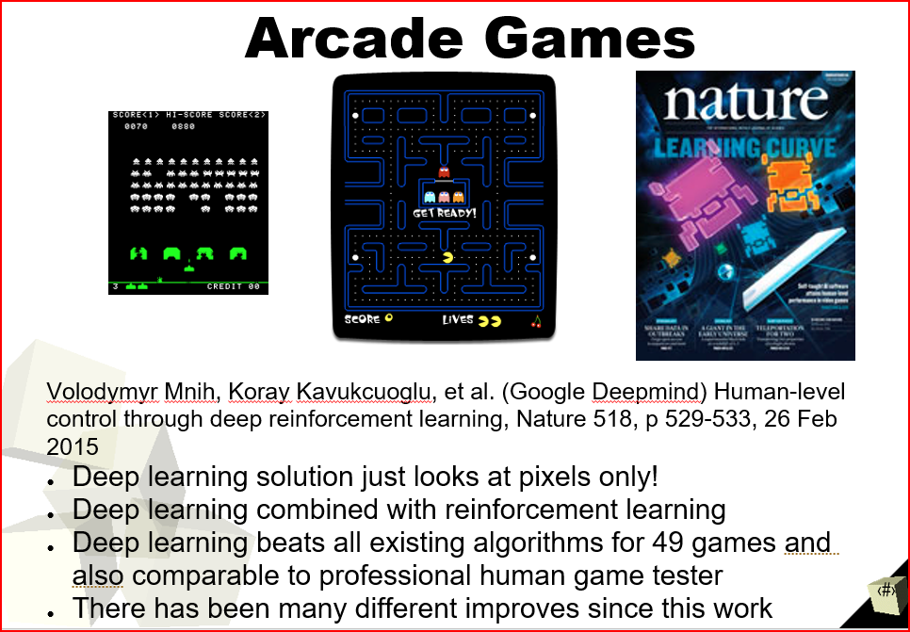

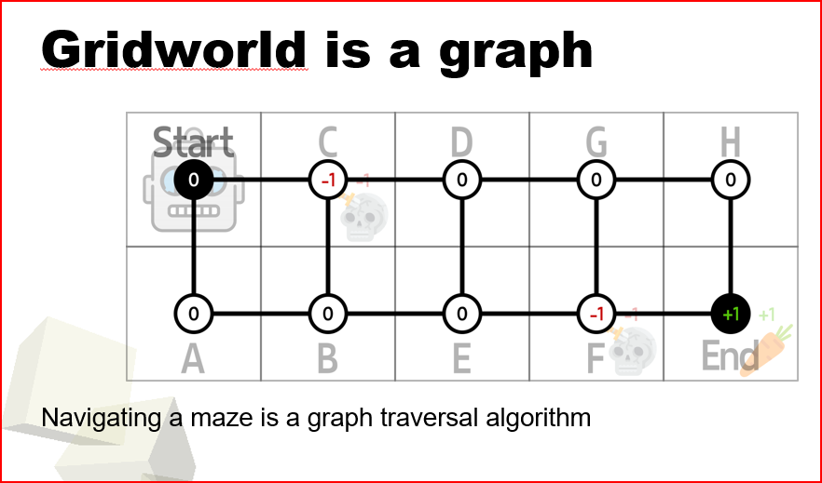

What do the following terms mean? Environment, agent, policy, reward, state, action.

**Environment:** The environment represents the external world or the task in which the agent operates. It is the context in which the agent takes actions and receives feedback.

**Agent:** The agent is the learner or decision-maker that interacts with the environment. It takes actions based on its current understanding to achieve its goals.

**Policy:** The policy is the strategy or set of rules that the agent follows to decide what action to take in each state. It maps states to actions and guides the agent's decision-making process.

**Reward:** The reward is the numerical feedback that the agent receives from the environment after taking an action. It indicates how well the agent is performing the task. The agent's goal is to maximize the cumulative reward over time.

**State:** The state is the current representation of the environment. It contains all the relevant information the agent needs to make decisions and take actions.

**Action:** The action is the specific move or decision made by the agent in a particular state. It is chosen based on the policy to influence the environment and receive rewards.

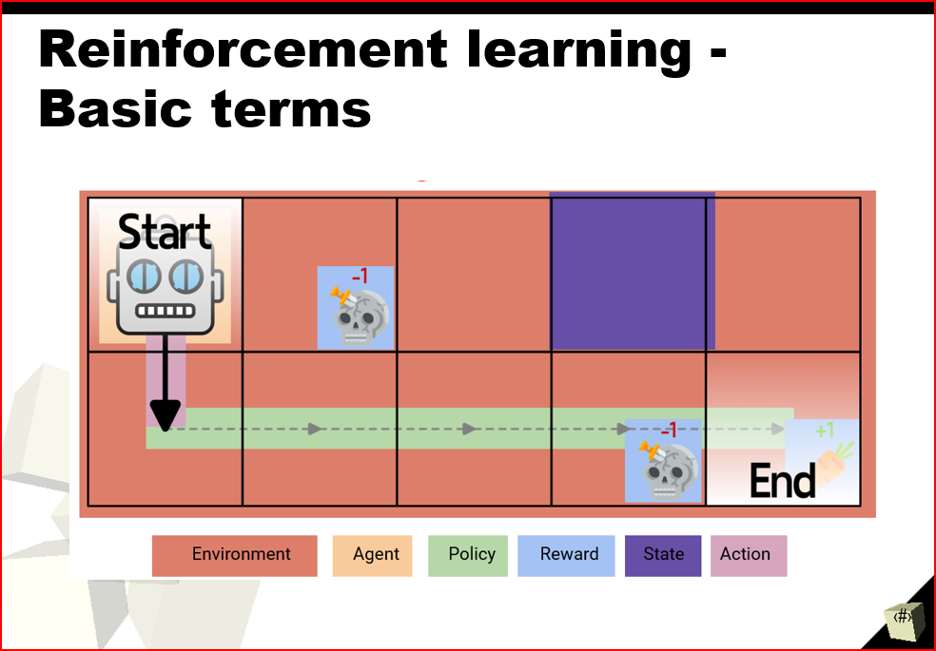

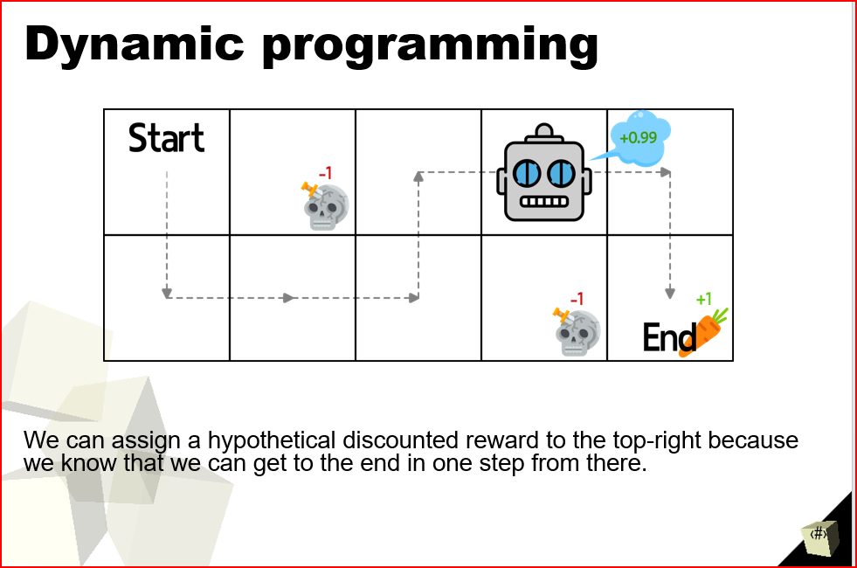

What is the long-term reward of a state? How is it different from immediate reward?

The long-term reward of a state considers all future rewards the agent anticipates accumulating from that state, whereas the immediate reward focuses on the reward received right after the agent takes an action and transitions to a new state. The long-term reward guides the agent's decision-making over multiple time steps to maximize cumulative rewards, while the immediate reward influences the agent's choice in the current state only.

What is the greedy policy?

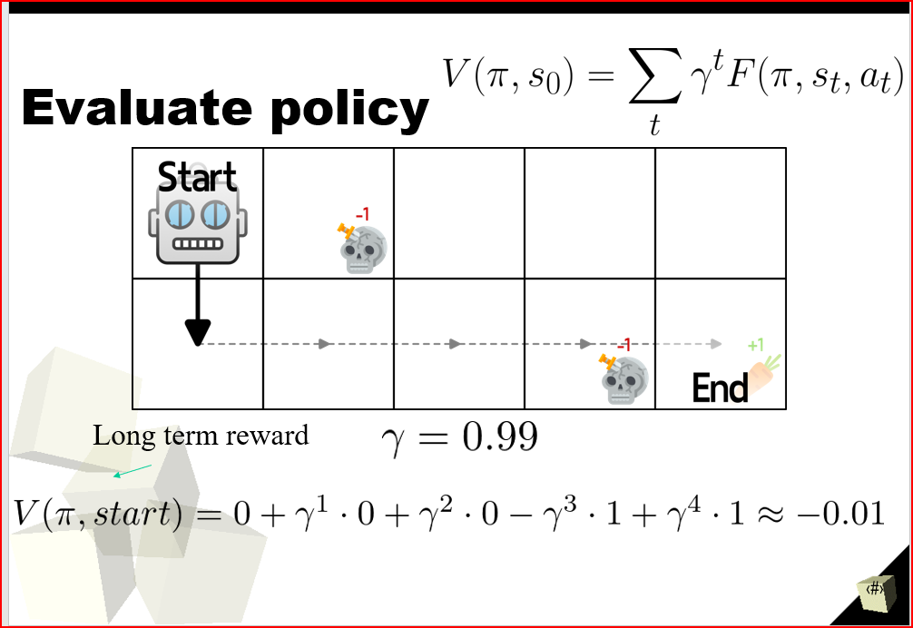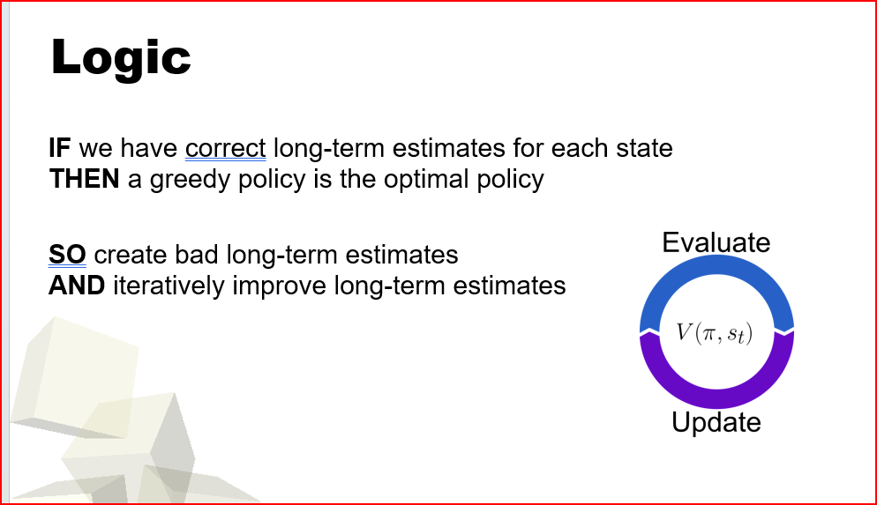

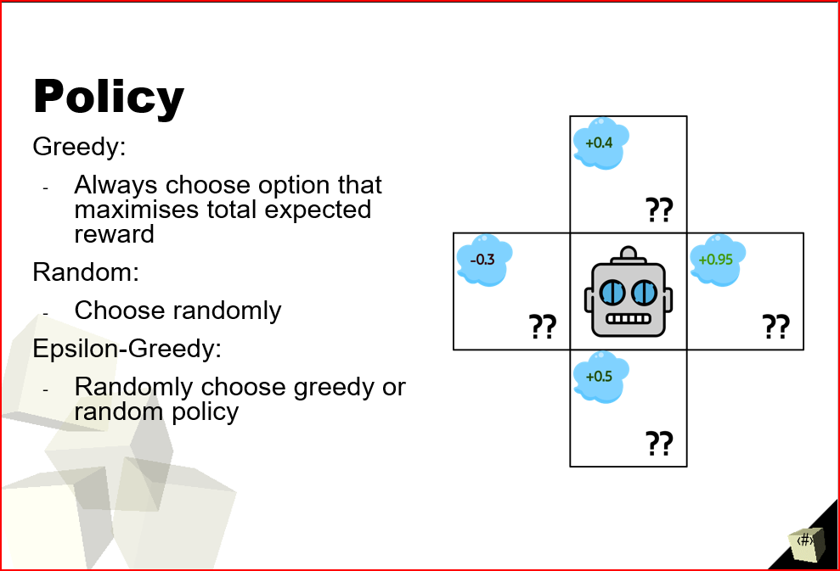

Why do we iteratively update the long-term expected reward?

We iteratively update the long-term expected reward in reinforcement learning to continuously improve the agent's decision-making policy. By updating the expected reward after each action and incorporating new experiences, the agent can learn from trial and error, adjust its strategy, and make better decisions over time. This iterative process allows the agent to discover optimal actions and policies that lead to maximizing cumulative rewards in complex and dynamic environments.

What is the discount factor used for?

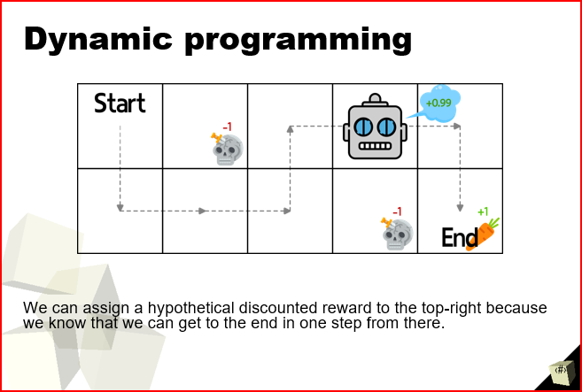

So, we can assign what’s called a “long-term reward” which is a hypothetical discounted reward.

We know we can get from that square to the +1, so we know that going to that square is good, and we can calculate.

**Definitive answer:**

The discount factor is used in dynamic programming and reinforcement learning to balance the importance of immediate rewards versus future rewards. It values immediate rewards more when the discount factor is close to 1 and prioritizes long-term rewards when the discount factor is closer to 0. By adjusting the discount factor, the agent can choose to focus on short-term gains or prioritize long-term planning in its decision-making process.

What is the optimal policy?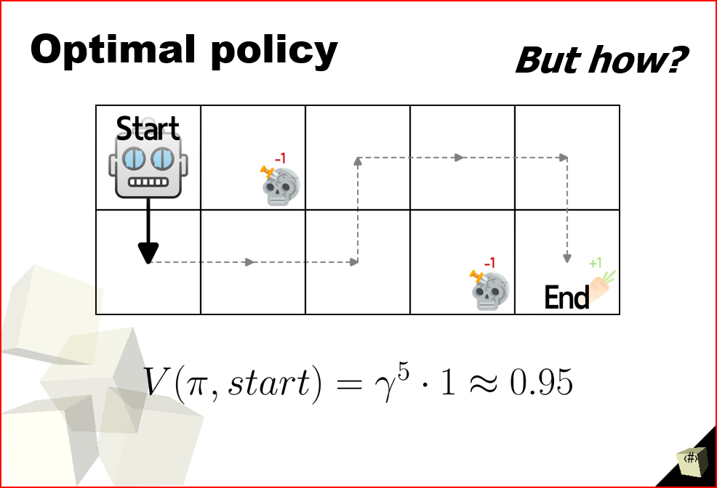

This is the optimal policy. We know it’s the optimal policy because it doesn’t hit any of the negative rewards, and it reaches the goal in the fewest possible steps.

In complex scenarios, why do we determine long-term reward for a state-action pair, rather than a state?

Back in the video game example, in more complex scenarios, there are infinite states, so we can’t assign a value to each state. Instead, we assign a long-term reward to each action.

In grid world, this is roughly equivalent, since every action takes us to a state we’ve probably seen before.

Why is deep learning good for reinforcement learning in a complex environment?

Deep learning is effective for reinforcement learning in complex environments because deep neural networks can learn intricate patterns and representations from raw data. In complex environments, there may be high-dimensional and non-linear relationships between states, actions, and rewards. Deep learning models can automatically extract relevant features, capture long-term dependencies, and adapt to changing environments, enabling the agent to handle complex scenarios and make better decisions based on raw sensory inputs.

Week 5

Lecture 9

* Given a time series forecasting problem, where you need to predict multiple values in the future. What are some of the different deep learning approaches to solve the problem?
  + Analyze the tradeoffs between the different approaches.

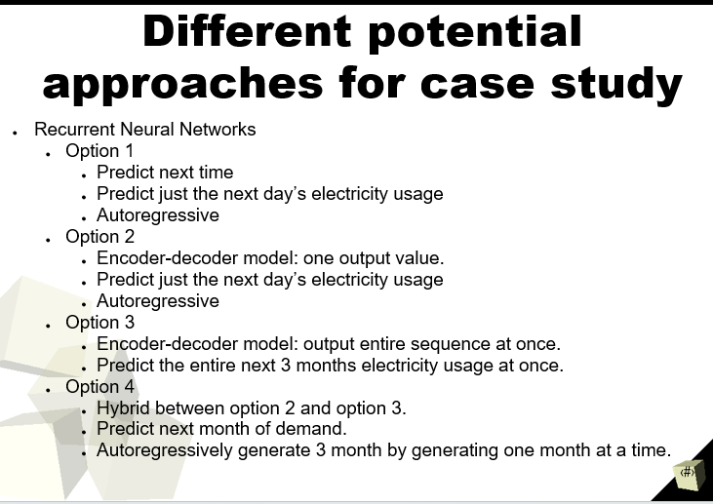

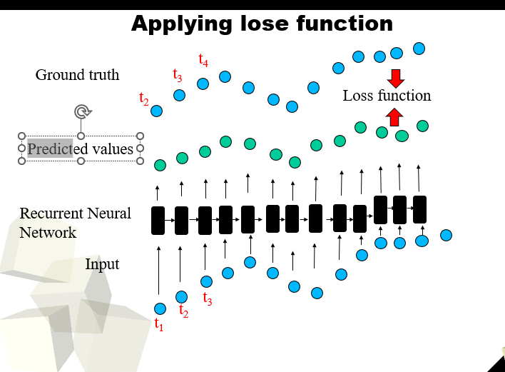

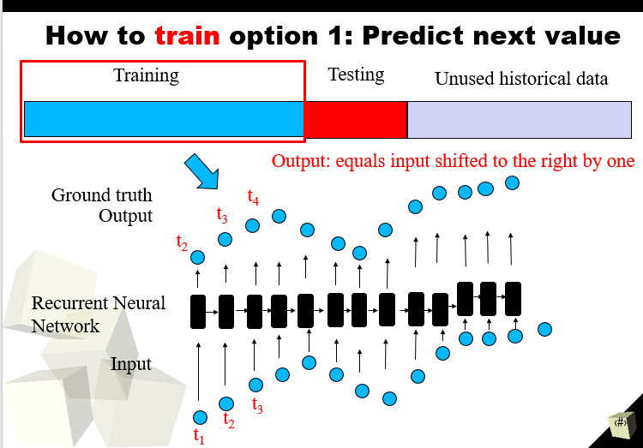

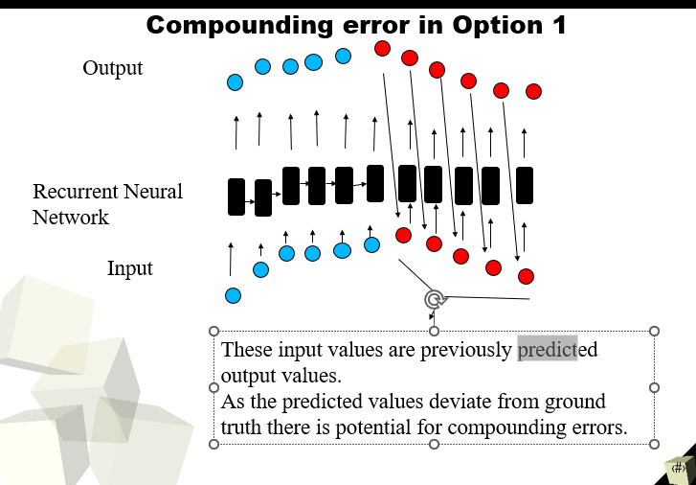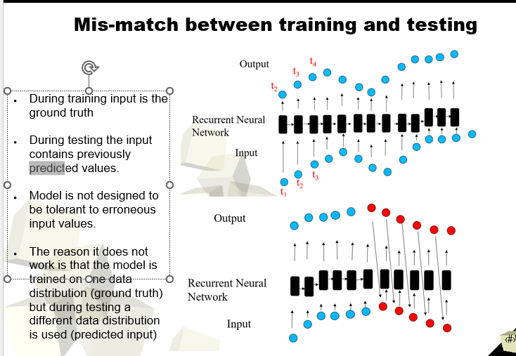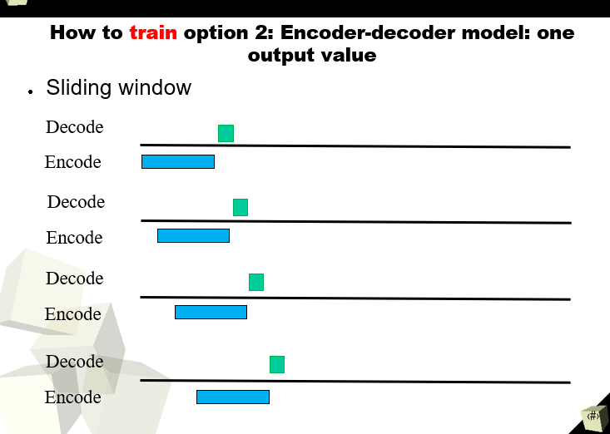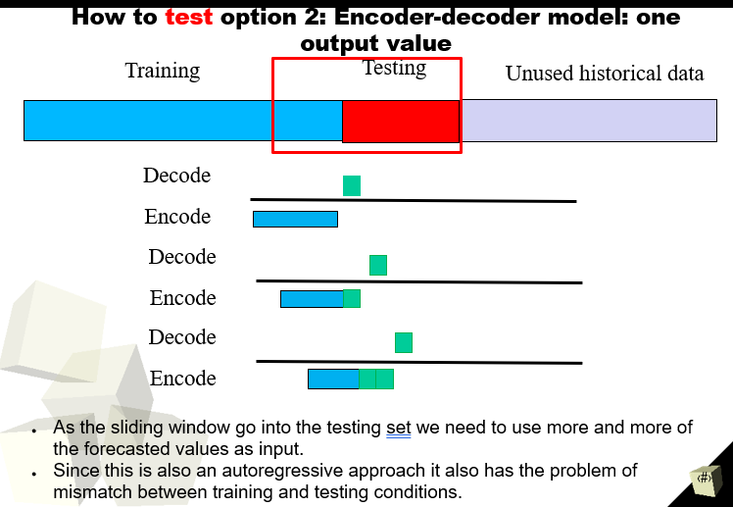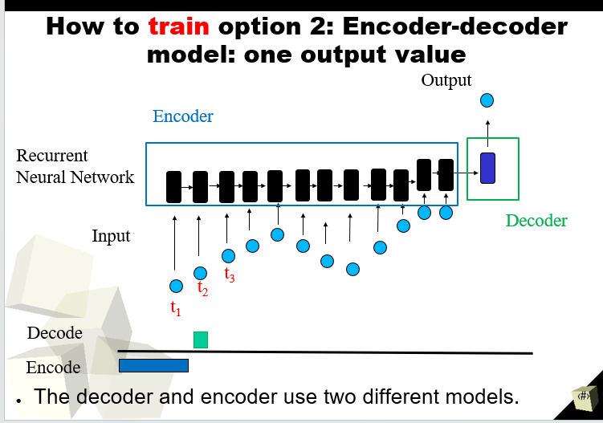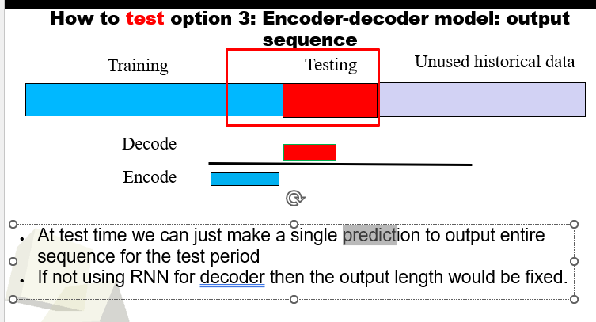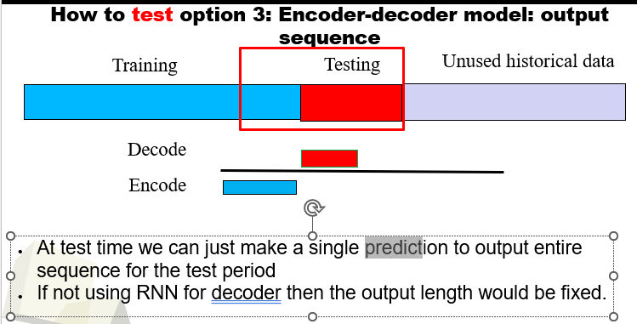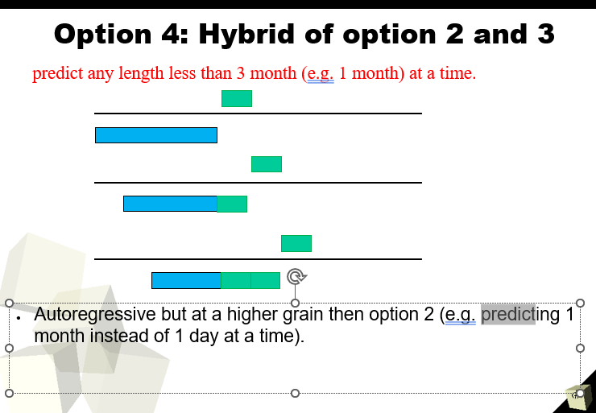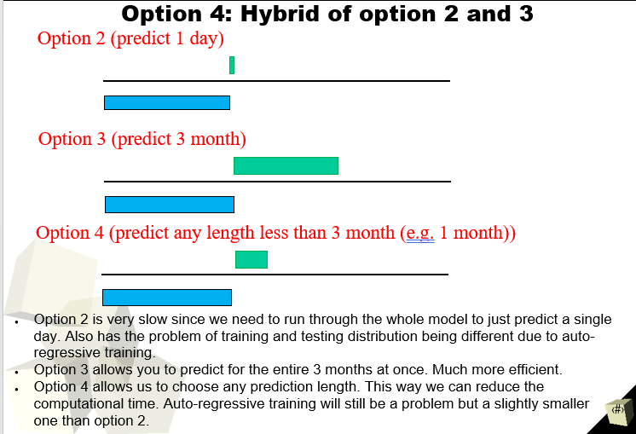

* How do we incorporate static and dynamic input data together for time series forecasting?

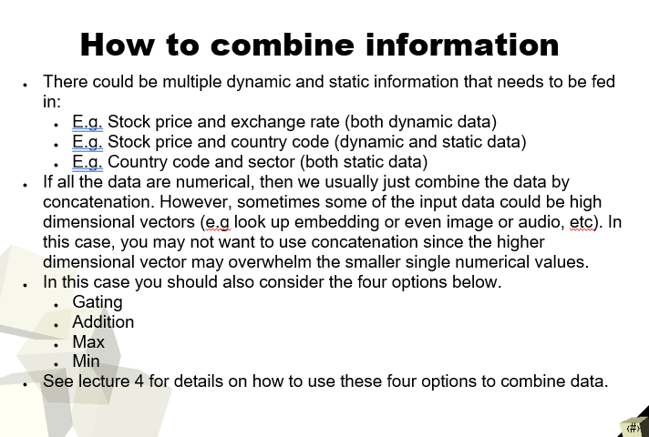

* What kinds of problems is reinforcement learning useful for? 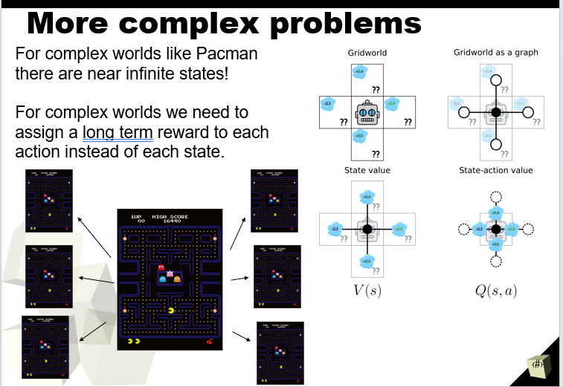
* Why is it necessary to specify a reward function for reinforcement learning?

The Reward Function is an incentive mechanism that tells the agent what is correct and what is wrong using reward and punishment. The goal of agents in RL is to maximize the total rewards. Sometimes we need to sacrifice immediate rewards to maximize the total rewards. 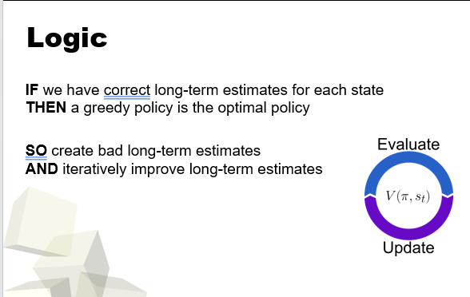

* How can reinforcement learning use the reward function to produce the optimal policy?

In reinforcement learning, the agent is rewarded for taking controls that lead to successful states. The rewards can be immediate, such as receiving a point for each step taken in the right direction, or they can be delayed, such as receiving a point at the end if the goal was reached.

* 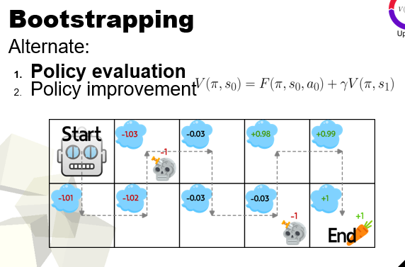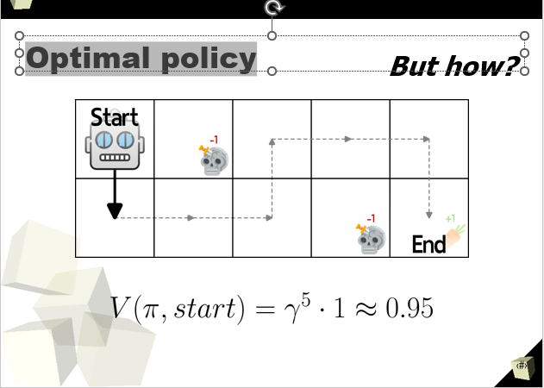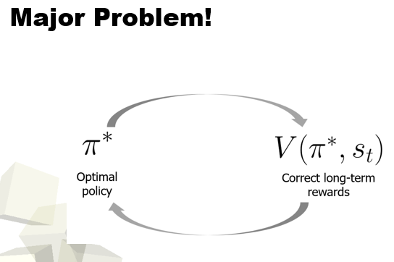
* Why is it a good idea to combine reinforcement learning and deep learning together.

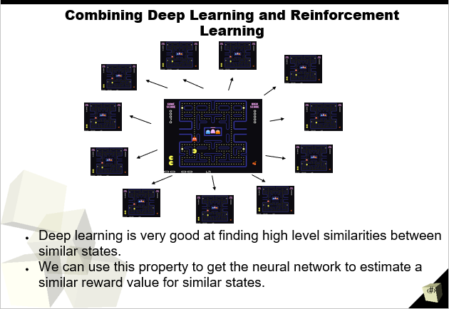

What does the Region Proposal Network (RPN) do?

The Region Proposal Network (RPN) is a part of the Faster R-CNN object detection framework. It is responsible for proposing potential bounding boxes (regions) in an image that may contain objects of interest. RPN generates these proposals based on learned features from the image and helps the Faster R-CNN model focus on relevant regions for further object detection and classification, improving efficiency and accuracy in the process.

What are fully convolutional neural networks?

Fully Convolutional Neural Networks (FCNs) are neural network architectures that consist entirely of convolutional layers, without any fully connected layers. They are designed for tasks like semantic segmentation, where the goal is to assign a class label to each pixel in an image. FCNs preserve spatial information and enable end-to-end learning for dense predictions, making them well-suited for tasks requiring pixel-wise predictions.

How do we both predict for every pixel efficiently, and use a large receptive field at the same time?

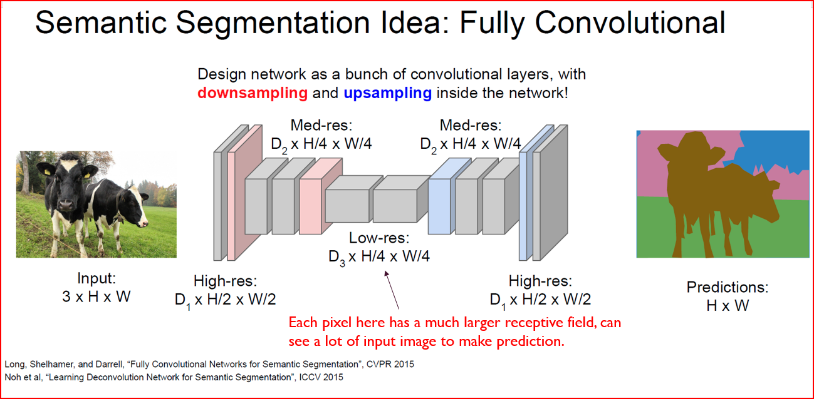

To predict for every pixel efficiently and use a large receptive field, Fully Convolutional Neural Networks (FCNs) use techniques like dilated convolutions and skip connections. Dilated convolutions increase the receptive field without increasing the number of parameters, allowing the network to capture broader context information efficiently. Skip connections, such as in U-Net architectures, combine features from different layers to maintain high-resolution information and improve segmentation accuracy while efficiently predicting for each pixel. These strategies enable FCNs to achieve both dense predictions and capture long-range dependencies effectively.

Why do we need to interpret model predictions?

Interpreting model predictions is essential to understand how and why the model makes decisions. It provides insights into the model's behaviour, helps identify potential biases or errors, builds trust in the model's predictions, and enables users to make informed and accountable decisions based on the model's output.

What do visualizing model predictions on images look like?

Visualizing model predictions on images involves overlaying the model's output on the original image to highlight regions of interest or areas where the model makes specific predictions. This process helps understand where the model focuses its attention, gain insights into its decision-making process, and assess the model's performance qualitatively by observing how well it identifies objects or regions of interest in the image. Visualization aids in debugging and interpreting the model's behaviour, making it easier to validate and improve its predictions.

What are the benefits of class activation maps (CAMs)?

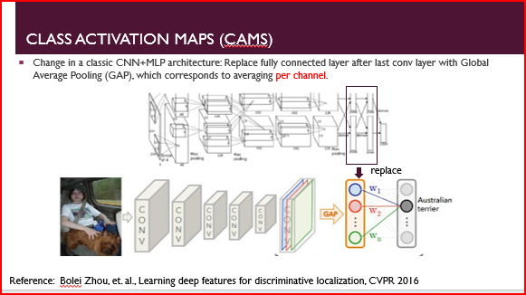

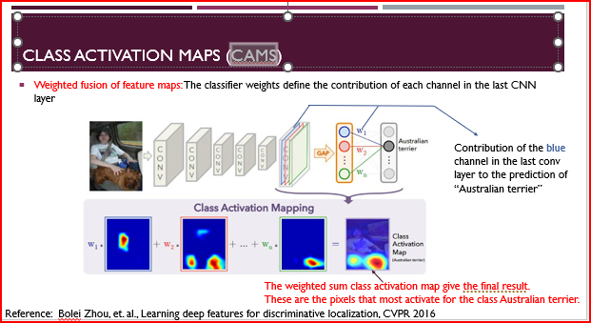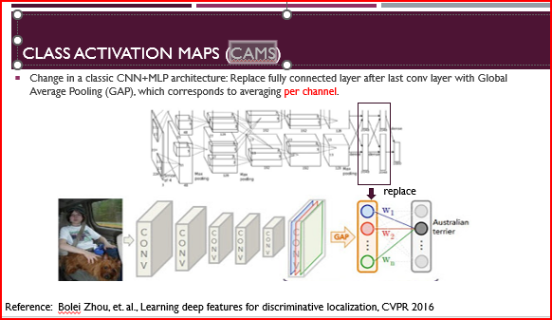

The following benefits include,

**Interpretability:** CAMs offer insights into how a deep learning model makes predictions by highlighting regions in the input image that contribute the most to its decision.

**Localization:** CAMs help localize objects or regions of interest in the image, aiding in object detection and segmentation tasks.

**Model Understanding:** CAMs allow researchers and practitioners to understand what features the model learns and what parts of the image are crucial for correct classification.

**Debugging:** CAMs aid in debugging models, revealing potential biases, errors, or areas of improvement in their predictions.

**Explainability:** CAMs enhance the model's explainability, making it more transparent and trustworthy, which is crucial for applications in critical domains like healthcare and autonomous systems.

Lecture 10

* What is challenging about multi-object detection?

The major challenges in object detection are classifying objects and determining their position. Is to find the bounding box and class of each object in the scene.

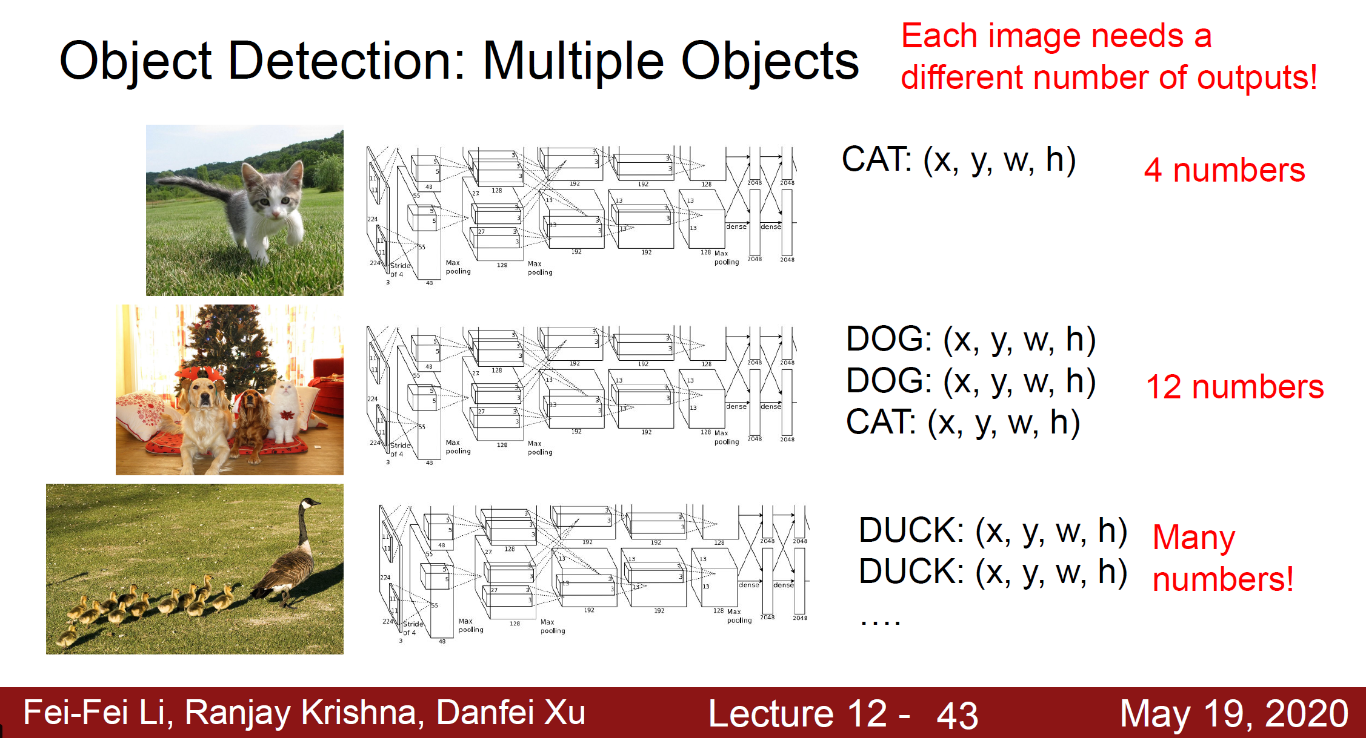

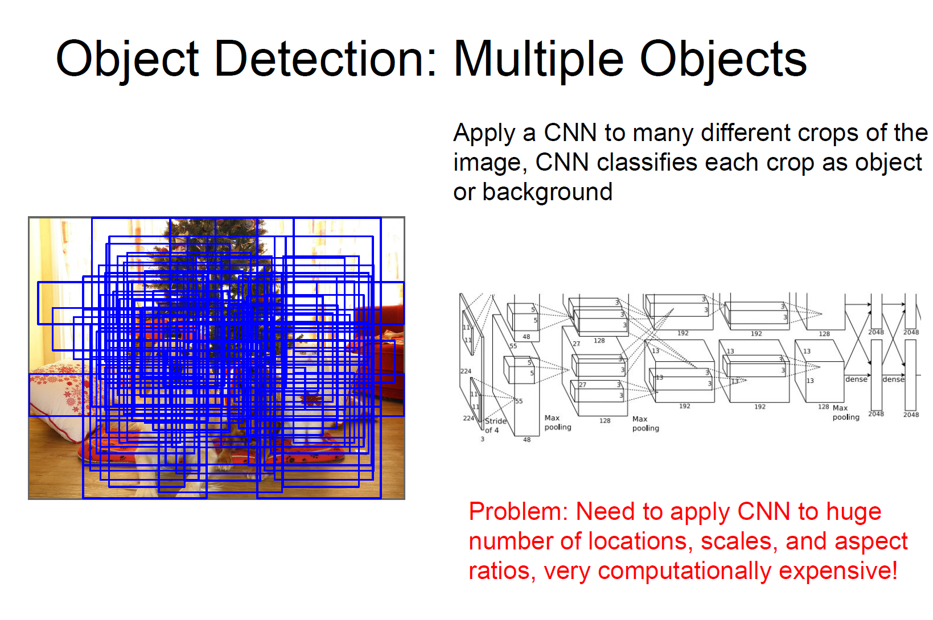

* How do one stage and two stage object detectors differ?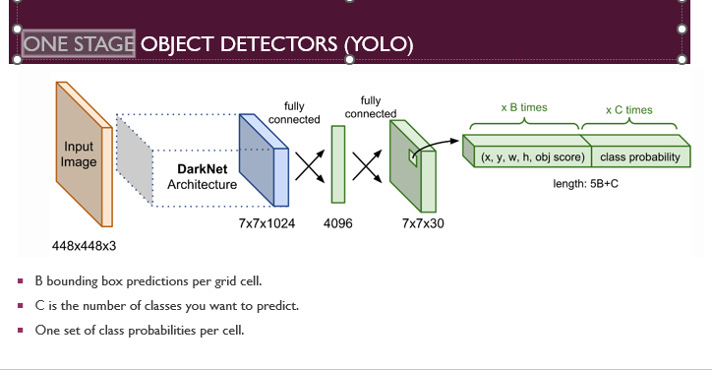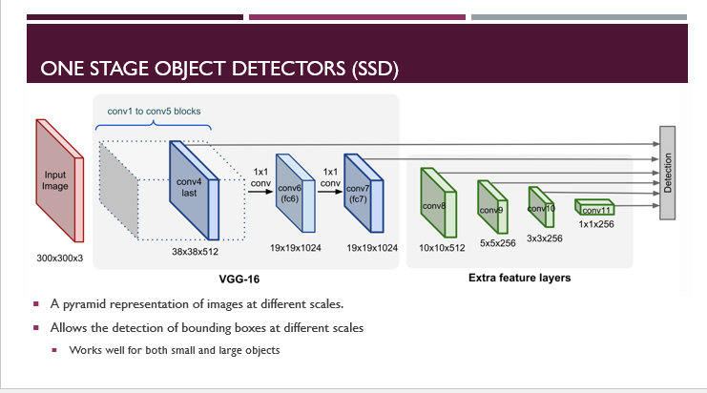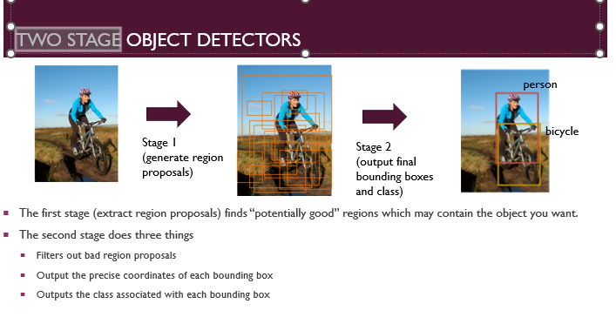
* How does Fast RCNN work faster than RCNN?

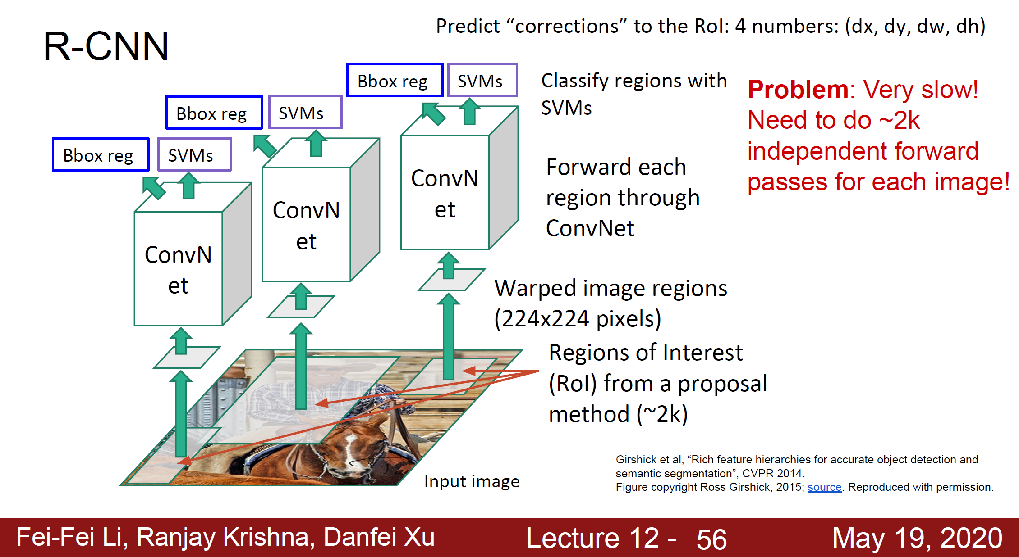

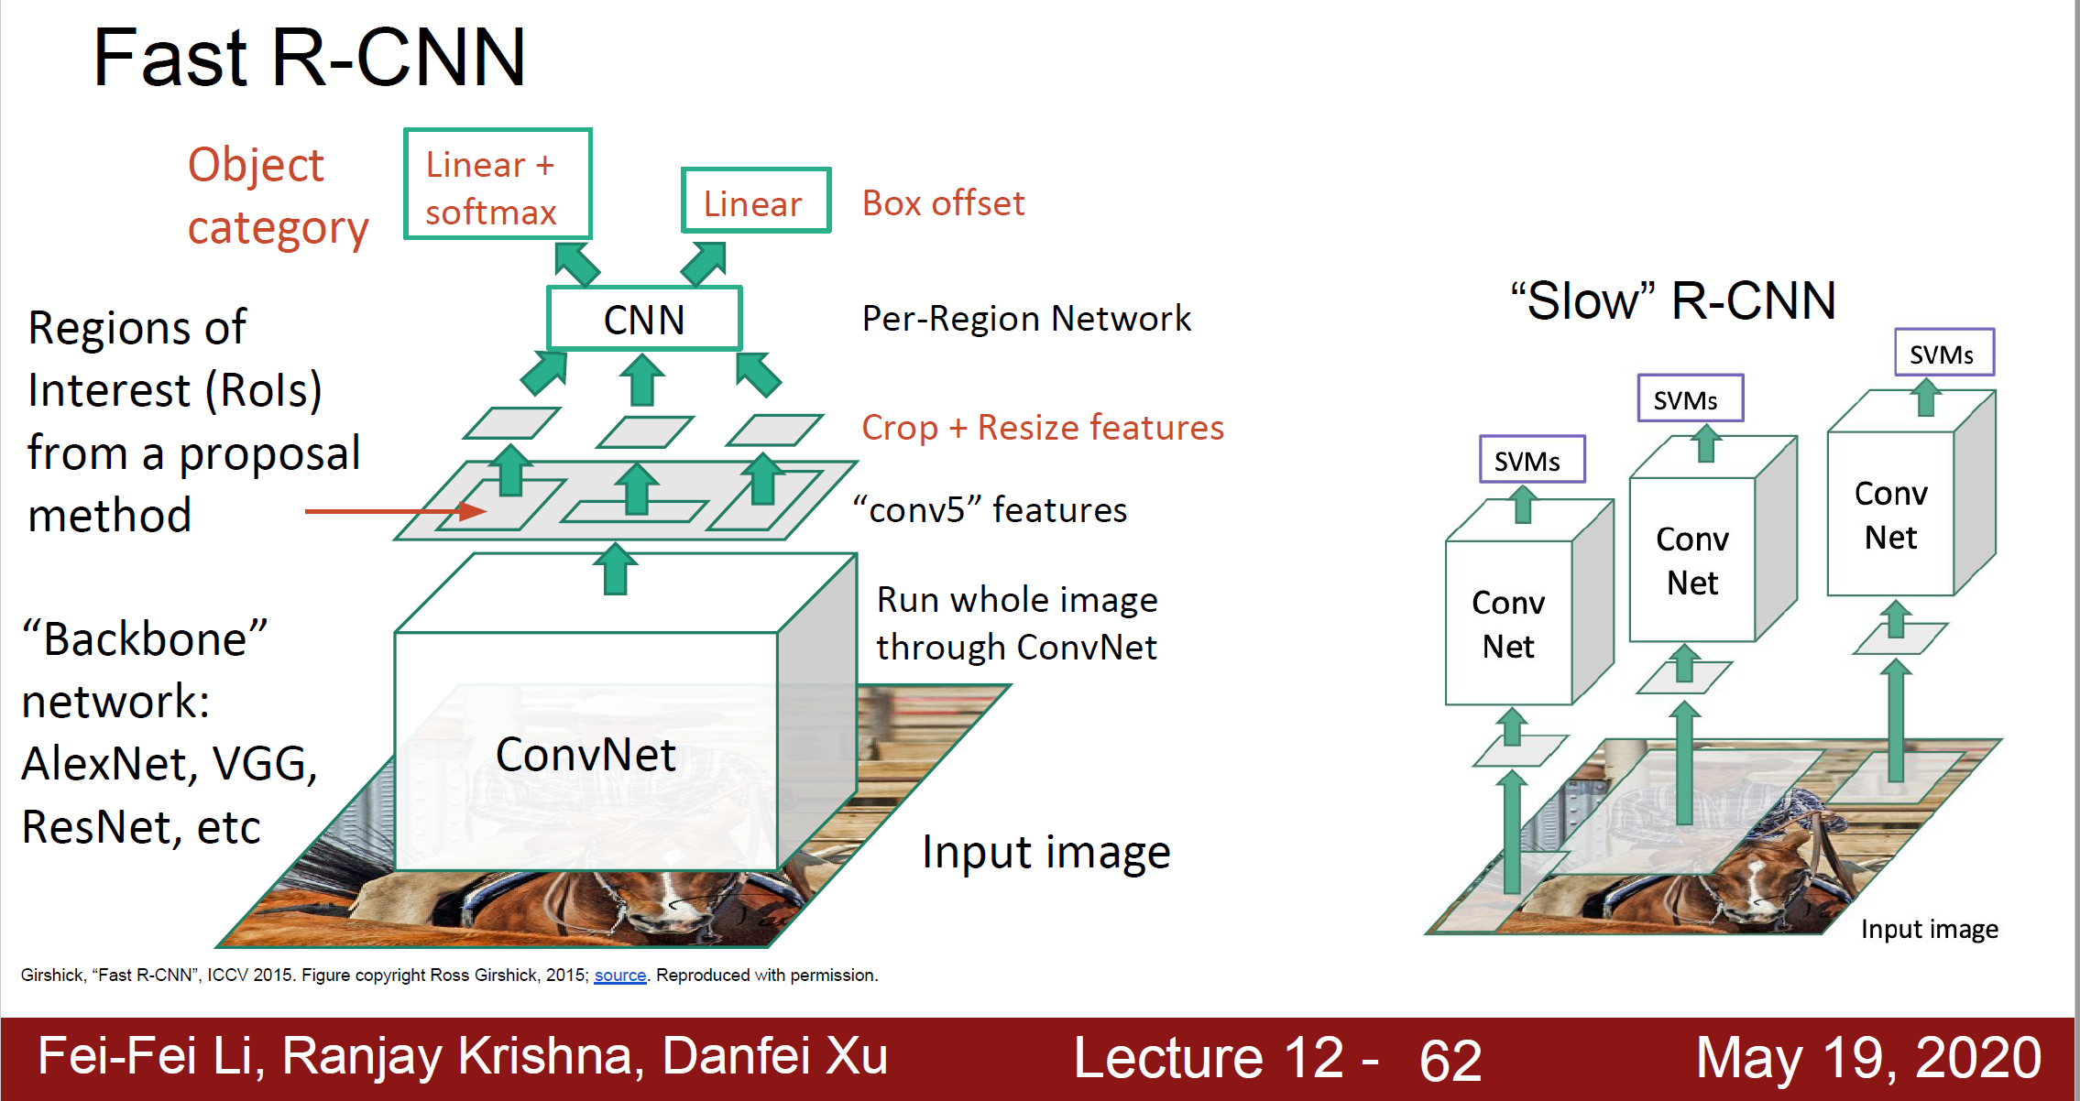

Faster RCNN is the modified version of Fast RCNN. The major difference between them is that Fast RCNN uses selective search for generating Regions of Interest, while Faster RCNN uses “Region Proposal Network”, aka RPN. Compare them in terms of their speed.

* How does region of interest pooling work?

ROI pooling solves the problem of fixed image size requirement for object detection network. ROI pooling produces the fixed-size feature maps from non-uniform inputs by doing max-pooling on the inputs.

* How does Faster RCNN work faster than Fast RCNN?

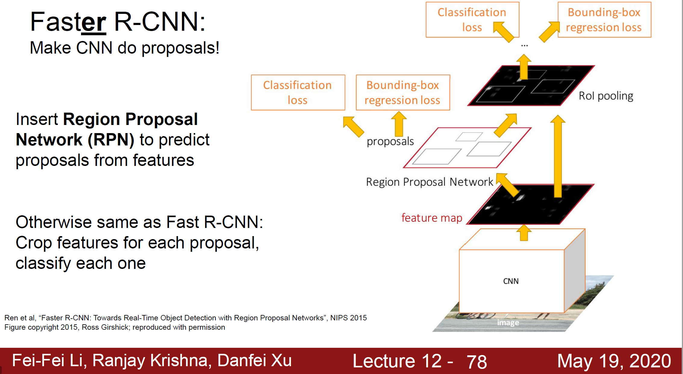

See and comment in comparison in terms of speed.

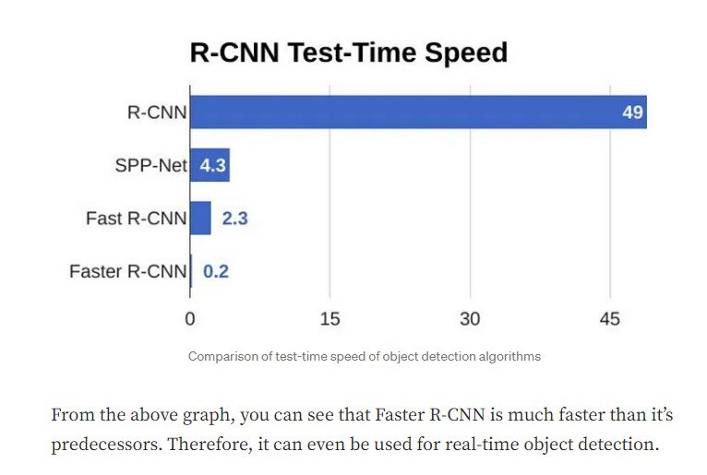

* ? How does corner net differ from the RCNN variants?
* Why is it a good idea to use fully convolutional networks for semantic segmentation?
* What information does to class activation maps (CAMs) give us? Also how does it work?
* How does corner net differ from the RCNN variants?

CornerNet and RCNN variants differ in their detection principles, object representation, architecture, training approach, and how they handle occlusion and overlapping objects. CornerNet takes a one-stage approach, directly predicts keypoints and bounding boxes, and uses an hourglass architecture, while RCNN variants use region proposals and rely on bounding boxes. CornerNet aims for real-time efficiency, while RCNN variants have achieved state-of-the-art performance at the cost of increased complexity.

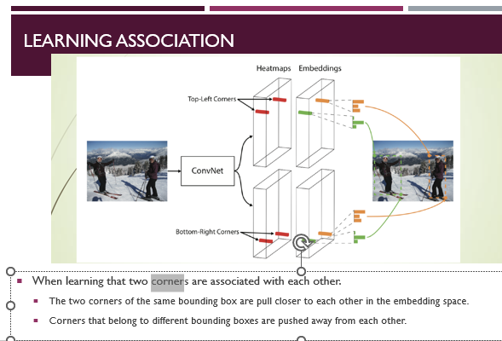

* Why is it a good idea to use fully convolutional networks for semantic segmentation?

This enables to avoid the use of dense layers means less parameters (making the networks faster to train).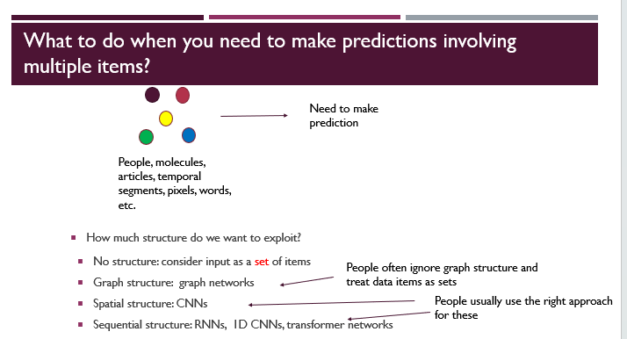

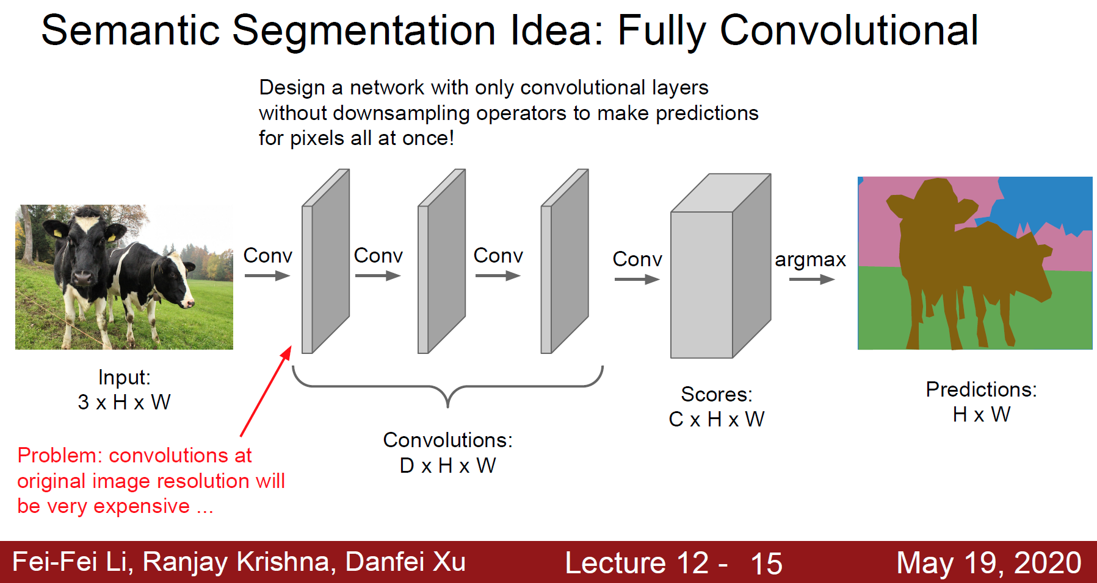

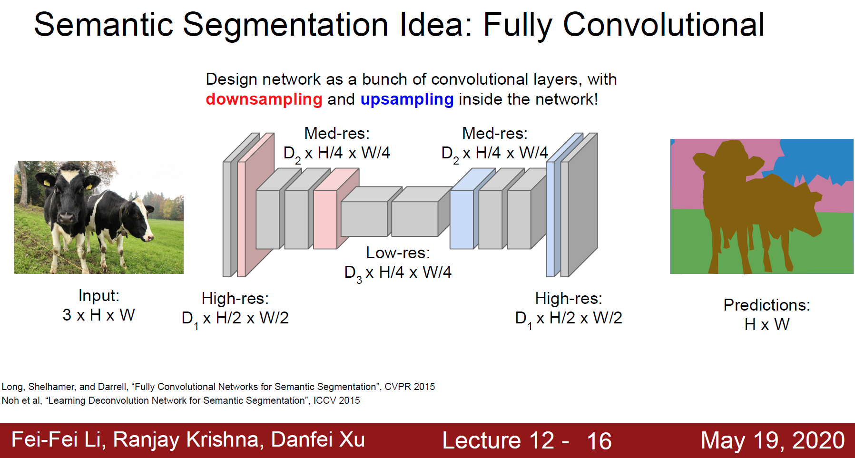



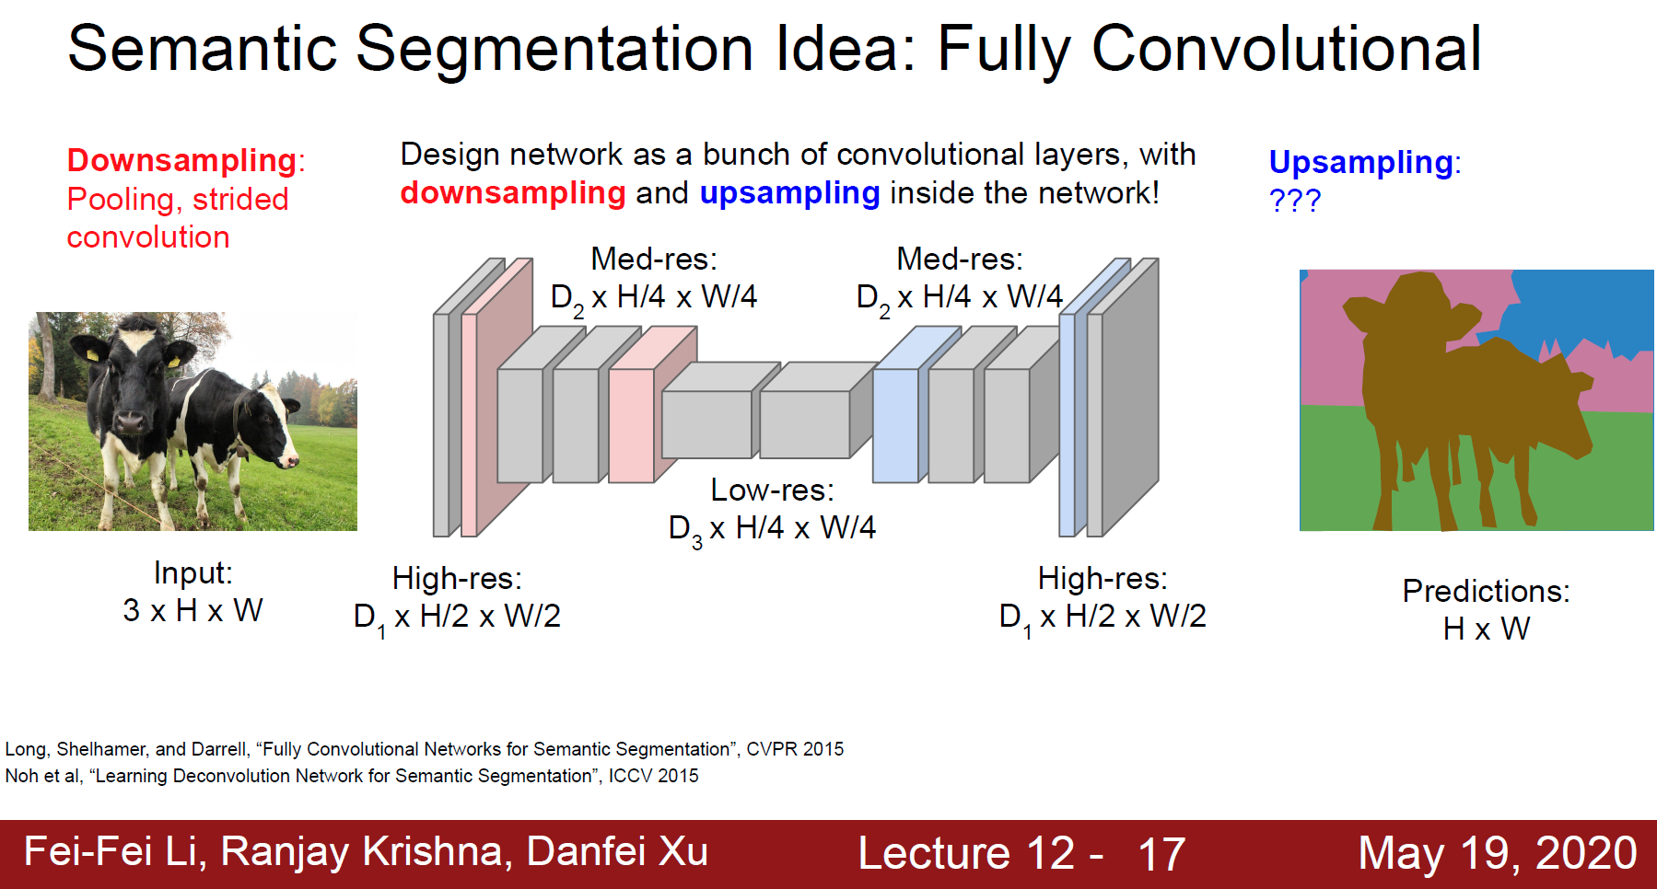

* What information does class activation maps (CAMs) give us? Also how does it work?

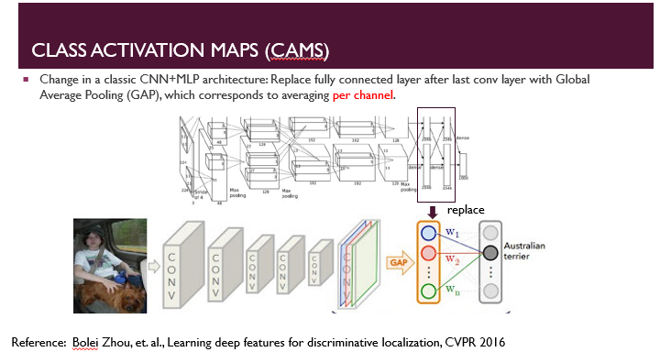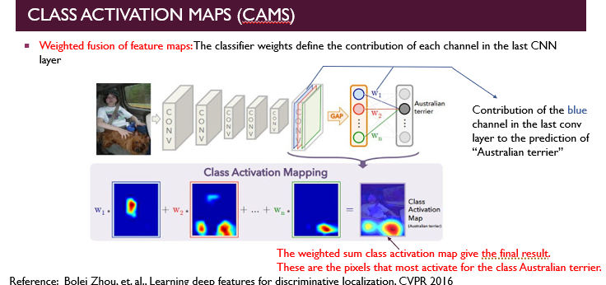

Week 6

Lecture 11

* In what situations is graph neural networks useful?

Graph Neural Networks are useful in cases such as Molecule Property prediction and Temporal Action localization. Graph Neural Networks (GNNs) are a powerful tool for solving many NLP problems. GNNs have been used to solve tasks like text classification, exploiting semantics in machine translation, user geolocation and relation extraction.

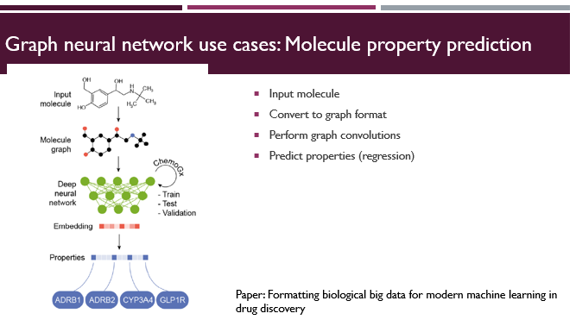

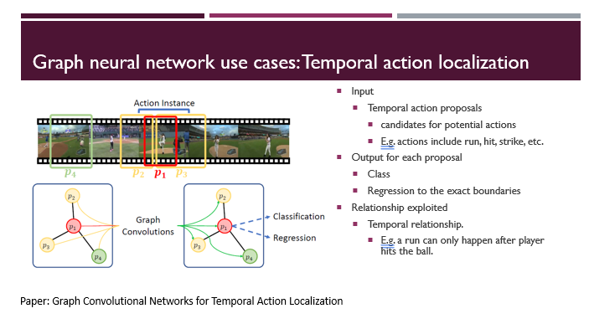

* What is the best way to make predictions when the input is a set of items? 
* How does graph convolutions work?

The filters act as a sliding window across the whole image/sequence and enable CNNs to learn features from neighbouring cells.

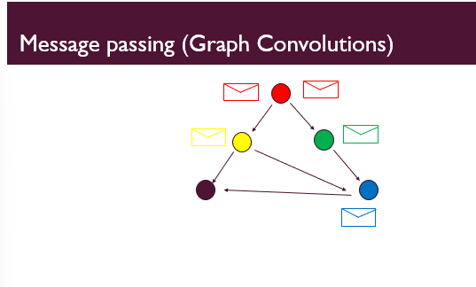 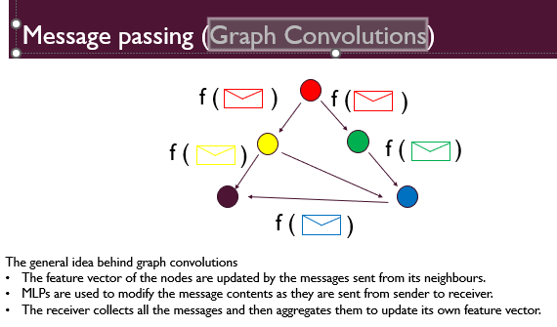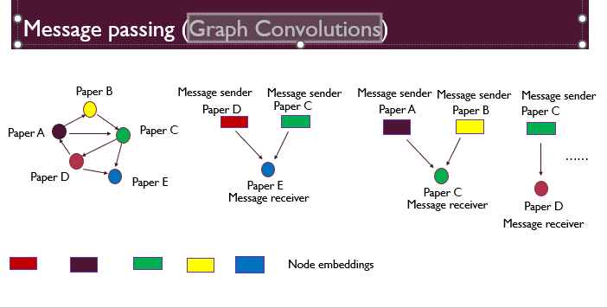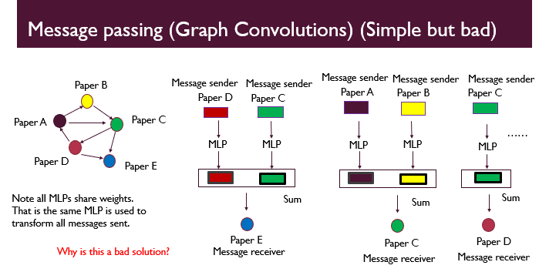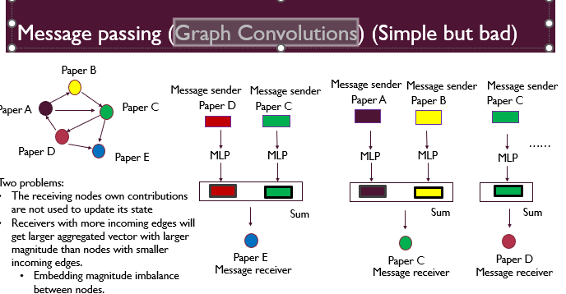w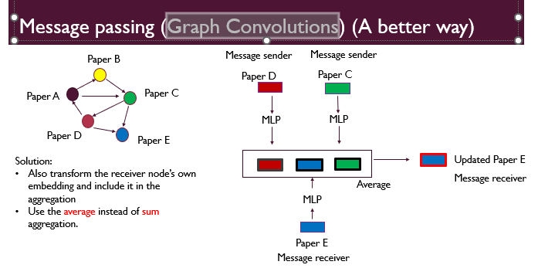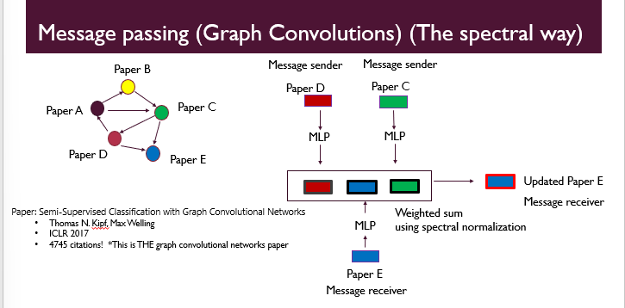

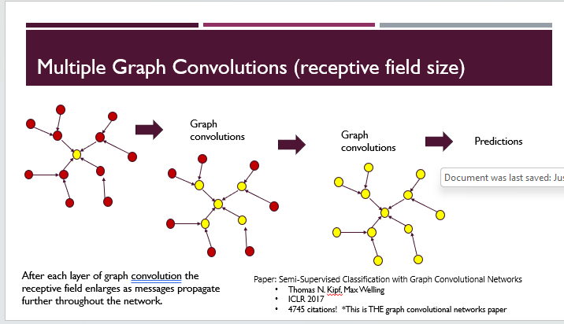

* How to get the edges for the graph?

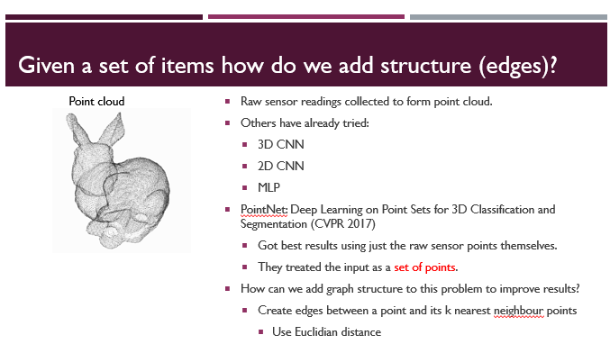

* How does dynamic graph convolutions work? 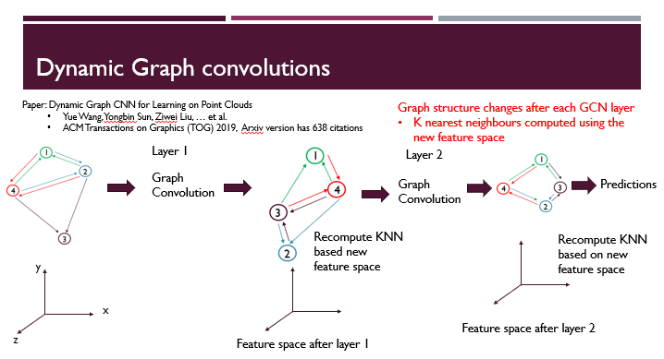
* When is domain adaptation needed?

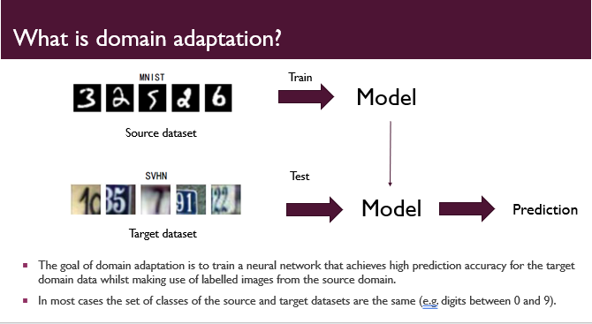

Domain adaptation is a field associated with machine learning and transfer learning. This scenario arises when we aim at learning from a source data distribution a well performing model on a different (but related) target data distribution.

* Name two ways the feature extractor for domain adaptation models can be trained so it outputs features that are domain agnostic.

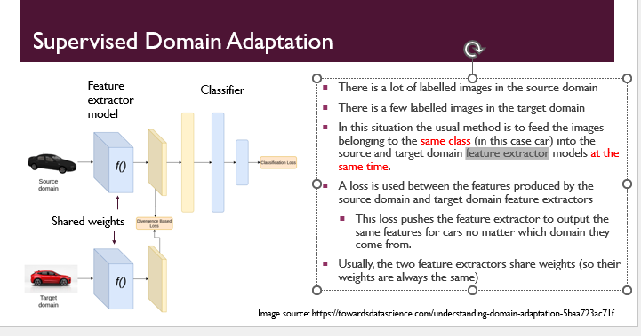

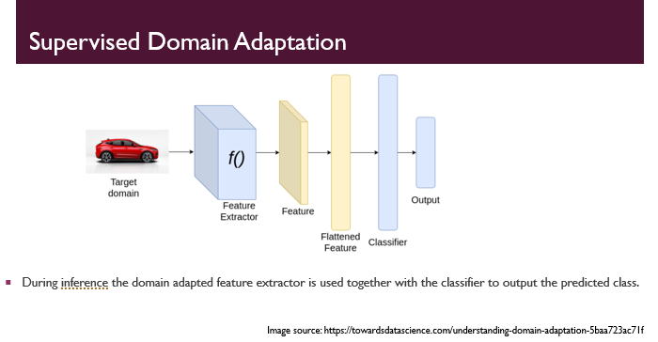

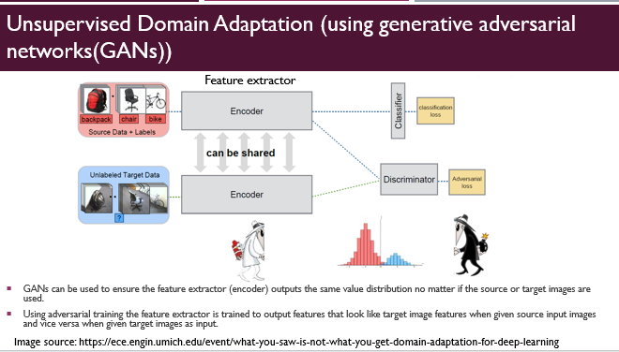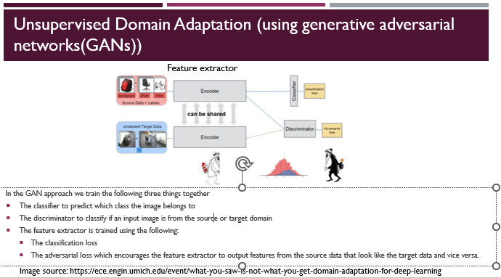

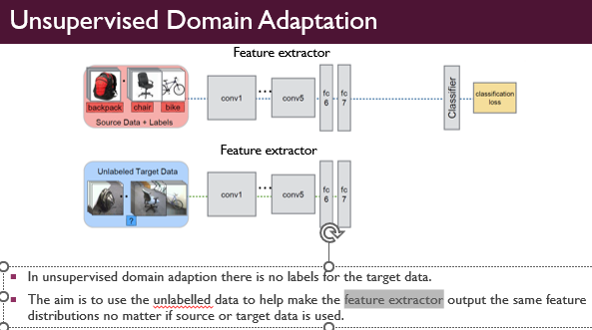

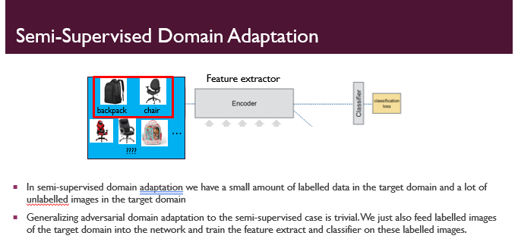

In what way is transductive different to how we have trained models in the past?

Traditional supervised learning is done using inductive learning.

However, many of the graph network benchmark datasets are designed for transductive learning.

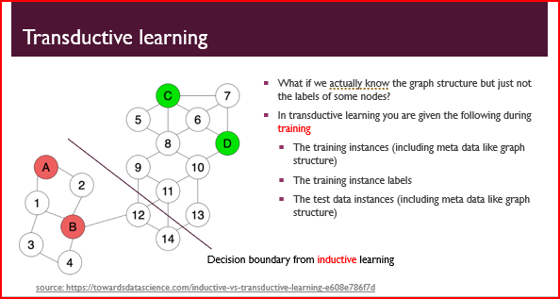

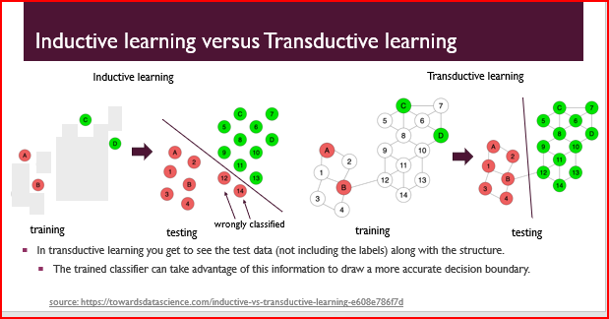

* **Inductive learning**
  + **Advantages**
    - Builds a generic classifier that can be applied to any future data
      * Do not need to see any test data during training
  + **Disadvantages**
    - Lower accuracy since it does not see any structure of test data during training.
* **Transductive learning**
  + Advantages
    - Can get higher accuracy by taking advantage of structure in the test data (although not the label) when training classifier
  + **Disadvantages**
    - Model can not be directly used on new test data without retraining.
      * When new data arrives you need to retrain the whole model.

**Definitive answer:**

Transductive learning differs from traditional training methods in that it focuses on making predictions for specific, unseen data points within the training set rather than generalizing to entirely new data in the test set. Transductive learning uses labeled data during training to directly infer labels for specific instances, while traditional methods aim to learn a model that can generalize to unseen data points.

Can we train a graph neural network with inductive learning?

Yes, we can train a graph neural network with inductive learning. In inductive learning, the graph neural network is trained on a subset of the graph data and then can generalize to predict labels for entirely new nodes or graphs that were not seen during training. Inductive learning enables the graph neural network to handle previously unseen data points or graphs efficiently and effectively.

How can we make predictions using sets as input?

To make predictions using sets as input in graph neural networks, we can use permutation-invariant aggregation functions like sum, mean, or max pooling to combine the node features within the set into a fixed-size representation. This aggregated representation is then fed through the graph neural network to make predictions for the entire set, allowing graph neural networks to handle input sets efficiently and capture relationships between elements within the sets.

How do graph convolutions use set-based operations?

Graph convolutions use set-based operations by aggregating the node features within each neighbourhood (set of neighbouring nodes) in the graph. These aggregations, such as sum, mean, or max pooling, combine the node features into a fixed-size representation, which is then used to update the central node's feature. This process is repeated for all nodes in the graph, allowing graph convolutions to efficiently capture and propagate information across the graph's structure while respecting the set-based relationships between nodes.

How can we invent edges for datasets that don’t already have them?

To invent edges for datasets that don't already have them in the context of graph convolutional neural networks, we can use heuristics or similarity measures between data points to create connections between nodes. For example, we can use distance thresholds, similarity scores, or domain-specific rules to determine if nodes should relate to edges. This process is known as graph construction or graph augmentation and allows us to convert non-graph data into graph structures suitable for graph convolutional neural networks, enabling effective learning and inference on the data.

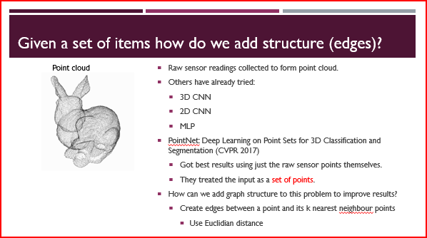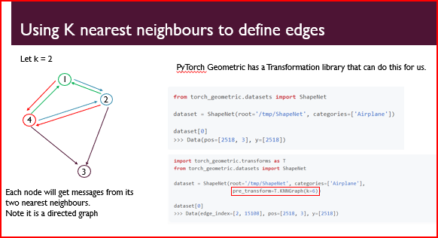

What does it mean for features to be domain agnostic?

In the context of domain adaptation, features being domain agnostic means that the learned representations or features extracted from the source domain data can be effectively used and transferred to the target domain data without significant loss of performance. Domain-agnostic features are not heavily biased towards the characteristics of a specific domain and can generalize well across different domains, facilitating the adaptation of a model from the source domain to the target domain.

What are the different types of domain adaptation? Describe an algorithm for each.

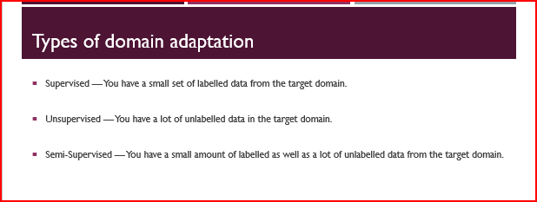

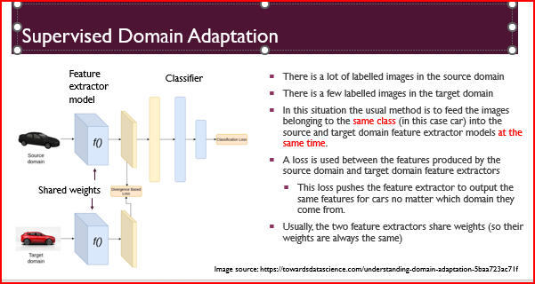

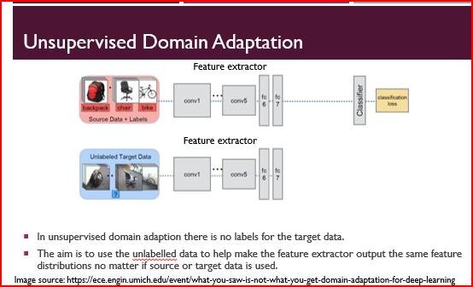

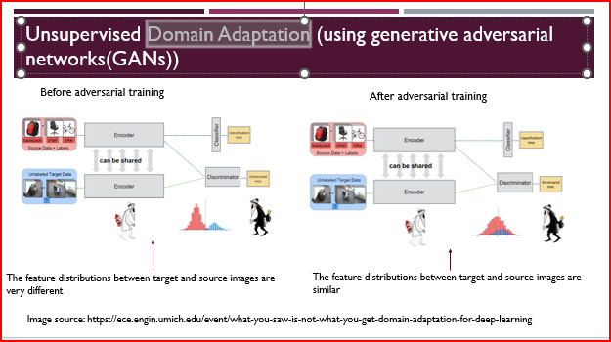

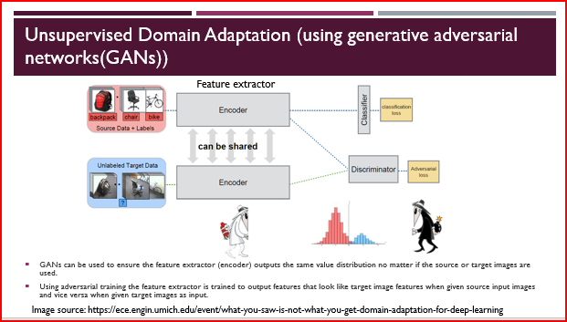

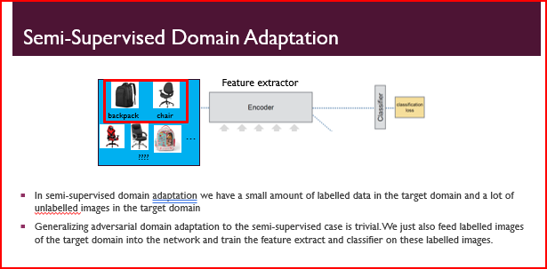

**There are several types of domain adaptation, and here are three algorithms representing each:**

**Domain-Invariant Representation Learning:**

Algorithm: Domain Adversarial Neural Network (DANN)

Description: DANN learns domain-invariant representations by training a neural network with two components: a feature extractor and a domain classifier. The feature extractor learns to extract features that are domain-invariant, while the domain classifier tries to distinguish between source and target domain data. The feature extractor and domain classifier are trained simultaneously in a domain adversarial manner, minimizing the domain classification loss and maximizing the domain confusion loss to align the feature distributions between the two domains.

Instance Re-weighting:

**Algorithm: Importance Weighted Adaptation (IWA)**

**Description:** IWA addresses domain shift by re-weighting the importance of each instance in the source domain during training. It assigns higher weights to source domain instances that are more similar to the target domain to reduce the impact of domain discrepancies. By adjusting the instance weights, IWA encourages the model to focus more on informative source domain samples that can generalize well to the target domain.

**Domain-Adaptive Regularization:**

**Algorithm:** Maximum Mean Discrepancy (MMD)

Description: MMD minimizes the discrepancy between the feature distributions of the source and target domains by adding a domain-adaptive regularization term to the loss function during training. MMD calculates the distance between the means of the feature representations in the source and target domains. By minimizing the MMD loss, the model is encouraged to learn domain-invariant features and adapt to the target domain.

These algorithms represent different approaches to tackle domain adaptation challenges by learning domain-invariant features, re-weighting instance importance, or incorporating domain-adaptiveregularization. Each algorithm is designed to help bridge the domain gap and improve the performance of models on target domain data using knowledge from the source domain.

**Programming Questions**

* The programming questions will give you some code and ask you what you think is wrong with the code.
* For example, given the following code, please identify any mistakes with the code (assume **linSize** is the correct input size for the linear layer):

class ConvNet(nn.Module):

def __init__(self, device, linSize):

super().__init__()

self.seq = nn.Sequential(

nn.Conv2d(1, 2, 3, padding=1),

nn.ReLU(),

nn.Conv2d(4, 10, 3, padding=1),

nn.ReLU(),

nn.Flatten(),

nn.Linear(linSize, 5)

nn.ReLU(),

nn.Linear(linSize, 1)

)

self.to(device)

def forward(self, x):

return self.seq(x)